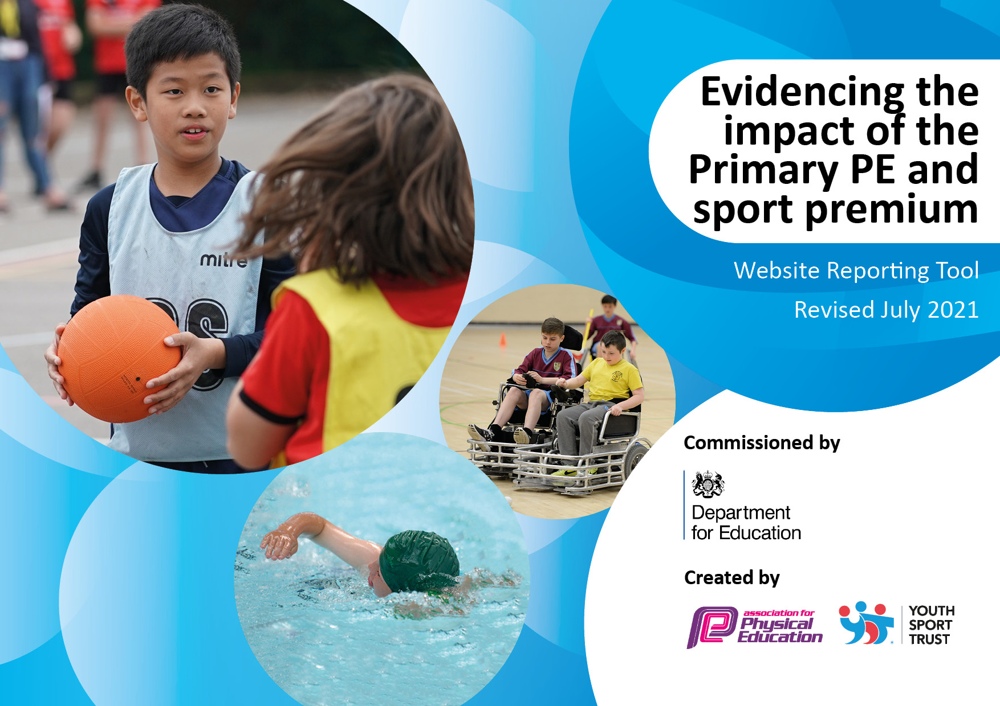
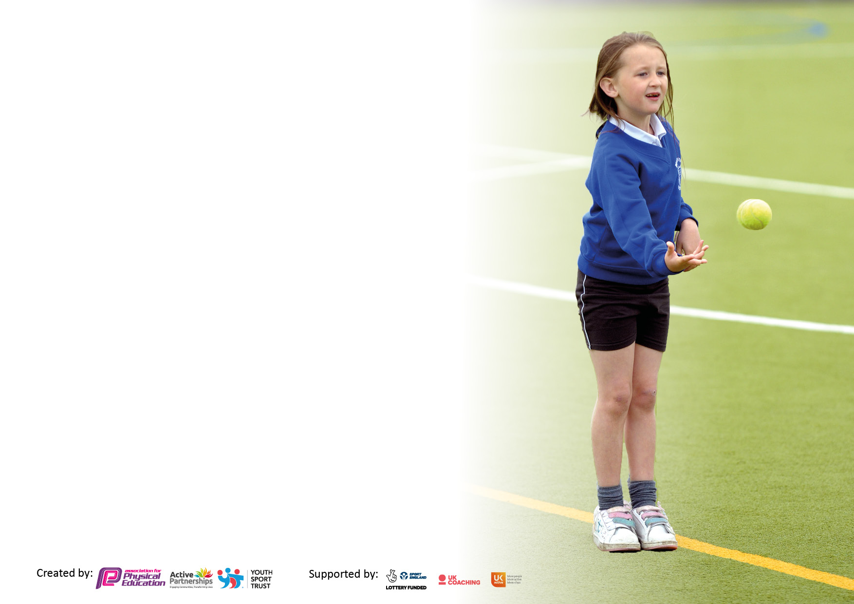

It is important that your grant is used effectively and based on school need. The Education Inspection Framework makes clear there will be a focus on ‘whether leaders and those responsible for governors all understand their respective roles and perform these in a way that enhances the effectiveness of the school’.

Under the Quality of Education Ofsted inspectors consider:
Intent - Curriculum design, coverage and appropriateness
Implementation - Curriculum delivery, Teaching (pedagogy) and Assessment
Impact - Attainment and progress

To assist schools with common transferable language this template has been developed to utilise the same three headings which should make your plans easily transferable between working documents.

Schools must use the funding to make additional and sustainable improvements to the quality of Physical Education, School Sport and Physical Activity (PESSPA) they offer. This means that you should use the Primary PE and sport premium to:

- Develop or add to the PESSPA activities that your school already offer
- Build capacity and capability within the school to ensure that improvements made now will benefit pupils joining the school in future years
- The Primary PE and sport premium should not be used to fund capital spend projects; the school’s budget should fund these.

Pleasevisitgov.ukfortherevisedDfEguidanceincludingthe5keyindicatorsacrosswhichschoolsshoulddemonstrate animprovement.Thisdocumentwillhelpyoutoreviewyourprovisionandtoreportyourspend.DfEencouragesschools to use this template as an effective way of meeting the reporting requirements of the Primary PE and sport premium.

We recommend you start by reflecting on the impact of current provision and reviewing the previous spend.

Schools are required to publish details of how they spend this funding, including any under-spend from 2019/2020, as well as on the impact it has on pupils’ PE and sport participation and attainment. All funding must be spent by 31st July 2022.

We recommend regularly updating the table and publishing it on your website throughout the year. This evidences your ongoing self-evaluation of how you are using the funding to secure maximum, sustainable impact. Final copy must be posted on your website by the end of the academic year and no later than the 31st July 2021. To see an example of how to complete the table please click HERE.

Details with regard to funding
Please complete the table below.

Total amount carried over from 2019/20 | £0.00
Total amount allocated for 2020/21 | £17,808
How much (if any) do you intend to carry over from this total fund into 2021/22? | £2756
Total amount allocated for 2021/22 | £17808
Total amount of funding for 2021/22. To be spent and reported on by 31st July 2022. | £20380
Swimming Data
Please report on your Swimming Data below.

Meeting national curriculum requirements for swimming and water safety.

N.B. Complete this section to your best ability. For example you might have practised safe self-rescue techniques on dry land which you can then transfer to the pool when school swimming restarts.
Due to exceptional circumstances priority should be given to ensuring that pupils can perform safe self rescue even if they do not fully meet the first two requirements of the NC programme of study
What percentage of your current Year 6 cohort swim competently, confidently and proficiently over a distance of at least 25 metres?  N.B. Even though your pupils may swim in another year please report on their attainment on leaving primary school at the end of the summer term 2020.  Please see note above | 70%
What percentage of your current Year 6 cohort use a range of strokes effectively [for example, front crawl, backstroke and breaststroke]?  Please see note above | 55%
What percentage of your current Year 6 cohort perform safe self-rescue in different water-based situations? | 70%
Schools can choose to use the Primary PE and sport premium to provide additional provision for swimming but this must be for activity over and above the national curriculum requirements. Have you used it in this way? | No – due to COVID – We usually send the children swimming in year 6 summer 2, however this was not possible on this occasion due to restrictions being in place.
Note:
As a result of Covid, and the vast amount of disruption to learning that has occurred; for the academic year 2021-2022, the school has decided to change the delivery of swimming. Previously year 3 has swum for an entire term – this is the equivalent of 12 hours with additional sessions paid out of the Sports Premium funding.

For 2021-22, the school will instead be sending year 6 swimming. As the year 6 cohort have already swum, this will only be booster sessions, funded by the Sports Premium funding, this will be noted in the financial year of April 21 – March 22

Action Plan and Budget Tracking
Capture your intended annual spend against the 5 key indicators. Clarify the success criteria and evidence of impact that you intend to measure to evaluate for pupils today and for the future.

Academic Year: 2020/21 | Total fund allocated: | Date Updated:
Key indicator 1: The engagement of all pupils in regular physical activity – Chief Medical Officers guidelines recommend that primary school pupils undertake at least 30 minutes of physical activity a day in school |  |  |  | Percentage of total allocation:
 |  |  |  | 24.03%
Intent | Implementation |  | Impact
Your school focus should be clear what you want the pupils to know and be able to do and about  what they need to learn and to  consolidate through practice: | Make sure your actions to achieve are linked to your intentions: | Funding allocated: | Evidence of impact: what do pupils now know and what can they now do? What has changed?: | Sustainability and suggested next steps:
Provide students with a range of activities that they can participate in during social times. This would then hopefully increase their physical activity.  Further improve the lunch time provision to encourage a larger variety of activities available. | Install a variety of playground lines and activities for the children to use during social time  Purchase a variety of lunch time equipment such as different balls/hoops and other sporting equipment | £4000  £280.01 | A wider variety of activities are now available for the students to take part in, and enjoy exercising with each other.  Lunch time provision improved with a greater enjoyment being had by the children. This then resulted in a larger amount of exercise at social times  78% of students reported that they enjoyed the variety of lunch time activities more than previously.  Key statements include:  “The lines mean that we have actual pitches on the playgrounds”  “I like the keepy up zone as I can set myself a challenge to beat each week” | This is a larger, one off payment with the children being reminded of how to use and enjoy using the lines at social times.  Equipment will need to be updated as the lunch time provision changes, assess to see what can be improved and then look to improve on the next academic year.
Key indicator 2: The profile of PESSPA being raised across the school as a tool for whole school improvement |  |  |  | Percentage of total allocation:
 |  |  |  | 8.97%
Intent | Implementation |  | Impact
Your school focus should be clear what you want the pupils to know and be able to do and about  what they need to learn and to  consolidate through practice: | Make sure your actions to achieve are linked to your intentions: | Funding allocated: | Evidence of impact: what do pupils now know and what can they now do? What has changed?: | Sustainability and suggested next steps:
Further improve the quality of PE teaching through the range of equipment available to teachers.  Increase the profile of PESSPA | Purchase and upgrade a variety of PE equipment, to be used in the lessons to help students with their education and provision.  Purchase staff PE kits so that pupils can recognise the importance being placed on PE within the school improvement plan. | £1427.92  £169.08 | Equipment has improved, giving students a better resource and therefore able to access a higher quality of lessons.  Pupils have a sense of belonging to a school, that the teachers are placing PE and school sport as a priority. | Continued funding of equipment needed to ensure the highest quality of teaching is available.  Continued purchase of new staff PE kit for staff coming into the school

Key indicator 3: Increased confidence, knowledge and skills of all staff in teaching PE and sport |  |  |  | Percentage of total allocation:
 |  |  |  | 44.31%
Intent | Implementation |  | Impact
Your school focus should be clear | Make sure your actions to | Funding | Evidence of impact: what do | Sustainability and suggested
what you want the pupils to know | achieve are linked to your | allocated: | pupils now know and what | next steps:
and be able to do and about | intentions: |  | can they now do? What has
what they need to learn and to |  |  | changed?:
consolidate through practice:
Ensure that all staff are adequately prepared and trained to deliver PE and school sport.  Continue to provide staff with assistance in the delivery of PE and sport within their lessons and at social times | The payment of TLR for a PE specialist to undertake the role of PE coordinator in the school, this is to aid the rest of the school staff and implement high quality first teaching  Employ a PE apprentice to support the knowledge and skills of the teachers and people delivering PE. | £4045.48  £3844.64 | Pupils have access to a wide range of sports and activities due to the curriculum that has been developed by the PE coordinator.  87% of school teaching staff reported increased confidence as a result of the apprentice being in the class to support during PE lessons.  Children had an extra adult in the class to get targeted, high quality provision. | Continue to pay for the TLR so that members of the school community can have an expert in the field to assist them with any teaching or learning queries.  Apprentice was for a year and the contract has since ended. The school has no plans to employ another apprentice for the academic year 21-22, this is due to a change of course with our local provider.
Additional comments:

Key indicator 4: Broader experience of a range of sports and activities offered to all pupils |  |  |  | Percentage of total allocation:
 |  |  |  | 7.21%
Intent | Implementation |  | Impact
Your school focus should be clear | Make sure your actions to | Funding | Evidence of impact: what do | Sustainability and suggested
what you want the pupils to know | achieve are linked to your | allocated: | pupils now know and what | next steps:
and be able to do and about | intentions: |  | can they now do? What has
what they need to learn and to |  |  | changed?:
consolidate through practice:
To be able to experience Outdoor and Adventurous Activity within a safe and enjoyable setting. This range of activities is unique to our school and is will be delivered to all members of our setting. These activities will focus on key areas of Outdoor and Adventurous activity; including teamwork, leadership and communication skills.  Additional achievements: | Improve the provision of our Forest School area so that students can have the highest possible provision that the school can offer. | £1285.00 | Students reported an improved response to forest school. Forest School has enabled students to develop key areas of communication that they have then been able to take back into the classroom. | Continued monitoring of the provision of Forest School. OAA has now become a central aspect of the curriculum with every class having 6 weeks delivered to them through the course of the academic year.

Key indicator 5: Increased participation in competitive sport |  |  |  | Percentage of total allocation:
 |  |  |  | %
Intent | Implementation |  | Impact
Your school focus should be clear | Make sure your actions to | Funding | Evidence of impact: what do | Sustainability and suggested
what you want the pupils to know | achieve are linked to your | allocated: | pupils now know and what | next steps:
and be able to do and about | intentions: |  | can they now do? What has
what they need to learn and to |  |  | changed?:
consolidate through practice:
For pupils to take part in a range of competitive activities and games throughout the school year – both inter school and intra school.  Extra curricular sports are part funded by the TLR to the PE lead and also by the apprentice. | This was made incredibly difficult as a result of COVID, there were no external sporting events due to the restrictions and case numbers in the local area being very high. | Cited above | Unfortunately, due to the pandemic, these were limited. However, we were creative with our use of PE lessons and instead were able to create a series of competitions within classes. This meant that students were able to still enjoy competition, but within a smaller scale.

Signed off by
Head Teacher:
Date:
Subject Leader:
Date:
Governor:
Date:

