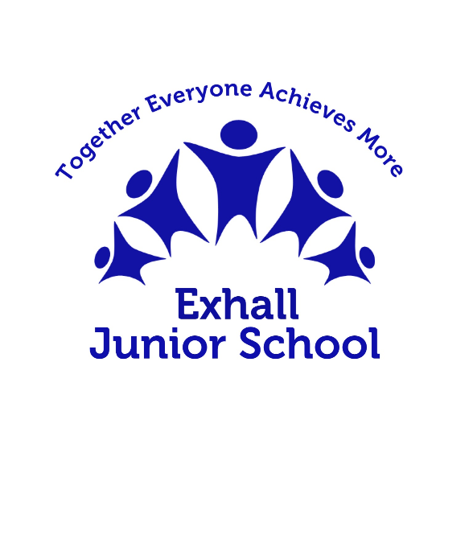

# Curriculum Offer

# PSHRSE

|  |
| --- |
| Statement of Intent |
| At Exhall Junior School our personal, social, health, Relationships and Sex education (PSHRSE) curriculum supports our students into becoming healthy, independent and empathetic citizens ready to move into the next phase of their development. It aims to help them understand how they are developing personally, physically and socially, and tackles many of the moral, social and cultural issues that are part of growing up in a modern and diverse society. We provide our students with opportunities for them to learn about rights and responsibilities and to understand what it means to be a member of a diverse and ever-changing community. Our students are encouraged to develop their sense of self-worth by playing a positive role in contributing to school life and the wider community. All lessons are underpinned by our school’s core values of being ‘Safe, Ready and Respectful’ which fit perfectly with our curriculum offer and lesson themes. |

|  |
| --- |
| Special Educational Needs (SEND) / Pupil Premium / Safeguarding |
| All lessons planned and taught will ensure inclusion of all children. Children with SEND will be differentiated for and if necessary there will be pre-teaching of vocabulary. Over learning of themes will ensure key messages are repeated and vocabulary embedded. Additional resources for lessons on puberty can be found in the resource area for students with ASD or for students with significant cognition and learning needs.  Pupils who are Pupil Premium are known by the class teacher who will ensure that targeted questioning is used to elicit understanding, challenge misconceptions and support personal growth including being aspirational.  We understand that some of the information taught can be challenging and staff will have prior knowledge of students who may be affected by themes covered. |

|  |
| --- |
| Implementation |
| **Clear and comprehensive Personal, Social, Health and Relationships and Sex Education programme of study**:  Scheme of work is in line with the new recommendations of teaching RSE in England (September 2020). The teaching and learning of PSHRSE is planned explicitly within each year group in-line with the newest statutory guidance.  **PSHRSE programme of work is progressive in content and aimed at the correct audience**  The school will use Warwickshire and DFE guidance to support a spiral curriculum that looks at: Families and People Who Care For Me; Caring Friends; Respectful Relationships; On-Line Relationships and Being Safe.  The school curriculum will also focus on extra learning themes which are: health (the importance of physical activity and diet for a healthy lifestyle), wellbeing (including mental health), puberty, drug education and financial education. The Scheme of work includes the Protective Behaviours programme ‘Taking Care’ and character education.  **Parent Consultation**  Parents are informed of the content of the RSE programme of study and further support / clarification is given if required. Parents will be informed before any units commence stating statutory elements that must be taught and attended by their child. Parents have the opportunity to contribute their views and ideas that they feel would be beneficial for the students at Exhall Juniors School.  **Pupil Voice**  Students are able to contribute to the curriculum by suggesting themes or real-life issues they are worried about or would like to know more about; focusing on and supporting them in ways that ensure they feel safe and respected.  **Vocabulary**  During lessons, key vocabulary and terminology used throughout the teaching of PSHRSE will be made explicit and will underpin classroom practice.  **Wider Curriculum**  Where appropriate other subjects will make a link to PSHRSE, ensuring language is used consistently used by all staff. Curriculum links will be made to and share the teaching of core objective (Computing and e-safety, PE and Physical well-being & maths and financial education)  **Displays across school**  PSHE and the schools core values will be on display throughout school to reinforce the PSHE curriculum enabling students to make links and reinforce its importance and value.  **Assemblies**  Whole school and class assemblies always make a link to PSHRSE by using the core vocabulary or drawing upon key skills such as empathy, disagreeing respectfully, staying safe, problem solving and sharing opinions.  **School Vision and Values**  Lessons will link where they can to British Values, SMSC and the schools Key values of: Safe, Ready and Respectful |

|  |  |
| --- | --- |
| Long Term Curriculum Plan | Coverage of Skills |
| <https://drive.google.com/file/d/1lJ4uEtduqSBppoE-UucI15bU_cASEsM9/view?usp=sharing> | <https://drive.google.com/file/d/14RdiPpffMDFSDYbtj5X3Wx6E0FtAVSmH/view?usp=sharing> |

|  |
| --- |
| Impact |
| By the end of year 6:  _ that students know how to keep themselves and others healthy and safe;  _that they understand they live in a diverse society and feel able to challenge stereotyping or other forms of prejudice;  _ they are able to reflect on their learning and the progress they have made, and to transfer knowledge and skills from one school subject to another, and from one school to another, into their lives and in the wider community.  _have develop the knowledge, skills, attitudes and understanding they need to fulfil their potential and be aspirational;  _have built relationships with adults and peers and to have feel valued by them;  _to have made real decisions, to have taken part in activities that involved choice and given the opportunity to demonstrate their ability to take responsibility for their decisions;  _ to have been part of a community where they felt safe and supported;  _developed the ability and confidence to ask questions, challenge others respectfully, draw on their own experience, express their views and opinions and put what they have learned into practice. |