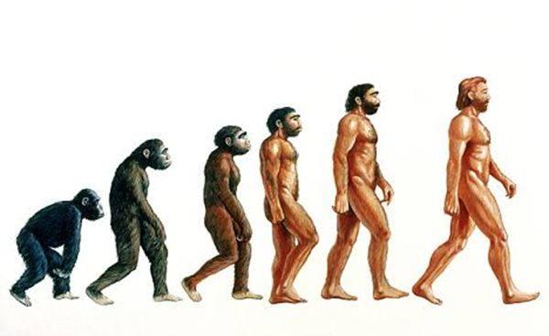

Key Vocabulary

Adaptation – The process of change so that an organism or species can become better suited to their environment

Body fossil – Preserved remains of the body of the actual animal or plant itself

Breeding – The mating and production of offspring by animals

Environment – The surroundings or conditions in which a person, animal, or plant lives

Evolution – The process by which different kinds of living organism are believed to have developed from earlier forms during the history of the earth

Fossil – The remains or impression of a prehistoric plant or animal embedded in rock and preserved

Inherit – To gain a quality, characteristic or predisposition genetically from a parent or ancestor

Offspring – A person’s child or children/ an animal’s young

Reproduction – The production of offspring by a sexual or asexual process

Selective breeding – The process by which humans use animal breeding and plant breeding to develop selective characteristics by choosing particular animals and plants

Trace fossil – Indirect evidence of life in the past such as the footprints, tracks, burrows, borings and waste left behind by animals

**Year 6 – Spring 1 – Knowledge Organiser  
Evolution and Adaptation**

**Evolution – Science – Spring 1**

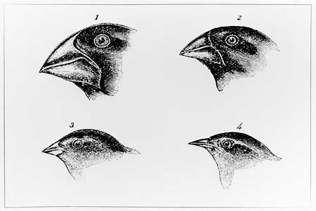

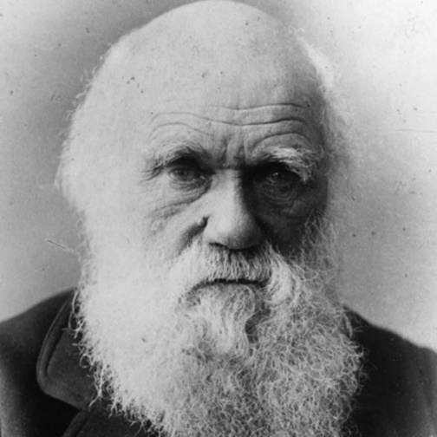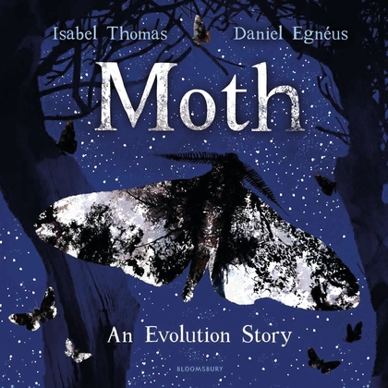

**Also in Year 6:  
Topic: Where does our stuff come from?   
Art: Art Skills  
D+T: Felt Phone Cases  
R.E: Is it better to express your religion in arts/architecture or charity/generosity?  
P.E: Tag Rugby/Netball  
Spanish: Animals and Culture  
PSHE: SRE, E-Safety and SEAL**

**Please remember to read with your child at least 3 times a week!**

We will also be immersing into this book.

Charles Darwin – Famous Scientist