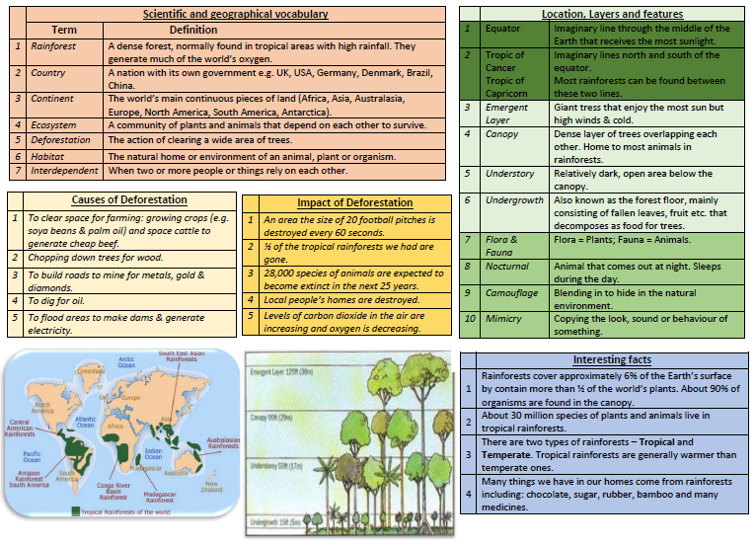

Year 4/5 Knowledge Organiser – The Amazon Rainforest

In 4/5, We will also be studying Maths – Fractions, English – The book ‘Explorer’ and our Greek Performance, Science – Forces, PSHE – Character Education, RE – Hindu and methods of worship. Class D will be doing Forest School on a Thursday, classes C and E will be doing PE and ICT. **Please read at home at least 3 times a week!!!**