**Year 6 Knowledge Organiser -Where does our stuff come from?**

****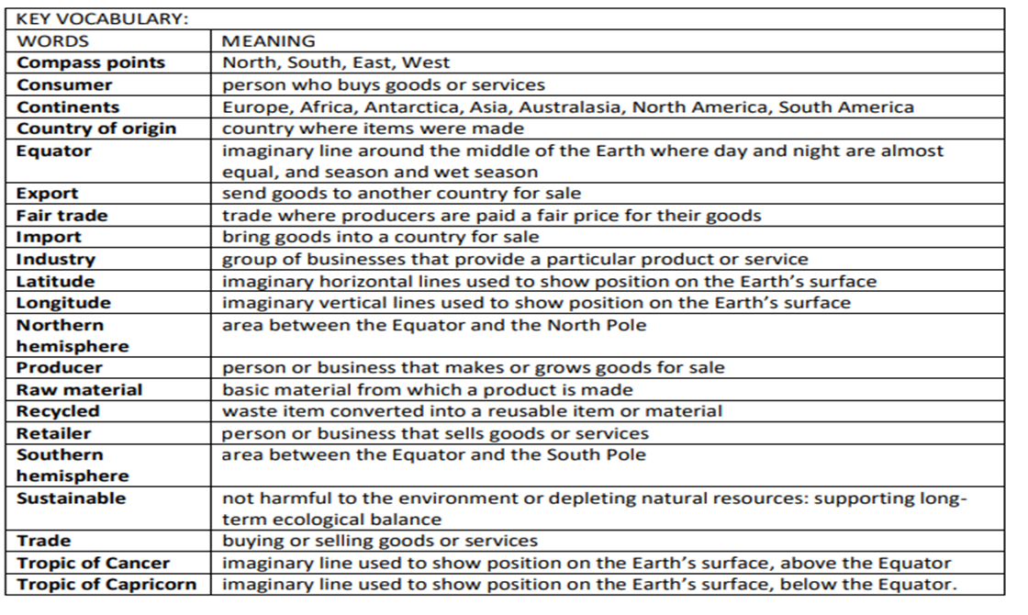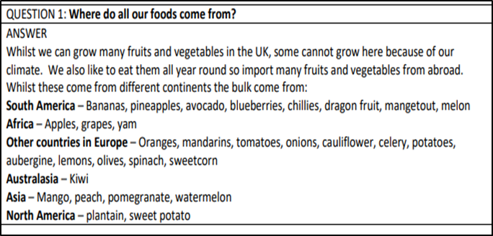

**Task for Home:**

Look at the section ‘where do our foods come from?’

Can you find out or name other products (non-edible) that may also be imported from those countries?

**Also in Year 6:  
Topic: Where does our stuff come from?   
Science: Animals including Humans  
Art: Art Skills  
R.E: What does it mean to be a Muslim in Britain today?  
P.E: Tennis/Hockey  
Spanish: Stories and conversation  
PSHE: Character Education and E-Safety**

