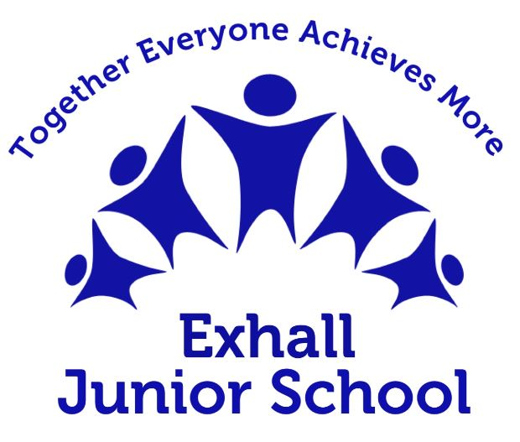
Music
National Curriculum
Key stage 2
Pupils should be taught to sing and play musically with increasing confidence and control.
They should develop an understanding of musical composition, organising and
manipulating ideas within musical structures and reproducing sounds from aural memory.
Pupils should be taught to:
- play and perform in solo and ensemble contexts, using their voices and playing musical
instruments with increasing accuracy, fluency, control and expression
- improvise and compose music for a range of purposes using the inter-related dimensions of music
- listen with attention to detail and recall sounds with increasing aural memory
- use and understand staff and other musical notations
- appreciate and understand a wide range of high-quality live and recorded music drawn
from different traditions and from great composers and musicians
- develop an understanding of the history of music.
INTENT
At the heart of our curriculum are our school curriculum drivers –Being Safe Ready and Respectful. The drivers shape our curriculum, bring about the aims and values of our school, and respond to the needs of our community. Music provision at Exhall Junior School is a cornerstone to shaping our students into being well-rounded, knowledgeable individuals. It is a universal language that embodies one of the highest forms of creativity. We ensure that children are engaged and inspired to develop a love of music and their talent as musicians, and so increase their self-confidence, creativity and sense of achievement. With progression, they will develop a critical engagement with music, allowing them to compose, and to listen with discrimination to a wide repertoire of music. Our curriculum for Music aims to ensure that all pupils can:
• perform, listen to, review and evaluate music across a range of historical periods, genres, styles and traditions, including the works of the great composers and musicians
• learn to sing and to use their voices, to create and compose music on their own and with others, have the opportunity to use technology appropriately and have the opportunity to progress to the next level of musical excellence
• understand and explore how music is created, produced and communicated, including through the inter-related dimensions: pitch, duration, dynamics, tempo, timbre, texture, structure and appropriate musical notations.
IMPLEMENTATION
Here at Exhall Junior School, we ensure that sufficient time is given to music in order to enable pupils to meet the expectations set out in the National Curriculum programme of study. Music planning is personalised to the needs of our children; it challenges them and builds on previous learning. To further enhance musicianship and creativity, children take part in weekly singing assemblies, and performance through class assemblies and other events such as end of year performances.
IMPACT
At Exhall Junior School, we want our music provision to impact our children in the ways listed below. We want our children to become musical, creative pupils. In order to achieve that, our children will show:
• A rapidly widening repertoire which they use to create original, imaginative, fluent and distinctive composing and performance work.
• A musical understanding underpinned by high levels of aural perception, internalisation and knowledge of music, including high or rapidly developing levels of technical expertise. • Very good awareness and appreciation of different musical traditions and genres.
• An excellent understanding of how musical provenance – the historical, social and cultural origins of music – contributes to the diversity of musical style.
• The ability to give precise written and verbal explanations, using musical terminology effectively, accurately and appropriately.
• A passion for and commitment to a diverse range of musical activities.

