PSHE and RSE curriculum – Living in the wider world, health and well-being & Relationships (RSE)
Relationships forms part of the RSE curriculum – (Families and people who are for me, Caring friendships, Respectful relationships, On-line relationship and being safe)
Health and well-being (safety and Risk, health, Mental Health)
Living in the wider world (Rights and Responsibilities, money, identity)
 | Autumn 1 | Autumn 2 | Spring 1 | Spring 2 | Summer 1 | Summer 2
Year 3 | Protective behaviours  Taking Care Scheme  +  Black History Month | Character Education  + Anti Bullying Week | Relationship Education  + Safer Internet Day | Character Education  + Careers week | Character education  +  Mental health awareness week | Growing up & Life Cycles  + My Money week  + World environment day
Year 4/5 | Protective behaviours  Taking Care Scheme  +  Black History Month | Character Education  + Anti Bullying Week | Relationship Education  + Safer Internet Day | Character Education  + Careers week | Character education  +  Mental health awareness week | Growing up & Life Cycles  + My Money week  + World environment day
Year 6 | Protective behaviours  Taking Care Scheme  +  Black History Month | Character Education  + Anti Bullying Week | Relationship Education  + Safer Internet Day | Character Education  + Careers week | Character education  +  Mental health awareness week | Growing up & Life Cycles  + My Money week  + World environment day

ICT Overview | Autumn | Spring | Summer
3 | Be Sharp  Be Alert (1 lesson) | Safer Internet week | Be Secure  Be Kind
4&5 | NSPCC Share Aware | Safer Internet week | NSPCC Act Your Age  CEOPS – Too Much Time on Line
6 | Be Sharp  Be Alert (2 lessons) | Safer Internet week | Be Secure  Be Kind
Curriculum Links | Knowledge organiser to include vocabulary for ICT/E-Safety  PSHE & Protective behaviours curriculum  Assembly | Knowledge organiser to include vocabulary for ICT/E-Safety  PSHE & RSE curriculum  Assembly | Knowledge organiser to include vocabulary for ICT/E-Safety  PHSE & RSE curriculum  Assembly

RSE – Life cycles and Growing-up overview

Year 3 and 4 | My Body  _How have I changed since I was baby?  _Why do I change as I get older?  _Why do some children grow quicker than others?  _Why do boys and girls grow differently?  _Why are we all different and is it okay to be different?  _What is similar and different about boys and girls?  -How can I keep myself healthy (general hygiene)? | Life Cycles  _Why do we have babies?  _why do you need a male and a female to have a baby?  _Do different animals have babies?  _How do animals look after babies before birth?  _What happens when people get older?
Year 5 and 6 | My body  -What is puberty, does everyone go through it and at what age?  -What changes do boys and girls go through?  -Is my body normal and what is a normal body?  How will my body change as I get older?  -Why is personal Hygiene important? | Life cycles  -What is sex?  -What is sperm and what is an egg?  -How does fertilization happen?  -How do babies develop?  -How is a baby born?  -What do babies need to be happy and healthy?

https://www.pshe-association.org.uk/calendar
Anti-bullying week – Nov World Health day – April (assembly)
Black history month – October Pride month – June (assembly)
Mental health awareness week May My money week – June
Safer internet day – February Earth day – April (assembly)
National Careers week – March World environment day – June

Relationships overview for KS2 from DFE guidance
Families and people who care for me
- that families are important for children growing up because they can give love, security and stability
- the characteristics of healthy family life, commitment to each other, including in times of difficulty, protection and care for children and other family members, the importance of spending time together and sharing each other’s lives
- that others’ families, either in school or in the wider world, sometimes look different from their family, but that they should respect those differences and know that other children’s families are also characterised by love and care
- that stable, caring relationships, which may be of different types, are at the heart of happy families, and are important for children’s security as they grow up
- that marriage represents a formal and legally recognised commitment of two people to each other which is intended to be lifelong
- how to recognise if family relationships are making them feel unhappy or unsafe, and how to seek help or advice from others if needed
Year 3, Year 4 & 5, Year 6 - (Taught in Spring 1 – total of 5 session (including caring friendships and respectful relationships)
Year Group | Y3 | Y4 & 5 | Year 6 | Notes
Objective to cover.  1 lesson to include both objectives | - that families are important for children growing up because they can give love, security and stability  - the characteristics of healthy family life, commitment to each other, including in times of difficulty, protection and care for children and other family members, the importance of spending time together and sharing each other’s lives | - that others’ families, either in school or in the wider world, sometimes look different from their family, but that they should respect those differences and know that other children’s families are also characterised by love and care  - that stable, caring relationships, which may be of different types, are at the heart of happy families, and are important for children’s security as they grow up | - that marriage represents a formal and legally recognised commitment of two people to each other which is intended to be lifelong  - how to recognise if family relationships are making them feel unhappy or unsafe, and how to seek help or advice from others if needed | Links in with protective behaviours (Taking Care) programme

Caring Friendships
- how important friendships are in making us feel happy and secure, and how people choose and make friends
- the characteristics of friendships, including mutual respect, truthfulness, trustworthiness, loyalty, kindness, generosity, trust, sharing interests and experiences and support with problems and difficulties
- that healthy friendships are positive and welcoming towards others, and do not make others feel lonely or excluded
- that most friendships have ups and downs, and that these can often be worked through so that the friendship is repaired or even strengthened, and that resorting to violence is never right
- how to recognise who to trust and who not to trust, how to judge when a friendship is making them feel unhappy or uncomfortable, managing conflict, how to manage these situations and how to seek help or advice from others, if needed
Year 3, Year 4 & 5, Year 6 - (Taught in Spring 1 – total of 5 session (including Families and people who care for me and respectful relationships)
Year Group | Y3 | Y4 & 5 | Year 6 | Notes
Objective to cover.  2 lesson to include both objectives | - how important friendships are in making us feel happy and secure, and how people choose and make friends  - the characteristics of friendships, including mutual respect, truthfulness, trustworthiness, loyalty, kindness, generosity, trust, sharing interests and experiences and support with problems and difficulties | - that healthy friendships are positive and welcoming towards others, and do not make others feel lonely or excluded  - that most friendships have ups and downs, and that these can often be worked through so that the friendship is repaired or even strengthened, and that resorting to violence is never right | - how to recognise who to trust and who not to trust, how to judge when a friendship is making them feel unhappy or uncomfortable, managing conflict, how to manage these situations and how to seek help or advice from others, if needed | Also links in with the messages from anti-bullying week.

Respectful Relationships
- the importance of respecting others, even when they are very different from them (for example, physically, in character, personality or backgrounds), or make different choices or have different preferences or beliefs
- practical steps they can take in a range of different contexts to improve or support respectful relationships
- the conventions of courtesy and manners
- the importance of self-respect and how this links to their own happiness
- that in school and in wider society they can expect to be treated with respect by others, and that in turn they should show due respect to others, including those in positions of authority
- about different types of bullying (including cyberbullying), the impact of bullying, responsibilities of bystanders (primarily reporting bullying to an adult) and how to get help
- what a stereotype is, and how stereotypes can be unfair, negative or destructive
- the importance of permission-seeking and giving in relationships with friends, peers and adults
Year 3, Year 4 & 5, Year 6 - (Taught in Spring 1 – total of 5 session (including caring friendships and families and people who care for me)
Year Group | Y3 | Y4 & 5 | Year 6 | Notes
Objective to cover.  2 lesson to include both objectives | - the importance of respecting others, even when they are very different from them concentrating on personality or make different choices or have different preferences or beliefs  - the conventions of courtesy and manners | - the importance of respecting others, even when they are very different from them concentrating on backgrounds or make different choices or have different preferences or beliefs  - the importance of self-respect and how this links to their own happiness | - the importance of respecting others, even when they are very different from them, concentrating on physically, or make different choices or have different preferences or beliefs  - that in school and in wider society they can expect to be treated with respect by others, and that in turn they should show due respect to others, including those in positions of authority | - about different types of bullying (including cyberbullying), the impact of bullying, responsibilities of bystanders (primarily reporting bullying to an adult) and how to get help  - what a stereotype is, and how stereotypes can be unfair, negative or destructive  To be covered during Anti-bullying week  - the importance of permission-seeking and giving in relationships with friends, peers and adults  To be covered in protective behaviours/on-line safety and in all PSHE lessons to do with safety/relationships!

On-line relationship
- that people sometimes behave differently online, including by pretending to be someone they are not
- that the same principles apply to online relationships as to face-to-face relationships, including the importance of respect for others online including when we are anonymous
- the rules and principles for keeping safe online, how to recognise risks, harmful content and contact, and how to report them
- how to critically consider their online friendships and sources of information including awareness of the risks associated with people they have never met
- how information and data is shared and used online
Year 3, Year 4 & 5, Year 6 – Taught one lesson per half-term + on internet safety day in February
Year Group | Y3 | Y4 & 5 | Year 6 | Notes
Objective to cover.  See Computing and E-Safety leads LTP | - that people sometimes behave differently online, including by pretending to be someone they are not  - that the same principles apply to online relationships as to face-to-face relationships, including the importance of respect for others online including when we are anonymous  - the rules and principles for keeping safe online, how to recognise risks, harmful content and contact, and how to report them  - how to critically consider their online friendships and sources of information including awareness of the risks associated with people they have never met  - how information and data is shared and used online | - that people sometimes behave differently online, including by pretending to be someone they are not  - that the same principles apply to online relationships as to face-to-face relationships, including the importance of respect for others online including when we are anonymous  - the rules and principles for keeping safe online, how to recognise risks, harmful content and contact, and how to report them  - how to critically consider their online friendships and sources of information including awareness of the risks associated with people they have never met  - how information and data is shared and used online | - that people sometimes behave differently online, including by pretending to be someone they are not  - that the same principles apply to online relationships as to face-to-face relationships, including the importance of respect for others online including when we are anonymous  - the rules and principles for keeping safe online, how to recognise risks, harmful content and contact, and how to report them  - how to critically consider their online friendships and sources of information including awareness of the risks associated with people they have never met  - how information and data is shared and used online | All years groups to cover all objectives through the GOOGLE – Be Internet Legends curriculum, during anti-bullying week and during internet safety week

Being Safe
- what sorts of boundaries are appropriate in friendships with peers and others (including in a digital context)
- about the concept of privacy and the implications of it for both children and adults; including that it is not always right to keep secrets if they relate to being safe
- that each person’s body belongs to them, and the differences between appropriate and inappropriate or unsafe physical, and other, contact
- how to respond safely and appropriately to adults they may encounter (in all contexts, including online) whom they do not know
- how to recognise and report feelings of being unsafe or feeling bad about any adult
- how to ask for advice or help for themselves or others, and to keep trying until they are heard,
- how to report concerns or abuse, and the vocabulary and confidence needed to do so
- where to get advice, for example family, school or other sources
Year 3, Year 4 & 5, Year 6 – Taught in Autumn 1 (4 lessons)
Year Group | Y3 | Y4 & 5 | Year 6 | Notes
Objective to cover. | - what sorts of boundaries are appropriate in friendships with peers and others (including in a digital context)  - about the concept of privacy and the implications of it for both children and adults; including that it is not always right to keep secrets if they relate to being safe  - that each person’s body belongs to them, and the differences between appropriate and inappropriate or unsafe physical, and other, contact  - how to respond safely and appropriately to adults they may encounter (in all contexts, including online) whom they do not know  - how to recognise and report feelings of being unsafe or feeling bad about any adult  - how to ask for advice or help for themselves or others, and to keep trying until they are heard,  - how to report concerns or abuse, and the vocabulary and confidence needed to do so  - where to get advice, for example family, school or other sources | - what sorts of boundaries are appropriate in friendships with peers and others (including in a digital context)  - about the concept of privacy and the implications of it for both children and adults; including that it is not always right to keep secrets if they relate to being safe  - that each person’s body belongs to them, and the differences between appropriate and inappropriate or unsafe physical, and other, contact  - how to respond safely and appropriately to adults they may encounter (in all contexts, including online) whom they do not know  - how to recognise and report feelings of being unsafe or feeling bad about any adult  - how to ask for advice or help for themselves or others, and to keep trying until they are heard,  - how to report concerns or abuse, and the vocabulary and confidence needed to do so  - where to get advice, for example family, school or other sources | - what sorts of boundaries are appropriate in friendships with peers and others (including in a digital context)  - about the concept of privacy and the implications of it for both children and adults; including that it is not always right to keep secrets if they relate to being safe  - that each person’s body belongs to them, and the differences between appropriate and inappropriate or unsafe physical, and other, contact  - how to respond safely and appropriately to adults they may encounter (in all contexts, including online) whom they do not know  - how to recognise and report feelings of being unsafe or feeling bad about any adult  - how to ask for advice or help for themselves or others, and to keep trying until they are heard,  - how to report concerns or abuse, and the vocabulary and confidence needed to do so  - where to get advice, for example family, school or other sources | All Taught Through the Protective behaviours scheme ‘Taking Care’  Supplemented through the year with e-safety lessons, Sex education lessons and anti-bullying week.

Character Education Termly Over view
Autumn 2
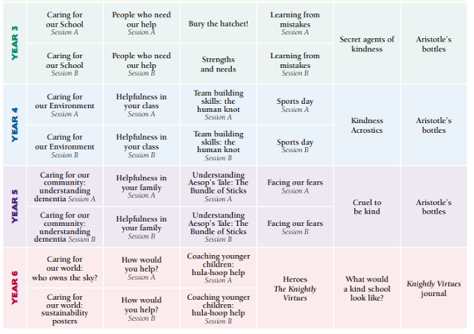

Spring 2
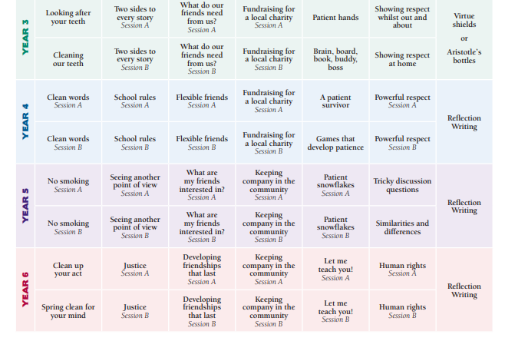

Summer 1
