What is this topic about?
During this topic we will investigate what life was like for children during the Victorian period (1837-1901) and compare it the lives of children now. We will discuss how and why they are different.

Vocabulary dozen
Age of majority: | the age at which children were usually regarded as full adults
Adolescence: | the period following the onset of puberty during which a young person develops from child into an adult
childhood: | the age span ranging from birth to adolescence
Child labour
Different types of schools: | charity, grammar, dame, public, board, church
extended family: | usually several relatives of different generations living in the same household
Factories | A place where many children during the time would have worked.
Governess
infant mortality rate: | the statistics of children dying in their first year of life
legislation: | law(s)
Philanthropist: | someone who helps others, often with money, and often secretly with no return.
Workhouse
Year 3 Autumn 1 – Knowledge Organiser
Our Autumn 1 theme…
Is it better to be a child now than in the past?
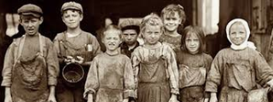

How to help at home:
- Look at the vocabulary Dozen – can you come up with definitions for the words missing them?

- Look at the Victorian figures, can you find out any more information about them?

- Talk to them about your own childhood including hobbies and toys.

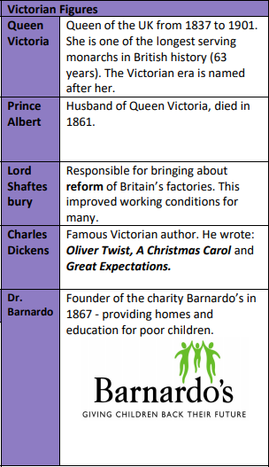
Also in Year 3 this term we will also be covering:
Science: Plants
PE: Ball skills including football and handball
Spanish: Greeting and Numbers
RE: What do different people believe about God?
Music: Singing (melody/tune/C Major scale)
ART/DT – Edible garden (what we eat that is grown)

Don’t forget to read with your children at least 3 times a week!

