Vocabulary dozen
Compass points | the four main directions on a magnetic compass and some of the divisions in between: N, NE, E, SE, S, SW. W. NW
Day | time from sunrise to sunset each day, in relation to the Earth’s rotation on its axis
Equator | imaginary line/circle of latitude around the Earth, midway between North and South Poles, dividing the Earth into Northern and Southern Hemispheres. The Equator lies at 0° latitude
Global Positioning Systems (GPS) | internationally used way of pinpointing an exact location on the Earth’s surface using space-based satellite technology
Lines of latitude | imaginary parallel lines/circles, horizontal to the Equator, that never meet, and get smaller towards the Poles
Lines of longitude | imaginary north-to-south lines/ circles, meeting at the North and South Poles to make segments. They are all the same length and go from pole to pole
Night | time from sunset to sunrise each day, in relation to the Earth’s rotation on its axis
Northern Hemisphere | half of the Earth north of the Equator
North Pole | point where the northern end of the Earth’s axis of rotation meets the Earth’s surface
Prime Meridian  (Greenwich Meridian, PM): | imaginary line/circle passing through the Royal Observatory at Greenwich, London, marking 0° longitude
Southern Hemisphere: | half of the Earth south of the Equator
Time zone: | area between lines of longitude following a standard time
Year 3
What is this topic about?
During this topic we will be using atlas’, globes and internet resources such as Google Earth to name and locate countries, continents and oceans.

Autumn 2 – Knowledge Organiser
How to help at home:
- Where have you been on holiday? Do you have any family members that live in a different country? Find out about those places using your own research.

Our Autumn 2 theme…
Where on Earth are we?
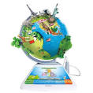

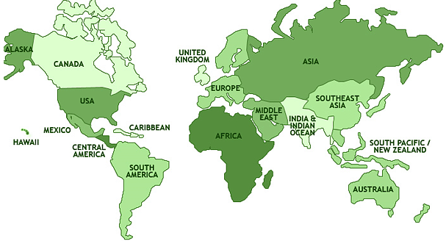
Can you find out the name of the continents?
5 are on the map above!
Also in Year 3 this term we will also be covering:
Science: Space
PE: Ball skills including football and handball
Spanish: Greeting and Numbers
RE: Why is the Bible so important for Christians?
Music: Singing (melody/tune/C Major scale)
ART/DT – Edible garden (what we eat that is grown)
Don’t forget to read with your children at least 3 times a week!

