St Giles Junior School – Geography Autumn 2
Topic: How is our Country changing? | Year 4/5 | Locational Knowledge / Human and Physical Geography
What should I already know?
The country I live in is called England.
I live in Warwickshire, which is a county in the West Midlands
Diagrams
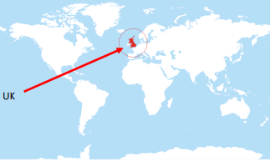
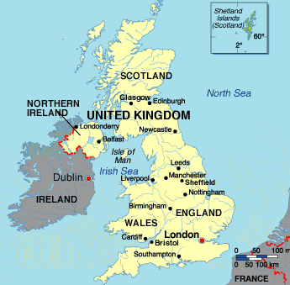
Also this term we are learning…
PSHE – Character Education
PE – Netball and Dance
Science – materials and their properties
RE – why is Jesus inspiring to some people?
Please remember to read at least 3 times a week at home!

Key Vocabulary - please complete the first 7 at home
Continent -
Country -
County -
Region -
Human Feature -
Industry -
Mountain -
North, South, East and West – compass points
Physical Feature – natural feature on the Earth’s surface e.g. lake, mountain etc
GDP – the nation’s income
River – a stream of water that outlets into a sea
Settlement – a place where people establish a community
Great Britain – geographical term for England, Wales and Scotland
The British Isles - consist of the islands of Great Britain, Ireland, the Isle of Man, the Hebrides and over six thousand smaller isles
The United Kingdom – political term for England, Wales, Scotland and Northern Ireland
City – a large or important town, often with a cathedral
Town -a populated area with fixed boundaries and a local government
Village – small community in a rural area

What will I know by the end of the unit?
There are 4 countries in the United Kingdom
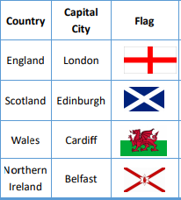
The capital cities of the UK
Where we live on a map
Understand the changes that have happened in our local area
Describe how several UK regions have changed over time
Recognised why the UK had changed through the years and why it will continue to change

Geographical skills
Learn to read maps and recognise where places are in the UK
Recognise points on a compass
Observe changes over time.

