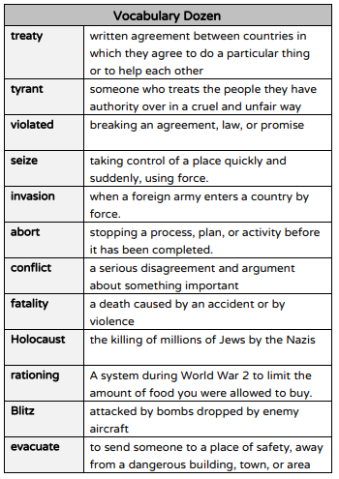Year 6 – Autumn 1 – Knowledge Organiser

How to help at home:

Look at the vocabulary Dozen – read through and discuss or research any unknown terms.

Look at the poster above – these were called ‘Propaganda Posters’ – can you research other posters that were made and common themes in them.

Ask family members if they know any interesting or unusual facts about WWII – do they know anybody who fought? Do they have any stories or photographs they can share?

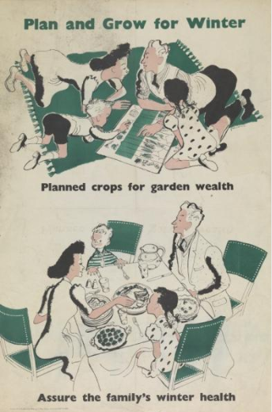

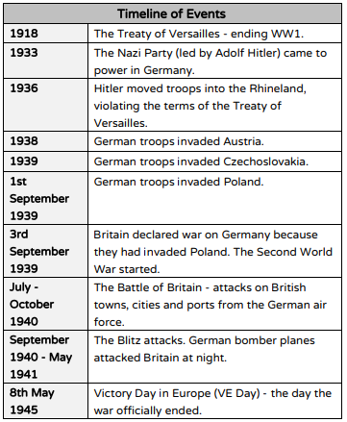

Also in year 6 this term we will also be covering:

Science: Light

PE: Ball skills including football and handball

Spanish: Greeting and Numbers

RE: Christianity and Humanism

Music: Singing (melody/tune/C Major scale)

ART/DT – cooking & war ART

Don’t forget to read with your children at least 3 times a week!

