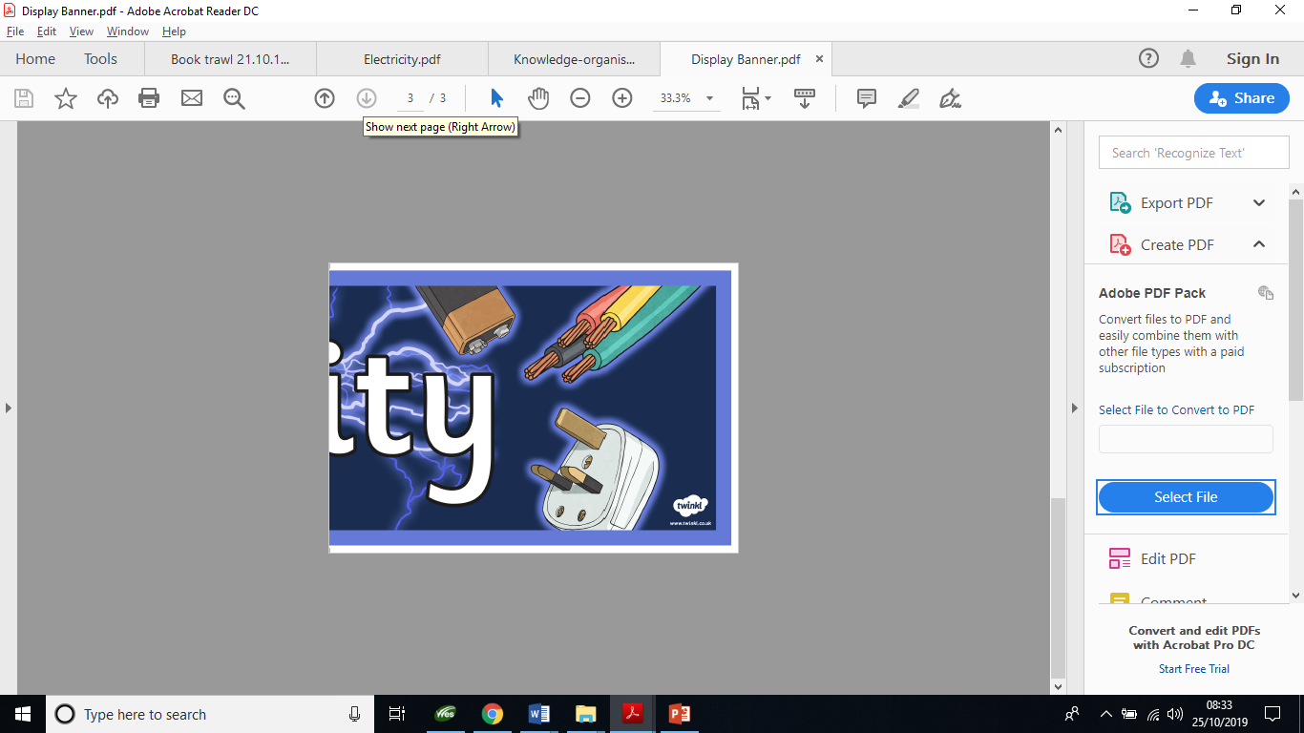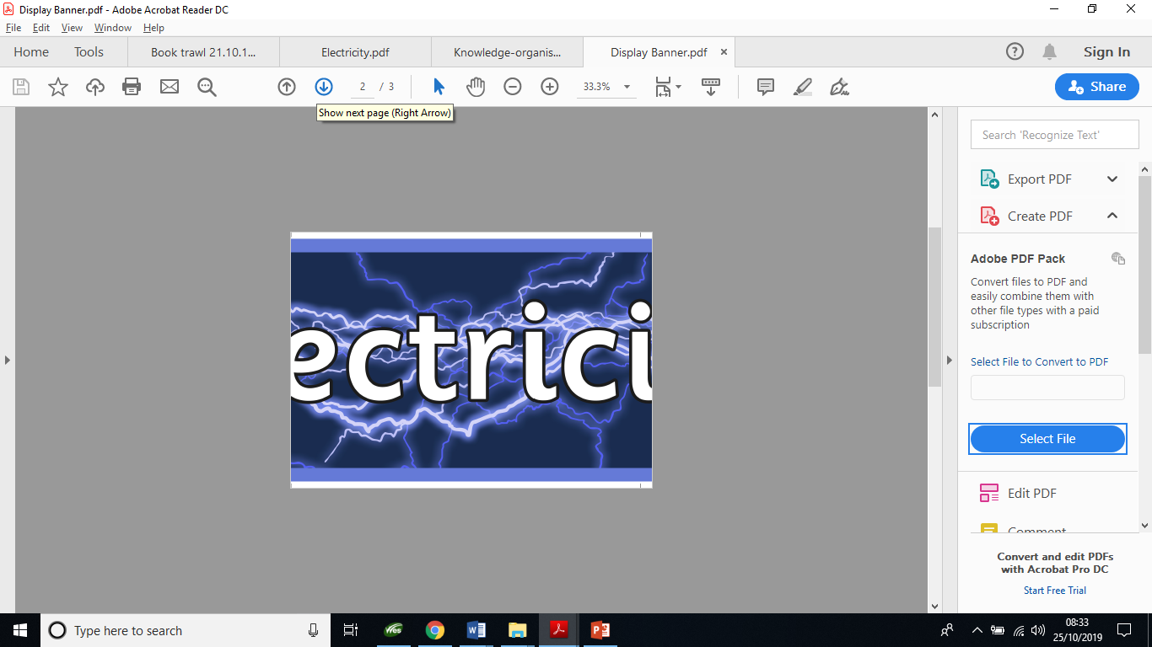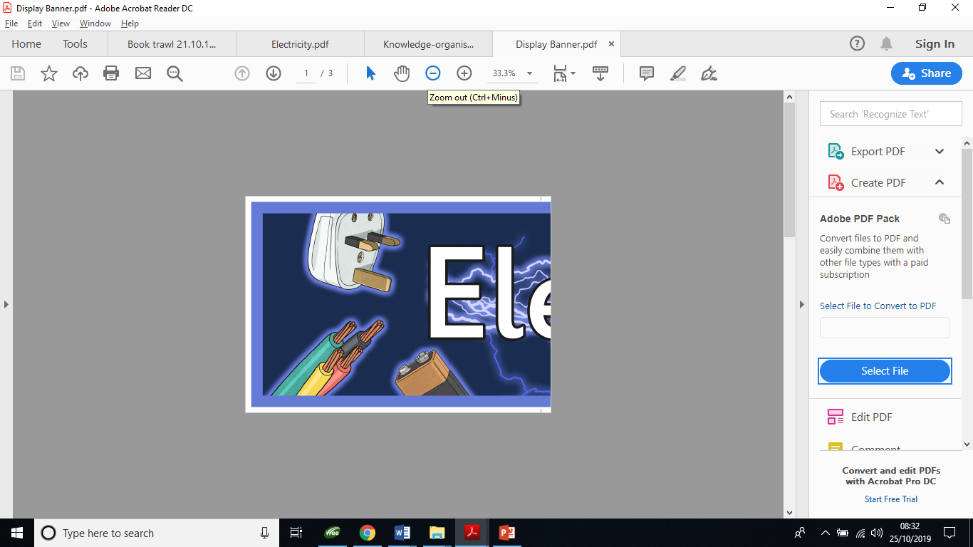

Have a look at the three scientist – can you research some information about them and their contributions to electricity.

Think about where they are from, when they were alive, what did they discover and why that might be important today!

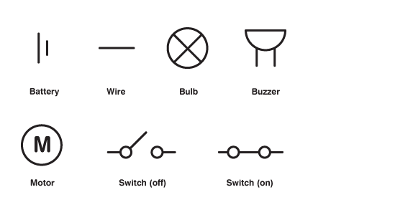

**Key Vocabulary**

**Battery – A container consisting of one or more cells where chemical energy is converted into electricity and used as a source of power**

**Bulb – A glass bulb which provides light by passing an electrical current through a filament**

**Buzzer – An electrical device that makes a buzzing noise and is used for signalling**

**Cell – A device containing electrodes that is used for generating current**

**Circuit – A complete and closed path around which a circulating electric current can flow**

**Conductor - A material or device which allows heat or electricity to carry through**

**Current – A flow of electricity which results from the ordered directional movement of electrically charged particles**

**Electricity – A form of energy resulting from the existence of charged particles**

**Filament – A conducting wire or thread with a high melting point that forms part of an electric bulb**

**Motor – A machine powered by electricity that supplies motive power for a vehicle or other moveable device**

**Switch – A device for making and breaking the connection in an electric circuit**

**Voltage – An electrical force that makes electricity move through a wire, measured in volts**

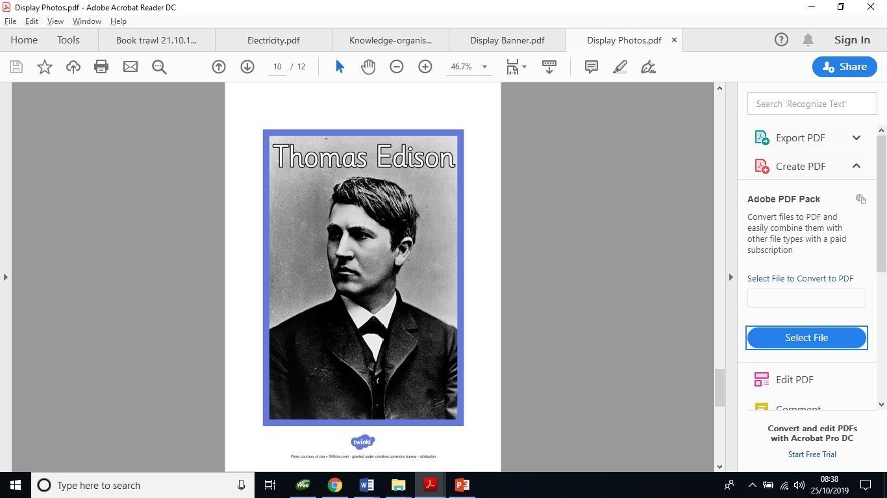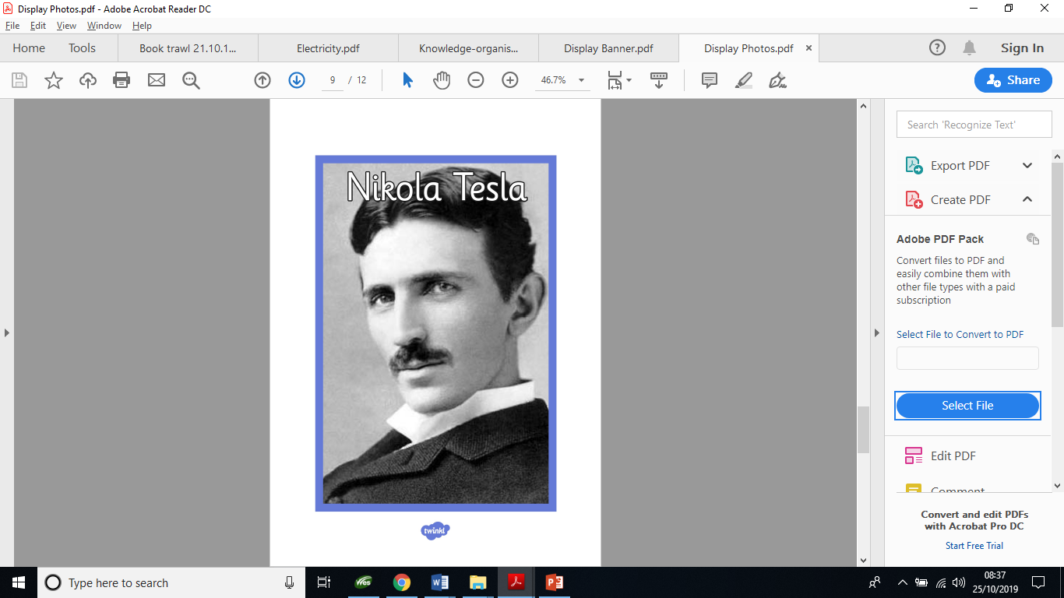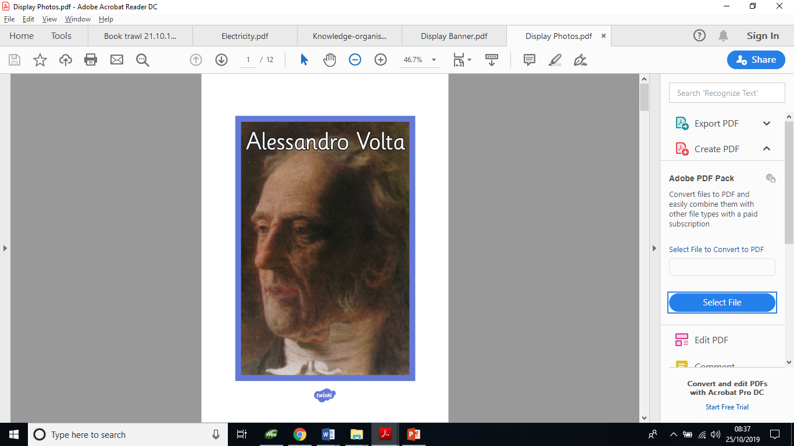

Also in year 6 this term we will also be covering:

PE: Dance and Gymnastics

Spanish: colours

RE: What does religion say when life gets hard?

DT: Construction and Model making (linked to science or topic)

Topic – World War 2

Don’t forget to read with your children at least 3 times a week!