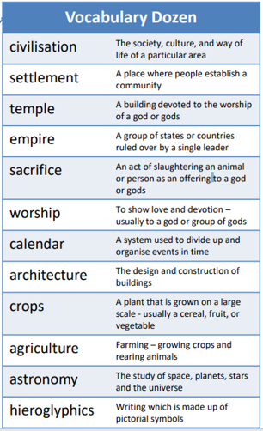

Years 4 & 5 – Knowledge Organiser – Autumn 1

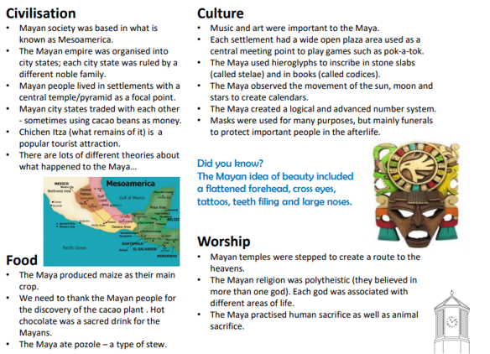

Please read through the vocabulary at home and practice spelling any tricky words.

-Can you find any facts that could be put under the heading:

Dress/costume

We will also be covering:

Maths – Place Value, reasoning and fluency in arithmetic

English – There’s a boy in the girl’s bathroom by Louis Sachar.

Science – Materials,

PE – Games

Remember to read with your child at least 3 times a week

