Pupil premium strategy statement

This statement details our school’s use of pupil premium (and recovery premium for the 2025 to 2026 academic year) funding to help improve the attainment of our disadvantaged pupils.

It outlines our pupil premium strategy, how we intend to spend the funding in this academic year and the effect that last year’s spending of pupil premium had within our school.

School overview
Detail | Data
School name | St. Gregory’s Catholic Academy
Number of pupils in school | 222 (including nursery)
Proportion (%) of pupil premium eligible pupils  These figures are based on the Oct. 2025 census. | 50 (23%) of pupils at St Gregory’s are PP.  The figure is 50 (25%) based on 201 pupils in Reception to Year 6.
Academic year/years that our current pupil premium strategy plan covers (3-year plans are recommended) | 2024-25/ 2025-26/ 2026-27
Date this statement was published | Autumn 2025
Date on which it will be reviewed | Autumn 2026
Statement authorised by | Stuart McGee (CEO)
Pupil premium lead | Marie Best (HT)
Governor / Trustee lead | Tyler Holmes
Funding overview
Detail | Amount
Pupil premium funding allocation this academic year | £79,080
Recovery premium funding allocation this academic year | £0
Pupil premium funding carried forward from previous years (enter £0 if not applicable) | £0
Total budget for this academic year  If your school is an academy in a trust that pools this funding, state the amount available to your school this academic year | £79,080

Part A: Pupil premium strategy plan

Statement of intent
At St. Gregory's Catholic Academy, we acknowledge the significant discrepancies in some areas of attainment between our pupil premium pupils and their peers nationally. This disparity is linked to our context. The Deprivation Profile shows that a significant proportion of pupils across all year groups live in highly deprived areas, with the majority falling within IDACI Bands A–D (the most deprived 17.5%). For example, in Reception, 83% of pupils are in Bands A–D, and the overall school deprivation indicator is 0.30, reflecting a high level of socio-economic disadvantage.
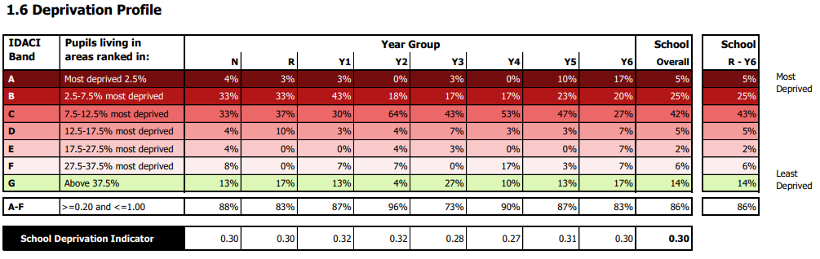
Our commitment is unwavering: we intend to address these gaps robustly through high-quality teaching and impactful interventions that are designed to rapidly close the achievement gaps. We recognise that effective, quality-first teaching is paramount in providing all pupils with the opportunity to succeed, and we are dedicated to ensuring that our teaching strategies are inclusive and responsive to the diverse needs of our pupils.
The pupil premium funding will be strategically allocated to support targeted interventions that directly address the barriers faced by our disadvantaged pupils, rather than simply increasing staff numbers. We believe that a strong, well-led, and well-managed curriculum is essential in bridging the significant gap in attainment for disadvantaged pupils. By focusing on evidence-based practises and tailored support, we are committed to fostering an environment where every pupil has the opportunity to thrive and achieve their full potential.
Through our collective actions and commitment to quality first teaching, we will work tirelessly to close the attainment gap and ensure that all pupils at St Gregory's Catholic Academy can succeed academically and develop the skills necessary for lifelong success.
The school recognises available evidence from both its own experience and that of others, including research-based evidence from the EEF, when allocating funding that is most likely to have an impact on improving pupils' achievement.
- This plan is to help close the gaps in attainment of our pupil premium children.
- Achievement data is reviewed regularly and robustly to monitor whether interventions or programmes are working effectively.
- This plan will help PP access wider opportunities with school hours and out of school hours.
- Class teachers know which pupils are eligible for pupil premium to enable them to assume responsibility for accelerating progress of those individuals, this is monitored by SLT and PP champion.
- This plan will ensure that attendance of PP children will at least be in line with the national average of all children.
- This strategy is a targeted and bespoke approach based on assessments of teachers. Identified children will be given support that will close gaps in their learning and knowledge. We acknowledge that wider strategies that support with mental health and wellbeing, attendance and behaviour may also have a positive impact on the success of the child at school.
- School takes a tiered approach to Pupil Premium spending. Teaching should be the top priority followed by a targeted approach and wider strategies.

Challenges

This details the key challenges to achievement that we have identified among our disadvantaged pupils.
Challenge number | Detail of challenge
1 | To close the gap between disadvantaged pupils and other achieving GLD in Reception. St. Gregory’s disadvantaged 20%, other 80% (60% gap) national gap 52%.
2 | To close the gap for disadvantaged pupils achieving combined RWM (expected standard or higher) at the end of KS2, currently 46%, other 82% (36% gap).
3 | To close the gap for disadvantaged pupils in Science, currently 62% with 88% for other – (26% gap).
4 | To close the gap of persistent absenteeism for PP pupils compared to others (St. Gregory’s – 25%, non-PP 7.7%).

Intended outcomes
This explains the outcomes we are aiming for by the end of our current strategy plan, and how we will measure whether they have been achieved.
Intended outcome | Success criteria
Raise the percentage of disadvantaged pupils achieving GLD from 20% to at least 40–50%, aiming to narrow the gap with their peers and move closer to the national average.  Ensure at least 80% of disadvantaged pupils make expected or better progress in Communication and Language and Literacy, which are key predictors of GLD.  Increase participation of families of disadvantaged pupils in early years learning activities, workshops, and home learning support by 30% or more.  Ensure all Reception staff are trained in evidence-based interventions (e.g.Talk Boost) and that disadvantaged pupils receive targeted, high-quality support. | At least 40–50% of disadvantaged pupils achieve GLD by the end of Reception. The gap between disadvantaged and other pupils reduces from 60% to below 40%  Disadvantaged pupils make at least expected progress from baseline assessments. Observations and assessments show improved vocabulary, listening, and comprehension.  At least 80% of disadvantaged families engage with home learning activities (e.g., reading logs, phonics games).  All Reception staff complete CPD on evidence-based interventions (e.g.Talk Boost) and apply strategies consistently. Disadvantaged pupils receive individual or small-group support at least 3 times per week, tracked through planning and assessment records.
Increase the percentage of disadvantaged pupils achieving the expected standard in all three subjects from 46% to at least 65%, aiming to significantly narrow the gap with their peers.  Ensure disadvantaged pupils make at least expected progress in Reading, Writing, and Maths from their prior attainment, with a focus on high-quality teaching, effective feedback, and tailored interventions.  Improve disadvantaged pupils’ access to a an inclusive curriculum, with strategies that boost engagement, confidence, and resilience, particularly in writing and maths. | By the end of KS2, at least 65% of disadvantaged pupils achieve the expected standard in Reading, Writing, and Maths combined, reducing the attainment gap to below 20%.  100% of disadvantaged pupils make expected or better progress in Reading, Writing, and Maths from their starting points, as evidenced by termly tracking and teacher assessments.  Disadvantaged pupils demonstrate high levels of engagement and participation in core learning and enrichment activities, with attendance at 95%+ and positive pupil voice feedback confirming improved confidence and motivation.
Increase the percentage of disadvantaged pupils achieving the expected standard in Science from 62% to at least 75%, aiming to reduce the attainment gap to below 15%.  Ensure disadvantaged pupils develop secure understanding of key scientific concepts and vocabulary through explicit teaching, practical investigations, and retrieval practice. | By the end of KS2, at least 75% of disadvantaged pupils achieve the expected standard in Science, reducing the attainment gap with other pupils to below 15%.  80% of disadvantaged pupils demonstrate secure understanding of key scientific concepts and vocabulary through end-of-unit assessments, pupil voice, and work scrutiny, showing clear progress from baseline.
Lower the percentage of PP pupils identified as persistently absent from 25% to below 15%, aiming to narrow the gap with non-PP pupils to under 10%.  Strengthen relationships with families of PP pupils through targeted support, regular communication, and early intervention, leading to improved attendance and reduced barriers to school access. | The percentage of PP pupils identified as persistently absent falls from 25% to below 15%, with the gap between PP and non-PP pupils reduced to under 10% by the end of the academic year.  100% of families of persistently absent PP pupils are engaged in targeted support plans, with evidence of improved attendance following interventions such as home visits, attendance panels, and personalised communication.

Activity in this academic year
This details how we intend to spend our pupil premium (and recovery premium funding) this academic year to address the challenges listed above.

Teaching (for example, CPD, recruitment and retention)
Budgeted cost: £3575
Activity | Evidence that supports this approach | Challenge number(s) addressed
Reading plus/SPAG and Spelling programmes used for interventions delivered by all class teachers from Y2 – Y6. | Children are assessed continuously and given a plan that matches their reading ability. The teacher is able to see areas of weakness immediately and provide resources and interventions based on their needs. | 2
CPD for all classroom-based staff on reading fluency and latest RWInc. Phonics training.  £3575 (cost for RWInc and programmes listed in activity above) | All class-based staff will receive training in reading fluency, reading comprehension and how we teach phonics.  All staff have access to RWInc. portal for up-to-date training on phonics.  Those staff delivering the phonics will be given the latest RWInc. training to support teaching and learning. | 1
Targeted EYFS & KS1 interventions to be carried out by staff. | Improved scores in phonics screening, baseline assessments, and teacher judgments for all PP pupils. Reduction in the number of PP pupils working below age-related expectations. | 1
CPD for all classroom-based staff on the teaching and assessment of the science curriculum. | Progress data showing accelerated learning in science concepts and vocabulary.  More consistent teacher assessment judgments across year groups, evidenced through moderation activities and pupil work scrutiny. | 3

Targeted academic support (for example, tutoring, one-to-one support structured interventions)
Budgeted cost: £20,536
Activity | Evidence that supports this approach | Challenge number(s) addressed
Pre/post teaching carried out by all staff. | Pre-post teaching enhances the children’s learning and retention by introducing key concepts before the main lesson and reinforcing them afterward. This method ensures that all children have the tools they need to succeed.  Pupils report feeling more confident and prepared for lessons after pre-teaching.  Pupils can articulate what they’ve learned and how post-teaching helped reinforce it. | 1/2/3
SEND support teacher to oversee all interventions and along with class teacher monitor their impact. | Regular review meetings between the SEND support teacher and class teachers with documented outcomes and next steps.  Half-termly tracking shows narrowing of gaps for SEND and disadvantaged pupils. | 1/2/3
Enrichment for targeted children.  £3,307 | Children are given the opportunity to attend after school and out of school activities, organised by the sports co-ordinator, where financial constraints would prevent the child from attending.  Persistent Absentees are targeted for attendance at these activities. | 1-4
TA support in each class.  £17,229 | TAs support PP children with pre and post teaching activities and the delivery of specific interventions across school. | 1-3

Wider strategies (for example, related to attendance, behaviour, wellbeing)
Budgeted cost: £55,837
Activity | Evidence that supports this approach | Challenge number(s) addressed
Weekly Attendance support  £4138 | Our absence rates for all pupils generally align with national average. The pink line on the graph below represents national overall absence rates for 2024-25, highlighting our priorities for 2025-26: PP and EHCP children.  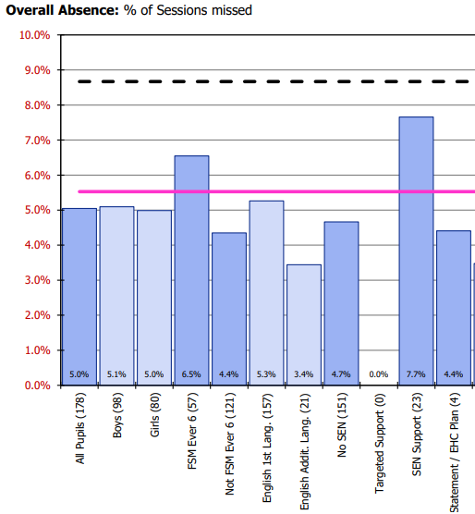 | 1-4
The Bungalow Partnership: Art /play therapists in school 2.5 days a week  £10,074 | The OFSTED framework highlights expectations that schools provide wider opportunities to remove barriers to learning. School recognises the impact of mental health and wellbeing and uses We PP funding to ensure our pupils have access to specialist support in school. | 1-4
Educational psychologist, termly support  £2,244 | When it becomes evident that a child needs more support to catch up to their peers. We discuss possible reasons and seek specialist advice. | 1-3
£1 book club  £300 | For disadvantaged children, this book club helps to remove financial barriers, ensuring they have access to quality reading materials. This supports academic growth and inspires a passion for reading. | 1-4
Subsidy of school trips/ residentials/enrichment visits  £7,500 | At St. Gregory’s, we believe in the transformative power of providing wider experiences for all students, especially those from disadvantaged backgrounds.  Educational visits are charged at a very low cost for our most disadvantaged and “working poor” families. | 1-3
Uniform and clothing  £1,500 | School uniform plays a vital role in fostering a sense of community and equality at St. Gregory’s. We recognise the importance of an affordable school uniform and use PP funding to support disadvantaged families. At the start of each academic year, we provide a free PE t-shirt for all children from nursery to Y6. We also subsidise Y6 hoodies.  The rest of the uniform can be purchased from most supermarkets. The tartan skirt/pinafore is optional. | 1-4
Employment of parent support/wellbeing officers  £30,081 | The presence of wellbeing officers in our school is invaluable. These dedicated professionals play a crucial role in supporting the mental and emotional health of our children. By providing a safe space for children to discuss their concerns, offering guidance and support, and implementing programs that promote overall wellbeing, our wellbeing officers help create a nurturing and inclusive environment. Their work not only enhances the individual child’s experience but also contributes to a positive school culture, where every child feels valued, supported, and ready to learn. Investing in the wellbeing of our students is essential for their academic success and personal growth, and our wellbeing officers are at the heart of this mission. | 1-4

Total budgeted cost: £79,948

Part B: Review of outcomes in the previous academic year

Pupil premium strategy outcomes
This details the impact that our pupil premium activity had on pupils in the 2024 to 2025 academic year.
In reviewing our absence rates, it was observed that 5% of all pupils were absent, compared to a higher rate of 6.5% among pupils eligible for the pupil premium. Our persistent absence rates raise significant concern with all pupils at a rate of 12.4% and pupil premium children at 25%. This indicates that pupils receiving the pupil premium are more likely to be persistent absentees than non-pupil premium pupils. Addressing this disparity is essential to ensure all pupils have equal opportunities for educational success. This will be our priority for relevant staff across school.
Absence rates:
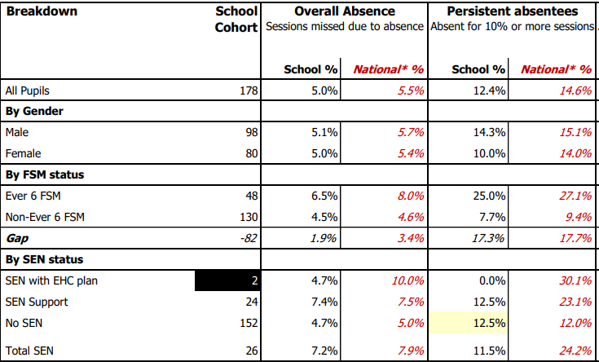
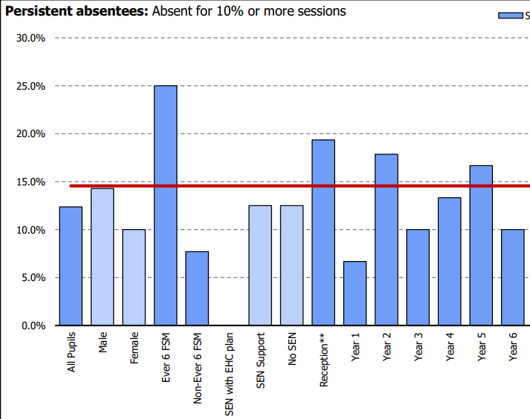
Y1 Phonics
In 2025, Year 1 pupils maintained strong performance with an average mark of 36, continuing to exceed the national average of 33. However, only 67% of disadvantaged pupils met the expected standard, compared to significantly higher outcomes among other pupils, highlighting an ongoing attainment gap. To address this, we will implement targeted interventions such as small group teaching and 1:1 teaching for disadvantaged learners. Regular monitoring and evaluation of these strategies will be key to ensuring their impact and promoting more equitable outcomes.
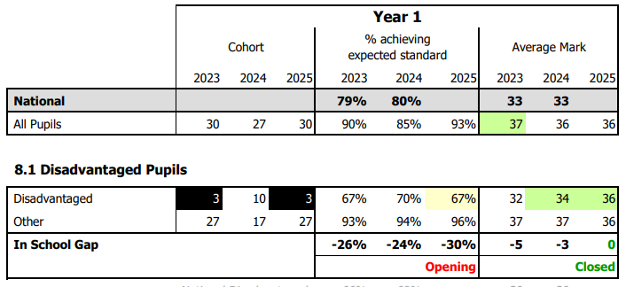

End of KS2:
In 2025, 67% of pupils at St Gregory's achieved the expected standard or higher, outperforming both the local authority average (64%) and the national average (62%). Additionally, 10% of pupils reached the higher standard, exceeding both local and national averages (8%). Among disadvantaged pupils, 46% met the expected standard in reading, writing, and maths combined—well below the national average of 69% for non-disadvantaged pupils—though 23% achieved the higher standard, outperforming the national figure of 11%. To address this disparity, we will implement targeted academic support for disadvantaged pupils, including structured intervention programmes and personalised learning plans, while continuing to nurture high achievers through enrichment opportunities and regular progress monitoring.
Reading, writing and maths combined
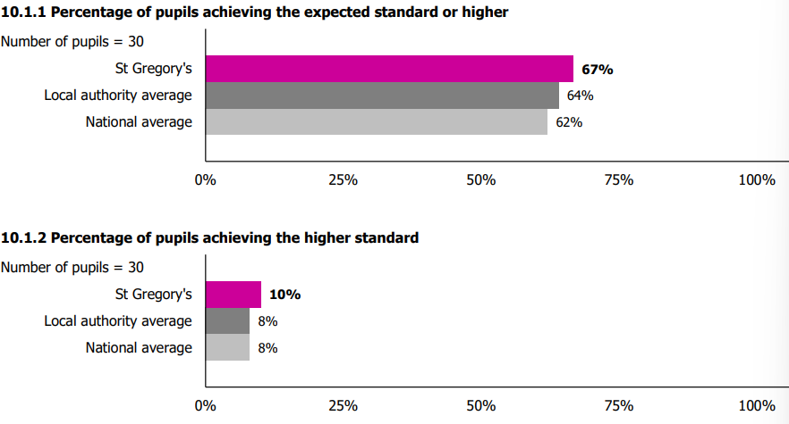
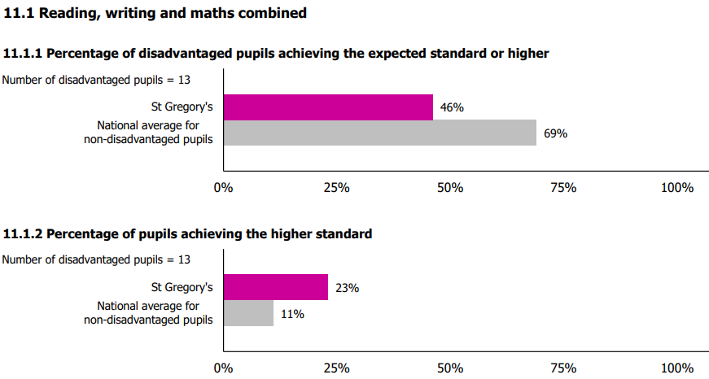

Externally provided programmes
Programme | Provider
RWInc. Phonics/Early Reading | Ruth Miskin Literacy
Reading Plus intervention | Reading Solutions
Times table rock star | Rockstars
Attachment based intervention | Drawing and Talking
Child counselling, psychotherapy, art, play, trauma therapy | Bungalow Partnership
Speech and Language 1:1 support | NHS S&L Department
OT 1:1 programmes | NHS Occ. Health Department
Educational Phycologist | Pegasus Services

Service pupil premium funding (optional)
For schools that receive this funding, you may wish to provide the following information:
Measure | Details
How did you spend your service pupil premium allocation last academic year? | Teaching children in small, targeted groups. Providing 1:1 or small group support with identified interventions.  SEMH and SEND support for targeted children.
What was the impact of that spending on service pupil premium eligible pupils? | Ability to consolidate prior learning at school and at home, resulting in improved progress and attainment.

Further information (optional)
Supporting pupil premium (PP) children is vital to creating an equitable educational environment where all children have the opportunity to succeed. At. St. Gregory’s, we aim to use PP funding to help close the attainment gaps between disadvantaged pupils and their peers. By providing targeted interventions, additional resources, and tailored support, we can address the unique challenges faced by these children and their families. Ensuring that PP children receive the necessary academic and emotional support not only helps them achieve their potential but also fosters a more inclusive and supportive school community. Prioritising the needs of PP children is essential for promoting fairness, enhancing educational outcomes, and building a stronger future for all.

