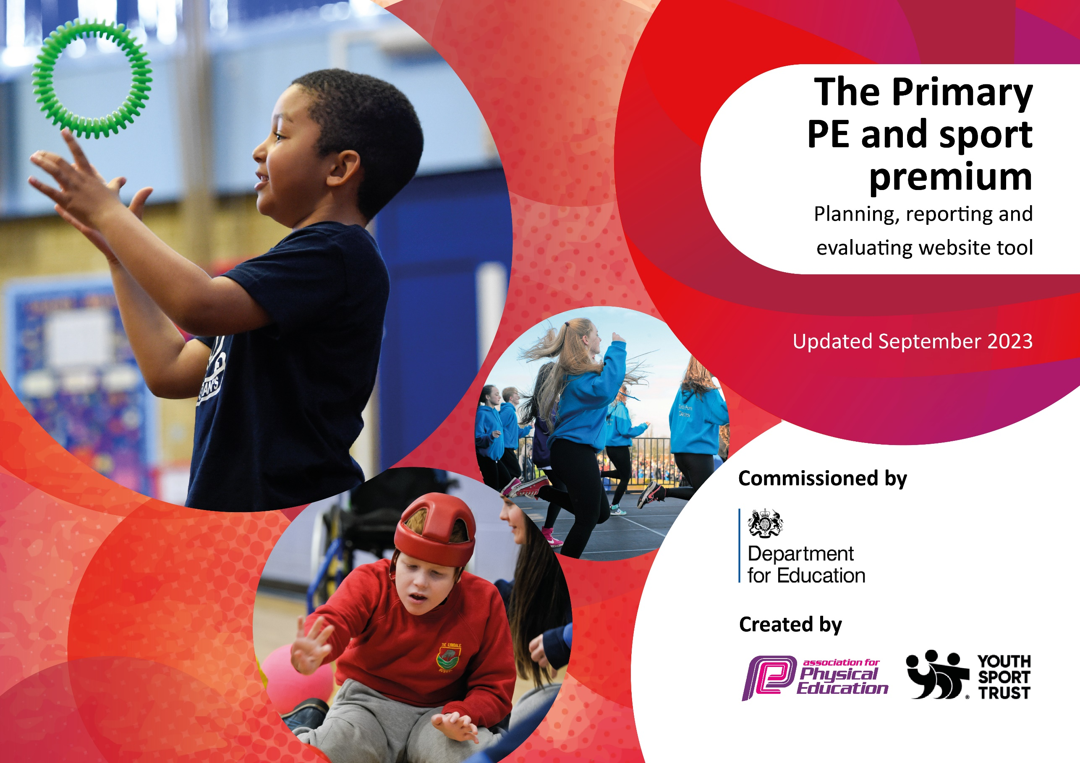

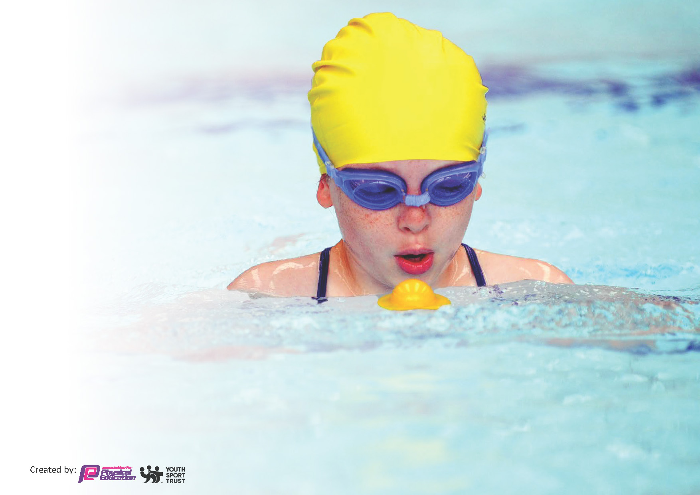
This template can be used for multiple purposes:
by:
- It enables schools to effectively plan their use of the Primary PE and sport premium
- It helps schools to meet the requirements (as set out in guidance) to publish information on their Primary PE and sport premium
- It will be an effective document to support Ofsted inspections enabling schools to evidence progress in Physical Education (PE) and evidence swimming attainment, which forms part of the PE National Curriculum. We would recommend schools consider
the Intent, Implementation and Impact of any spend, as examined within the Education Inspection Framework.

It is important that your grant is used effectively and based on school need.

Schools must use the funding to make additional and sustainable
improvements to the quality of the PE, School Sport and Physical Activity (PESSPA)
they offer. This means that you should use the Primary PE and sport premium to:

- Build capacity and capability within the school to ensure that improvements made now will benefit pupils joining the school in future years
- Develop or add to the PESSPA activities that your school already offers.

The Primary PE and sport premium should not be used to fund capital spend projects; the school’s core budget should fund these. Further detail on capital expenditure can be found in the updated Primary PE and sport premium guidance.

The Primary PE and sport premium guidance, outlines 5 key priorities that funding should be used towards. It is not

necessary that spending has to meet all the key priorities, you should select the priorities that you aim to use any funding towards.

Although completing this template is not a requirement for schools, schools are required to publish details of how they spend this funding. Schools must also outline what the impact this funding has had on pupils’ PE and sport participation and attainment and how any spending will be sustainable in the future. All funding must be spent by 31st July 2024.

The Department for Education has worked closely with the Association for Physical Education (afPE) and the Youth Sport Trust (YST) to develop this template and encourages schools to use it. This template is an effective way of meeting the reporting requirements of the Primary PE and sport premium.
Review of last year’s spend and key achievements (2023/2024)

We recommend you start by reflecting on the impact of current provision and reviewing your previous spend.

Activity/Action | Impact | Comments
Equipment audit and purchases.  Staff training.  New curriculum overview to incorporate a range of opportunities.  Further links made with sporting events linked to Trust and local community.  Embed daily movement to increase physical activity for all pupils to ensure 30 minutes is met.  After school sporting activities.  Appointment of sports apprentice.  Swimming lessons  Indian dance workshop  Holiday club | Curriculum delivery was effective due to the new overview and supporting equipment.  Children took part in a range of sporting events and developed new skills and confidence.  Daily movement embedded in most classes.  Children had the opportunity to take in a range of extra-curricular sports activities such as kickboxing, street dance, football and Commando Joe’s after school clubs.  Curriculum delivery was consistent and progressive.  74% of Year 6 children achieved their 25m.  26% achieved 10m using a float  Children across the school learnt Indian dance routines choreographed by the Education group  PP/disadvantaged attended sports, craft and wellbeing activities during February half-term. | Mr Hewitt will be working towards further Trust events for 2024-25.  Enhanced outdoor provision being developed for EY to develop gross motor skills.  OLSB swimming facilities are no longer available… new provision is being looked into for 2024-25.  Further clubs being considered for 2024-25.

Key priorities and Planning
This planning template will allow schools to accurately plan their spending.

Action – what are you planning to do | Who does this action impact? | Key indicator to meet | Impacts and how sustainability will be achieved? | Cost linked to the action
A range of visitors to enhance sports provision such as Street dance company  Active lunch time  Children will be involved in a range of sporting events/ competitions  Trust football tournament – new school strip/bibs purchased  Commando Joes subscription | Staff will have the opportunity to see quality PE delivered.  Pupils will experience a range of sporting activities alongside the curriculum.  Staff who supervise children during lunch time.  Pupils who are participating.  Children across school will have opportunities to take part in a variety of sporting events  Children across all key stages. | Key indicator 4: Broader experience of a range of sports and activities offered to all pupils.  Key indicator 1: The engagement of all pupils in regular activity.  Key indicator 4: Broader experience of a range of sports and activities offered to all pupils.  Key indicator 4: Broader experience of a range of sports and activities offered to all pupil | Children will engage in wider curriculum opportunities and have the opportunity to take part in sports that they may not otherwise experience.  Children will achieve their 30 minutes of exercise goal in school.  Children will experience competitive sport and develop the skills needed to achieve in different sports.  Children will develop team skills and experience a range of activities linked to wellbeing | £1,500  £500 to be spent on outdoor equipment  £600  £1,500

CPD for lead teacher  Stockton School Sports Partnership  Appointment of Sports coach  Swimming lessons | Lead teacher  Children who attend skills days and competitions. | Key Indicator 3: Increased confidence, knowledge, and skills of all staff in teaching PE and sport.  Key indicator 4: Broader experience of a range of sports and activities offered to all pupil  Key indicator 5: Increased participation in competitive sport  Key indicator 1: The engagement of all pupils in regular activity.  Key Indicator 3: Increased confidence, knowledge, and skills of all staff in teaching PE and sport.  Key indicator 4: Broader experience of a range of sports and activities offered to all pupil. | Primary teachers more confident to deliver effective PE supporting pupils to undertake extra activities inside and outside of school, including teaching water safety and swimming and as a result improved % of pupil’s attainment in PE.  The curriculum will be delivered to a high and consistent standard enabling all pupils to succeed.  Most children will achieve 25m before leaving Y6. | £2,308  £11,116

Key achievements 2024-2025
This template will be completed at the end of the academic year and will showcase the key achievements schools have made with their Primary PE and sport premium spending.

Activity/Action | Impact | Comments

Swimming Data
Meeting National Curriculum requirements for swimming and water safety.
Priority should always be given to ensuring that pupils can perform safe self-rescue even if they do not fully meet the first two requirements of the National Curriculum programme of study

Question | Stats: | Further context  Relative to local challenges
What percentage of your current Year 6 cohort can swim competently, confidently and proficiently over a distance of at least 25 metres? | % | Use this text box to give further context behind the percentage.  e.g., 30% - we are struggling to get pool space due to our local pool closing so we have had to use a much smaller local school pool. We have had to limit the number of pupils attending swimming lessons during one term which means some pupils have attended fewer swimming lessons than others.
What percentage of your current Year 6 cohort can use a range of strokes effectively [for example, front crawl, backstroke, and breaststroke]? | % | Use this text box to give further context behind the percentage.  e.g., Even though your pupils may swim in another year please report on their attainment on leaving primary school at the end of the summer term 2024

What percentage of your current Year 6 cohort are able to perform safe self-rescue in different water-based situations? | % | Use this text box to give further context behind the percentage.
If your schools swimming data is below national expectation, you can choose to use the Primary PE and sport premium to provide additional top-up sessions for those pupils that did not meet National Curriculum  requirements after the completion of core lessons. Have you done this? | Yes/No
Have you provided CPD to improve the knowledge and confidence of staff to be able to teach swimming and water safety? | Yes/No

Signed off by: M. Best

Head Teacher: | Marie Best
Subject Leader or the individual responsible for the Primary PE and sport premium: | Emily Rowney (PE Lead)
Governor: | Tyler Holmes
Date: | 27.09.24

