Pupil premium strategy statement

This statement details our school’s use of pupil premium (and recovery premium for the 2024 to 2025 academic year) funding to help improve the attainment of our disadvantaged pupils.

It outlines our pupil premium strategy, how we intend to spend the funding in this academic year and the effect that last year’s spending of pupil premium had within our school.

School overview
Detail | Data
School name | St. Gregory’s Catholic Academy
Number of pupils in school | 225 (including nursery)
Proportion (%) of pupil premium eligible pupils  These figures are based on the Oct. 2024 census. | 54 (24%) of pupils at St Gregory’s are PP.  The figure is 54 (26.5%) based on 204 pupils in Reception to Year 6.
Academic year/years that our current pupil premium strategy plan covers (3-year plans are recommended) | 2024-25/ 2025-26/ 2026-27
Date this statement was published | Spring 2025
Date on which it will be reviewed | Autumn 2025
Statement authorised by | Stuart McGee (CEO)
Pupil premium lead | Marie Best (HT)
Governor / Trustee lead | Tyler Holmes
Funding overview
Detail | Amount
Pupil premium funding allocation this academic year | £73,137
Recovery premium funding allocation this academic year | £0
Pupil premium funding carried forward from previous years (enter £0 if not applicable) | £0
Total budget for this academic year  If your school is an academy in a trust that pools this funding, state the amount available to your school this academic year | £73,137

Part A: Pupil premium strategy plan

Statement of intent
At St. Gregory's Catholic Academy, we acknowledge the significant discrepancies in some areas of attainment between our pupil premium pupils and their peers nationally. This disparity is linked to our context, as we serve a community marked by high levels of deprivation, (school deprivation indicator – 0.33) and many families classified as the "working poor." We are committed to addressing these challenges through targeted support and interventions to ensure all our pupils have the opportunity to succeed.
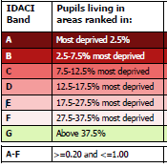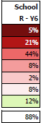
Our commitment is unwavering: we intend to address these gaps robustly through high-quality teaching and impactful interventions that are designed to rapidly close the achievement gaps. We recognise that effective, quality-first teaching is paramount in providing all pupils with the opportunity to succeed, and we are dedicated to ensuring that our teaching strategies are inclusive and responsive to the diverse needs of our pupils.
The pupil premium funding will be strategically allocated to support targeted interventions that directly address the barriers faced by our disadvantaged pupils, rather than simply increasing staff numbers. We believe that a strong, well-led, and well-managed curriculum is essential in bridging the significant gap in attainment for disadvantaged pupils. By focusing on evidence-based practises and tailored support, we are committed to fostering an environment where every pupil has the opportunity to thrive and achieve their full potential.
Through our collective actions and commitment to quality first teaching, we will work tirelessly to close the attainment gap and ensure that all pupils at St Gregory's Catholic Academy can succeed academically and develop the skills necessary for lifelong success.
The school recognises available evidence from both its own experience and that of others, including research-based evidence from the EEF, when allocating funding that is most likely to have an impact on improving pupils' achievement.
- This plan is to help close the gaps in attainment of our pupil premium children.
- Achievement data is reviewed regularly and robustly to monitor whether interventions or programmes are working effectively.
- This plan will help PP access wider opportunities with school hours and out of school hours.
- Class teachers know which pupils are eligible for pupil premium to enable them to assume responsibility for accelerating progress of those individuals, this is monitored by SLT and PP champion.
- This plan will ensure that attendance of PP children will at least be in line with the national average of all children.
- This strategy is a targeted and bespoke approach based on assessments of teachers. Identified children will be given support that will close gaps in their learning and knowledge. We acknowledge that wider strategies that support with mental health and wellbeing, attendance and behaviour may also have a positive impact on the success of the child at school.
- School takes a tiered approach to Pupil Premium spending. Teaching should be the top priority followed by a targeted approach and wider strategies.

Challenges

This details the key challenges to achievement that we have identified among our disadvantaged pupils.
Challenge number | Detail of challenge
1 | To close the 16% gap between disadvantaged pupils and all other achieving phonics pass mark in Year 1 (St. Gregory’s disadvantaged - 67%, national all pupils 83%).
2 | To close the 32% gap between combined RWM (expected standard) at the end of KS2, currently 29%, compared with national all combined of 61%.
3 | To close the 8% gap between combined greater depth at the end of KS2, currently 0% compared with national combined greater depth for all pupils of 8%.
4 | To close the gap of persistent absenteeism for PP pupils and all other pupils nationally (St. Gregory’s - 25.8%, national all pupils 15.4%).

Intended outcomes
This explains the outcomes we are aiming for by the end of our current strategy plan, and how we will measure whether they have been achieved.
Intended outcome | Success criteria
Increase phonics 1:1 tutoring and continue to check and re-group: Aim for at least 90% of disadvantaged pupils to achieve the required pass in the Year 1 phonics screening check in 2025, closing the gap with their peers.  Enhance reading engagement: Implement a reading engagement programme that increases participation in reading activities among disadvantaged pupils by the end of Year 1.  Strengthen parental involvement: Establish parental engagement initiative that results in 100% attendance at phonics workshops by parents of disadvantaged pupils by the end of the academic year. | Disadvantaged pupils will demonstrate the ability to decode and blend phonemes accurately in at least 90% of phonics assessment tasks, as evidenced by formative assessments conducted throughout the year.  Disadvantaged pupils will participate in reading activities organised by the reading lead, and tracked through reading logs, indicating increased motivation and practice.  Track attendance to ensure 100% parental engagement for all workshops.
Increase Combined RWM Percentage: Implement strategies to close the attainment gap and ensure that disadvantaged pupils achieve academic success alongside their peers.  Target disadvantaged pupils to reach the expected standard in combined RWM this year.  By the end of the academic year, staff participation in professional development sessions will lead to enhanced teaching quality and increased pupil engagement, as evidenced by improved assessment data and positive feedback from both pupils and parents. | By the end of the academic year, the % of disadvantaged pupils reaching the expected standard in combined RWM is at least in line with all pupils.  The gap between disadvantaged combined RWM and that of others should decrease by at least 25%, demonstrating progress towards disadvantage children being at least in line with all pupils.  Staff engagement in professional development sessions enhance teaching quality and pupil engagement, as reflected in assessment data and feedback from pupils and parents.
Increased number of disadvantaged pupils reaching greater depth in combined subjects by the end of year.  Teachers are trained to implement a challenging curriculum that fosters higher-order thinking.  Engage parents in disadvantaged pupil’s learning by offering resources for parents to support greater depth learning at home.  Provide enrichment opportunities for high-achieving pupils. | Tracking shows disadvantaged pupils demonstrating greater depth in combined reading, writing, and mathematics is at least in line with all pupils.  Teachers are trained to support pupils aiming for greater depth.  Pupils articulate key curriculum features that promote higher-order thinking through class discussions and tasks.  At least 70% of parents feel equipped to support their children's learning at home, as indicated by parental discussions.  Monitoring of enrichments opportunities indicates increased PP pupil’s engagement.
By the end of the academic year, the rate of persistent absenteeism among Pupil Premium pupils at St. Gregory’s will be reduced to match or fall below the national average for all pupils. | A robust system for tracking attendance encourages early intervention to address absenteeism promptly.  Increase parental engagement and provide targeted support programs for PP pupils to address underlying issues contributing to absenteeism.

Activity in this academic year
This details how we intend to spend our pupil premium (and recovery premium funding) this academic year to address the challenges listed above.

Teaching (for example, CPD, recruitment and retention)
Budgeted cost: £2,735
Activity | Evidence that supports this approach | Challenge number(s) addressed
Reading plus intervention to be delivered by all class teachers from year 2 upwards  £1,260 | Children are assessed continuously and given a plan that matches their reading ability. The teacher is able to see areas of weakness immediately and provide resources and interventions based on their needs. | 2/3
CPD for all class-based staff on reading fluency and latest RWInc. phonic training.  £1,475 | All class-based staff will receive training in reading fluency, reading comprehension and how we teach phonics.  All staff have access to RWInc. portal for up-to-date training on phonics.  Those staff delivering the phonics will be given the latest RWInc. training to support teaching and learning. | 1
Targeted EYFS & KS1 interventions to be carried out by staff. | Early inventions to reduce the disadvantaged gap. | 1/4

Targeted academic support (for example, tutoring, one-to-one support structured interventions)
Budgeted cost: £11,046
Activity | Evidence that supports this approach | Challenge number(s) addressed
Pre/post teaching carried out by all staff. | Pre-post teaching enhances the children’s learning and retention by introducing key concepts before the main lesson and reinforcing them afterward. This method ensures that all children have the tools they need to succeed. | 1/2/3/4
SEND support teacher to oversee all interventions and along with class teacher monitor their impact. | This ensures we have a “joined up” approach and a clear oversight of what interventions are being covered, who is accessing them and monitoring the impact of interventions carried out. | 1/2/3
Enrichment for targeted children  £2,046 | Children are given the opportunity to attend after school and out of school activities, organised by the sports co-ordinator, where financial constraints would prevent the child from attending. | 1-4
TA support x 2  £9,000 | TAs support PP children with pre and post teaching activities and the delivery of specific interventions in Y6 and Y1. | 1-3

Wider strategies (for example, related to attendance, behaviour, wellbeing)
Budgeted cost: £59,332
Activity | Evidence that supports this approach | Challenge number(s) addressed
Weekly Attendance support  £3,631 | Our absence rates for all pupils generally align with national average. The pink line on the graph below represents national overall absence rates for 2023-24, highlighting our priorities for 2024-25: PP and EHCP children.  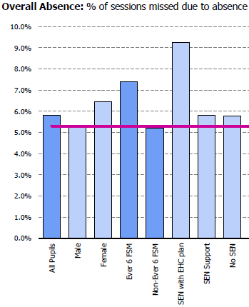 | 1-4
The Bungalow Partnership: Art /play therapists in school 2.5 days a week  £9,828 | The OFSTED framework highlights expectations that schools provide wider opportunities to remove barriers to learning. School recognises the impact of mental health and wellbeing and uses We PP funding to ensure our pupils have access to specialist support in school. | 1-4
Educational psychologist, termly support  £2,200 | When it becomes evident that a child needs more support to catch up to their peers. We discuss possible reasons and seek specialist advice. | 1-3
£1 book club  £200 | For disadvantaged children, this book club helps to remove financial barriers, ensuring they have access to quality reading materials. This supports academic growth and inspires a passion for reading. | 1-4
TVMS  £4,068 | All KS2 children will learn a musical instrument.  All children will receive singing and music lessons by qualified professionals.  Children will have the opportunity to join a lunchtime choir. | 1-4
Subsidy of school trips/ residentials/enrichment visits  £7,500 | At St. Gregory’s, we believe in the transformative power of providing wider experiences for all students, especially those from disadvantaged backgrounds.  Educational visits are charged at a very low cost for our most disadvantaged and “working poor” families. | 1-3
Uniform and clothing  £1,500 | School uniform plays a vital role in fostering a sense of community and equality at St. Gregory’s. We recognise the importance of an affordable school uniform and use PP funding to support disadvantaged families. At the start of each academic year, we provide a free PE t-shirt for all children from nursery to Y6. We also subsidise Y6 hoodies.  The rest of the uniform can be purchased from most supermarkets. The tartan skirt/pinafore is optional. | 1-4
Employment of parent support/wellbeing officers  £30,405 | The presence of wellbeing officers in our school is invaluable. These dedicated professionals play a crucial role in supporting the mental and emotional health of our children. By providing a safe space for children to discuss their concerns, offering guidance and support, and implementing programs that promote overall wellbeing, our wellbeing officers help create a nurturing and inclusive environment. Their work not only enhances the individual child’s experience but also contributes to a positive school culture, where every child feels valued, supported, and ready to learn. Investing in the wellbeing of our students is essential for their academic success and personal growth, and our wellbeing officers are at the heart of this mission. | 1-4

Total budgeted cost: £73,113

Part B: Review of outcomes in the previous academic year

Pupil premium strategy outcomes
This details the impact that our pupil premium activity had on pupils in the 2023 to 2024 academic year.
In reviewing our absence rates, it was observed that 5.8% of all pupils were absent, compared to a higher rate of 7.4% among pupils eligible for the pupil premium. This indicates that pupils receiving the pupil premium are more likely to be absent from school than non-pupil premium pupils. Addressing this disparity is essential to ensure all pupils have equal opportunities for educational success. This will be our priority for relevant staff across school.
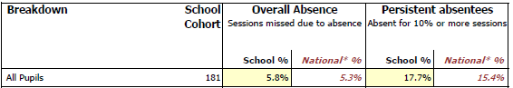
Absence rates:

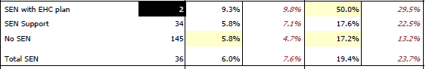

Good level of development at end of EYFS:
Data shows that our disadvantaged pupils achieved in line with all other pupils for Good Level of Development (GLD). However, our goal is not only to maintain our current performance but to exceed national standards, ensuring that every pupil achieves their full potential in all areas of development. To ensure these figures increase, we are committed to enhancing our teaching strategies, providing additional resources, and implementing targeted interventions.
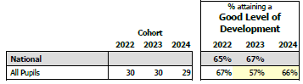
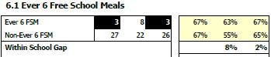
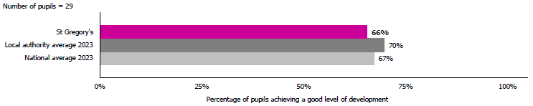
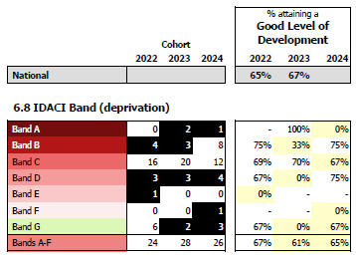

Year 1 and 2 phonics check results:
Year 1 and Year 2 phonics results are both above the national average as evidenced in our data. This achievement is a testament to the hard work and dedication of our pupils and teachers. Our fidelity to R.W.Inc. teaching methods, combined with targeted interventions and a supportive learning environment, have contributed to this success. While we celebrate these accomplishments, we remain committed to further improving our phonics teaching to ensure that every pupil continues to excel in these early literacy skills.
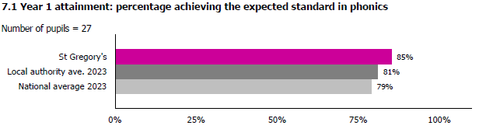
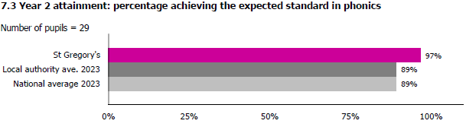
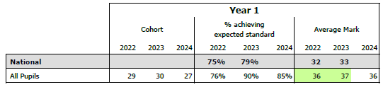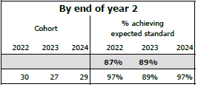
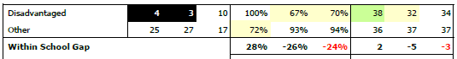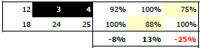

Year 4 times tables check:
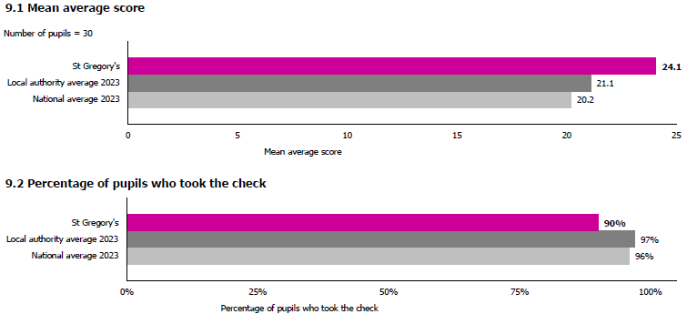
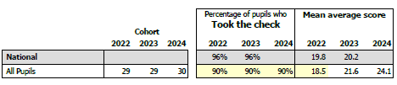
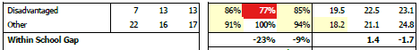

End of KS2:
Reading, writing and maths combined
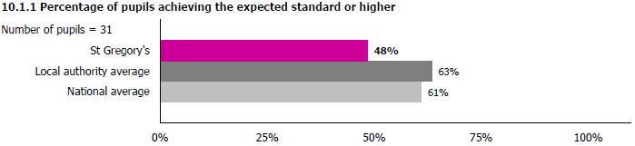
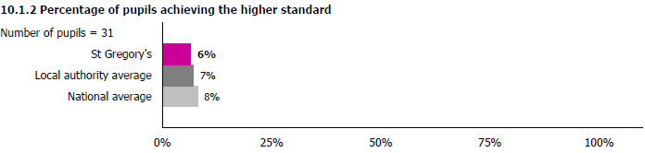
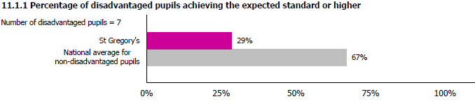
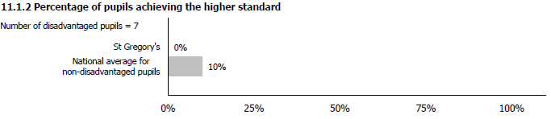
The number of pupils achieving the expected standard or higher in combined reading, writing and maths is a priority for our school this year. Currently, our data indicates that fewer pupil premium pupils achieve the expected or higher standard in comparison to all pupils and the national average. Addressing this gap is a top priority for us. We will implement targeted interventions and support strategies to help these pupils improve their performance and achieve these standards. By focusing on pupil premium children in pupil progress meetings, we aim to close the gap for this group.

Externally provided programmes
Programme | Provider
RWInc. Phonics/Early Reading | Ruth Miskin Literacy
Reading Plus intervention | Reading Solutions
Times table rock star | Rockstars
Attachment based intervention | Drawing and Talking
Child counselling, psychotherapy, art, play, trauma therapy | Bungalow Partnership
Speech and Language 1:1 support | NHS S&L Department
Educational Phycologist | Pegasus Services

Service pupil premium funding (optional)
For schools that receive this funding, you may wish to provide the following information:
Measure | Details
How did you spend your service pupil premium allocation last academic year? | Teaching children in small, targeted groups. Providing 1:1 or small group support for identified interventions.  SEMH and SEND support for targeted children.
What was the impact of that spending on service pupil premium eligible pupils? | Ability to consolidate prior learning at school and at home, resulting in improved progress and attainment.

Further information (optional)
Supporting pupil premium (PP) children is vital to creating an equitable educational environment where all children have the opportunity to succeed. At. St. Gregory’s, we aim to use PP funding to help close the attainment gap between disadvantaged pupils and their peers. By providing targeted interventions, additional resources, and tailored support, we can address the unique challenges faced by these children and their families. Ensuring that PP children receive the necessary academic and emotional support not only helps them achieve their potential but also fosters a more inclusive and supportive school community. Prioritizing the needs of PP children is essential for promoting fairness, enhancing educational outcomes, and building a stronger future for all.

