SEND Information Report
Approved on:
July 2023
Next review:
June-July 2024
St Gregory’s Catholic Academy Catholic Academy
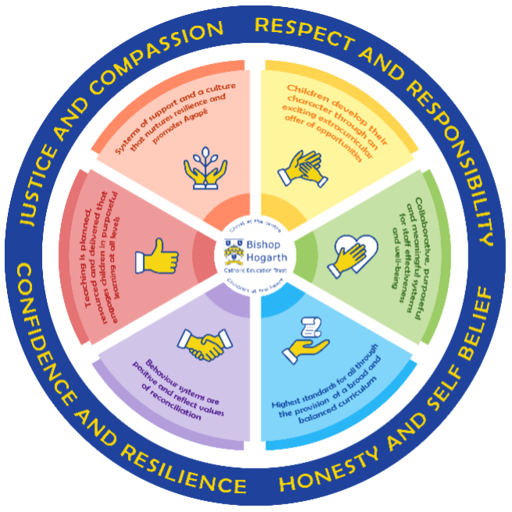
As part of the family of Bishop Hogarth Catholic Education Trust, our school has at its core, the virtues, and values of:
Respect for others and themselves, recognising that we are all created in the image of God and therefore must be compassionate towards others, especially the vulnerable. ​
Confidence in their own abilities, knowing that their talents are gifts from God and resilience to persevere when things become difficult. ​
Honesty in regard to the world around them and themselves and the ability to take responsibility for the times we may fall short of the mark. ​
Gratitude for all the amazing gifts from God and willingness to share their gifts both personal and material. ​

As an inclusive school, all teachers are teachers of pupils with Special Educational Needs & Disabilities. We deliver a curriculum and create an environment that meets the needs of every pupil within our school. We ensure that every pupil with Special Educational Needs and / or disabilities makes the best progress possible. We foster and promote effective working partnerships with parents / carers, pupils, and outside agencies. We consider the ‘whole’ child and strive to ensure that all our SEND pupils are prepared for adulthood.​

Our school’s approach to supporting pupils with SEND
At St Gregory’s Catholic Academy we aim to:

Develop the spiritual and intellectual wholeness of each child.
Offer children an educational experience where staff will strive to identify and remove barriers to learning and create an environment in which every child is encouraged to reach their potential and ensure “no child is left behind”

Our Core Offer
- Teachers are responsible for the progress of ALL pupils in their class. High quality teaching is personalised to meet every child’s need. This is the first step in supporting pupils who may have SEND (Special Educational Needs and Disabilities). All children are challenged to do their very best. This is enough for most pupils to make progress.
- All children will be taught a broad and balanced curriculum; differentiated to the needs of each individual. Where children require extra support, specialist resources or extension materials, these will be provided wherever possible.
- All children are known well by their class teacher, who develops strong relationships with them. Good behaviour and work is rewarded. ‘Behaviour and Discipline Policy’
- Your child can express their views in several ways, such as through their school council representatives, who speak directly to Class Teachers, Teaching Assistants (TAs) or to our Well-being Leads.
- Support for parents and families is available from our Well-being Leads: Pat Gilbert and Gina Keen
- We manage medical needs by working closely with parents and healthcare professionals. We listen to and act on their advice, providing staff training when needed. ‘Supporting Children with Medical Conditions’
- We run a wide range of extra-curricular clubs including choir, gardening, lego, multisports and crafts.
- There is also a SEND governor who has particular involvement with SEND policy and provision.

St. Gregory’s has a wealth of expertise from its staff over and above the qualifications needed for their jobs. Specialist services are always used when the need arises and the school feels it needs more support or advice to ensure a child fulfils their potential.
The following is a snapshot of our expertise, but is not an exhaustive list:
Expertise in School
- SENDco – Mrs Wilson
- Well-being Team – Mrs Gilbert, Miss Keen
- Qualified First Aid (Five Staff) including two Paediatric First Aiders
- Mental Health First Aider and Mental Health First Aid Champion (Two Staff)
- Anaphylaxis - Epi-pen trained
- Asthma Awareness
- Talkboost language development
- Nuffield Early Language Intervention (NELI)
- RWInc (Phonics programme)
- BLAST - Boosting Language Auditory Skills and Talking
- Sandwell Early Numeracy Test
- Team Teach trained staff: de-escalation techniques to support children with SEMH needs

At St. Gregory’s we involve other bodies; including health and social care, local authority support services, charitable and voluntary sector organisations in meeting the children’s SEND and supporting their families.

Expertise/Specialist Services secured by School
- Educational Psychologist
- Therapeutic Service/Child Psychotherapist
- Paediatric Physiotherapists
- Paediatric Occupational therapists
- Speech and Language therapists
- Visually/Hearing Impaired Service
- CAMHs – Child and Adolescent Mental Health Service
- The Bungalow Project (Emotional well-being support for children and their families)
- School Nurse/Health Visitors/Dental Health
- Child and Family Services
- Eastern Ravens
- Daisy Chain – Autism Spectrum Disorder (ASD) support
- Youth Direction
- Drug, Alcohol and Domestic Violence Support (CRI, Harbour)
- Fire Brigade/Cycling Proficiency – road/fire safety interventions

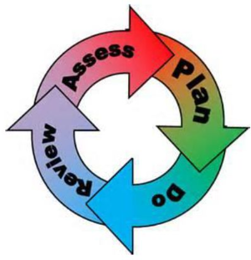
How will the school staff support my child?
The graduated response-Identifying, planning for and supporting pupils with SEND
Where a pupil is identified as having a special educational need, School will follow a graduated approach which takes the form of cycles of ‘Assess, Plan, Do, Review’. ​
• Assess a child’s special educational need. ​
• Plan the provision to meet your child’s aspirations and agreed outcomes. ​
• Do put the provision in place to meet those outcomes. ​
• Review the support and progress.

How does the school know if children need extra help and what do I do if I think my child has special educational needs?
- Assess
Identification – Your child will be identified as having SEND and/or a disability if they have significantly greater difficulty in learning than the majority of children of the same age or if they have a disability preventing or hindering the use of educational facilities provided for children of the same age within the Local Education Authority.
First steps - if from our rigorous tracking and monitoring of your child’s progress, it becomes apparent that he/she is not making expected progress then you will be invited to a meeting with their teacher and Mrs Wilson (SENDCo). Where appropriate, your child will be involved in this meeting. At the meeting, we will begin to explore the possible barriers to learning and you will be asked how we can best support your child.
Observations and assessments will then be carried out, and if required, input from specialist services may be sought with your permission.
Where appropriate, your child may be placed on our school’s Targeted Support or SEND Support Register and a plan will be devised by the class teacher that will set achievable targets. These will be reviewed and updated at least half-termly.
EHCPs (Education, Health and Care Plans) will be used when a child’s needs are deemed more complex and require the input from a range of outside agencies. This could be in the form of Educational Psychologists, Occupational Therapists or other professionals with an area of expertise, e.g. Autism. An EHCP helps to determine the level of educational, social and health support the child needs.
If you are concerned about your child’s progress or that your child may have SEN and/or a disability, please contact our SENDCo Anne-Marie Wilson on 01642 672262.

- Plan
Our procedures are in line with the SEND Code of Practice (2014).
The first point of contact is the class teacher, who has overall responsibility for the welfare of your child. Additional provision is planned carefully and overseen by Mrs Wilson, the SENDCo (Special Educational Needs and Disabilities Co-ordinator). It is implemented by a skilled team of teachers and supported by experienced teaching assistants.
SEND Resources
At St. Gregory’s we have an extensive range of different SEND resources and interventions available. These are closely matched to the needs of our children and their progress is monitored by the class teacher, the SENDCo, the Interventions Manager and staff with specific curriculum responsibilities.
Where provision does not result in adequate progress, as outlined in the SEND Code of Practice, the SENDCo (Mrs Wilson) should be consulted for advice.

- Do
Our teachers are skilled at adapting teaching and learning to meet the diverse needs in each class.
Daily planning considers individual children’s needs and requirements and is annotated and adapted according to need. Explicit reference is made in the teacher’s planning to the needs of those children identified with SEND.
Adaptive teaching is approached in a range of ways to support access to the curriculum and ensure that all children can experience success and challenge in their learning.
Grouping arrangements consider the different skills and abilities of each child. This ensures that learning is maximised.
Additional adults support groups and individual children with the long-term goal of developing independent learning skills. The class teacher monitors this support to avoid students becoming over reliant on this.
We fully encourage parental support and offer opportunities for individual meetings with parents/carers to provide clarity and recommendations on how they can support their child at home.
4. Review
If despite all steps taken, good progress is still not being made we will refer back to our graduated approach and increase/change support whilst continuing to monitor and review progress. It may also be necessary, at this stage, to consult with the expertise and specialist services secured by the school.
Consultation sessions are held in the Autumn and Spring terms where you can meet your child’s teacher to discuss and look at their work in different subject areas. A further opportunity is provided in the Summer term for you to discuss your child’s end of year report.
Parents that have children on the school’s SEND Support Register, are also invited to termly meetings to review their child’s SEN support plan. Your child will be involved in reviewing their targets at appropriate times throughout the term, with the class teacher or teaching assistant, and during the setting of new targets on a termly basis. If of course you would like to meet Mrs Wilson or your child’s class teacher at any point during the term, this can easily be arranged.
For every child who is in the care of the Local Authority, (Children, Young People In Our Care - CYPIOC), a Personal Education Plan (PEP) will be devised. This Plan will establish clear targets and actions to respond effectively to each child’s needs and provide a continuous record of their achievements.
If your child has an EHC plan, you will be invited to an annual review of this plan.

How will the curriculum at our school be matched to my child’s needs?
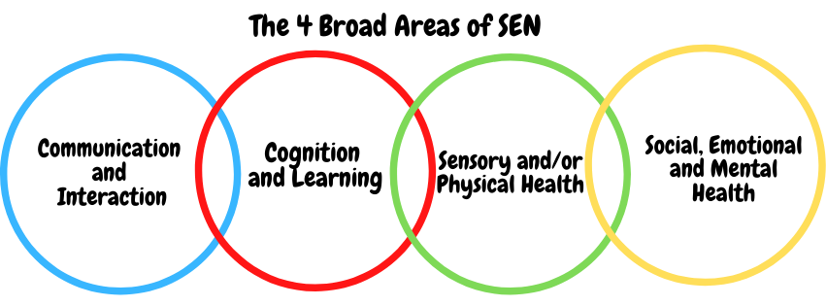SEN needs are classified under four broad areas of need. Below are the strategies, in class support and interventions that school may put in place to support your child.
Communication and Interaction
Strategies to support children with these needs include:
- Access to small group and/or individualised interventions to develop skills in communication and interaction emotional awareness, self-care, flexible thinking.
- Visual timetables used in every classroom
- Flexible approaches to timetable
- Conscious reduction of ‘teacher talk’
- Sensory feedback support e.g. fidget toys, wobble cushions
- Modifications to lunch and/or break times, e.g. duties, time change
- Access to additional aids/technology
- Explicit teaching of generalising skills from one context to another
- Careful planning of transitions, e.g. advance notice, familiar resources
- Mentoring and/or buddy systems

Cognition and Learning
Strategies to support children with these needs include:
- Developmental support for short and long term memory through a range of specific strategies.
- Regular, individually focused interventions, e.g. in reading, writing, phonics (RWInc.) and maths. Increased access to small group support in class
- Practical aids for learning, e.g. times table squares, time/number lines, pictures, photos, accessible reading material suited to age, individualised success criteria
- Increased access to ICT programmes, e.g. Reading Plus
- Flexible groupings
- Access to technical aids e.g. spell checker, ICT software and/or hardware
- Adaptations to assessments to enable access e.g. readers, scribe, ICT
- Curriculum/delivery adaptations to meet the learning needs of individuals
- Frequent repetition and reinforcement

Sensory/Physical
Strategies to support children with these needs include:
- Physical aids to support access e.g. wheelchair, walking frame, hearing aids, large print materials
- Access to a specialist teacher/learning support assistant qualified to support the learning of pupils who have: a hearing impairment, visual impairment
- Physio and Occupational Therapy programmes e.g. fine and gross motor skills development.
- Concrete apparatus available to support learning, e.g. Numicon materials (numeracy)
- Adapted curriculum to enable full access e.g. alternative recording devices, modified PE curriculum
- Sensory resources available e.g. wobble board, headphones/ear guards
- Access to support for personal care, e.g. school nurse service

Social, Emotional and Mental Health
Strategies to support children with these needs include:
- Access to time out/individual work area
- Mentoring/Buddy system
- Individualised rewards system
- Early Help Assessments accessed via our Well-being Leads to secure multi-agency targeted support.
- Access to counselling services, e.g. CAMHS, Psychotherapy services, Bungalow Project, Alliance
- Increased access to additional adults in and out of the classroom
- Alternative curriculum opportunities
- Supported transition programme with chosen secondary school
- Opportunities to develop Social and Emotional aspects of learning through small group work, e.g. Lunchtime Nurture Group.
- Access to specially designed games for the support of turn taking and co-operative behaviour skills.

What training is provided for staff supporting children with SEND?
All teachers have Qualified Teacher Status and our teaching assistants have a minimum of a level 2 qualification. All staff are either teachers of or are supporting students with SEND.
St. Gregory’s values staff training and organises courses/training programmes to ensure teachers and teaching assistants stay up to date with current research into teaching and learning.
Recent Full Staff Training:
Child Protection Training
Nasen – Whole school SEND
SEND updates
RWI phonics
Individual Staff Training
NASENCO award
SEND Briefings (Local Authority and BHCET)
Autism Awareness
Future Steps – Earth Handwriting Programme Team Teach

How do we support transition in our school?

Transition within classes/key stages: ​
Class teachers meet with each other to hand over all information regarding SEND pupils before the start of the academic year so that they are fully prepared for the child coming into their class. Where needed, SEND children who require additional support to ensure a smooth transition to their new class, will be included in a programme supported by Mrs Wilson, Mrs Gilbert and Miss Keen and will be given the opportunity for enhanced transition. A familiar adult may accompany them for a short period to ensure transition goes smoothly.

Transition to Secondary settings: ​
We work closely with all secondary schools in the area.
The majority of our children move on to Our Lady and St. Bede’s Catholic Academy in Stockton. The transition process will begin early, usually in Y5, for some of our more vulnerable children. Meetings are held for the transfer of essential information relating to IEPs, EHCPs, Child and Family Services and pastoral matters.
Mrs Gilbert & Miss Keen our Well-being leads work closely with the SENDCo and Y6 class teacher to support children who require additional provision during their transition period.
We can also support you in organising meetings with secondary school staff if you wish to speak to them personally.
When reviewing an EHCP for children in Y6, staff from the secondary school will always be invited to the review meetings.
During the last term, staff from OLSB come to meet our Y6 children and in addition to this, our Y6 children attend their chosen secondary school for two transition days.

Transition to a new school: ​
If your child moves to a new school within or at the end of an academic year, Mrs Wilson will contact the school SENDCo to ensure he/she knows about any special arrangements or support that needs to be made for your child. If necessary, a meeting will be arranged with other professionals. She will also transfer all records held for your child to the new school as soon as possible.

Where can I get further information about services for my child?

The Local Offer
Stockton-on-Tees Local Offer
https://www.stocktoninformationdirectory.org/kb5/stockton/directory/localoffer.page?localofferchannel=18

What key school documents refer to support and provision for pupils with SEND?

- SEND Policy​
- Admissions Policy​
- Supporting Pupils with Medical Needs Policy​
- Accessibility Plan​

Accessibility​
With due regard to our admission policy, parental choice and accessibility of the school building all children with special educational needs who apply will be accepted by the school. Admission Policy
- All of the main school building is fully wheelchair accessible.
- Disabled toilet facilities are located near the ICT suite.
- Communication with parents whose first language is not English is supported by advice from the Local Authority’s EAL (English as an additional language) team.
- Key documents are also translated for parents when required.

Activities Outside of School​
St. Gregory’s is an inclusive school and we will put in place appropriate support, whenever possible, to enable your child to be educated alongside their peers. This may include extra staffing and/or equipment.
Staff who are arranging an offsite trip will discuss with parents and the SENDCo any requirements needed and the suitability of any trip which the school is taking part in.
We will not stop your child from going on a trip due to their special educational needs and/or disability if the trip is suitable for your child and their safety and the safety of others is not compromised. Equality Act
The Head Teacher oversees all trips to ensure children are safe and included where possible.

What to do if you have a complaint, a compliment, or a query.

The school details and relevant contacts
Should you have any concerns about the support that your child is receiving, we hope that you will feel able to approach your child’s Class Teacher or the SENDCo to discuss this. They will be happy to meet with you and work together with you to help resolve any issues or concerns that you may have. We will always try to arrange a meeting at the earliest possible opportunity.
Our SEND Governor may also be contacted separately through the email address below: enquiries@stgregorys.bhcet.org.uk
However, if there are still unresolved issues, you may wish to make a formal complaint according to the procedures set out in Bishop Hogarth Education Trust’s Complaints Policy. You can view this document at:
https://bhcet.org.uk/wp-content/uploads/2020/04/Complaints-Policy-Review-November-2022.pdf

​
Name of school SEND governor.
To be confirmed.

