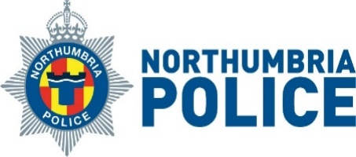

Dear Parents and Carers,

As the weather gets warmer and the summer holidays begin, we want everyone to enjoy South Tyneside's beaches, parks and public spaces safely.
Recently, there has been an increase in incidents involving young people taking risks, such as drinking alcohol, using drugs and behaving in ways that may be unsafe or against the law, which could lead to arrest. We know that most young people are respectful and make good choices, but we want families to be aware of the risks.
Some young people have become vulnerable because of intoxication, which can put them at risk of harm or exploitation. We ask parents and carers to talk to their children about staying safe, making good decisions and looking after themselves and their friends.
Water Safety
If your child is visiting the beach, river or any open water this summer, please advise:
- Always stay together and look out for each other.
- Never swim alone
- Only swim where it is safe to do so.
- Do not go into the water after drinking alcohol or taking drugs.
- If someone is in trouble in the water, call 999 and ask for the Coastguard.
- In an emergency at the beach, look for the nearest lifeguard.
Talking to your child about water safety could help save a life.
Where to Get Help and Support
If you are worried about a young person's alcohol or drug use, confidential support is available from Matrix Young People's Service:
📞 0191 497 5637
✉️ matrixenquiries@southtyneside.gov.uk
If anti-social behaviour or disorder is happening now, contact Northumbria Police on 101.
You can also report concerns about anti-social behaviour by emailing:
✉️ ASB@southtyneside.gov.uk
Turn over for more information

For support and advice on a range of family issues, please contact:
📞 0191 424 6210
- South Tyneside Youth Service - South Tyneside Youth Service - South Tyneside Council
- Family Hubs - Homepage - For Every Family
We hope all children, young people and families have a safe, happy and enjoyable summer.
Stuart Wright
Director of Place Strategy
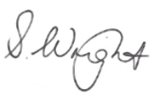
Phil Baker
Chief Inspector, Northumbria Police
