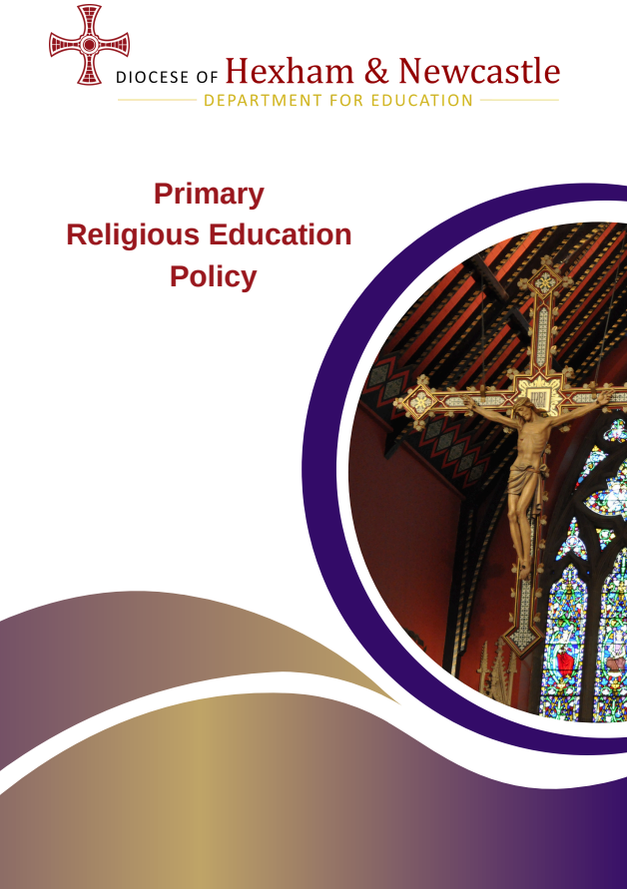

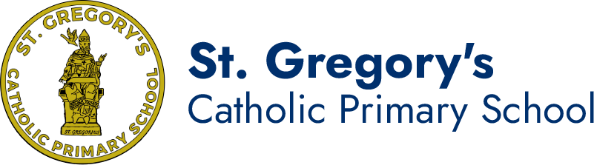

School mission statement:
We give thanks to God, work together and always try our best.
Shining in little ways for all to see.

- Context of this religious education policy

In the nineteenth century, St John Henry Newman passionately defended the principle that

Catholic universities become places where dialogue between academic disciplines was encouraged and celebrated as essential in the pursuit of truth. To dialogue means to reach out to others by actively listening to them.

In our times and circumstances, we strive to extend this principle to our schools, and the religious education curriculum needs to lead the way, offering everyone the opportunity to speak openly and with true freedom so that minds can meet in the pursuit of truth.

Newman said, ‘I wish the intellect to range with the utmost freedom, and religion to enjoy an equal freedom; but what I am stipulating for is, that they should be found in one and the same place and exemplified in the same persons.’

Our task is to make that place the Catholic school, with religious education at its heart.
- The importance of religious education

Religious education is the core of the core curriculum in a Catholic school. Placing religious education at the core of the curriculum helps the school to fulfill its mission to educate the whole person in discerning the meaning of their existence

A Catholic education is “focused on integral formation of its students and at the same time prepares them for full participation in civic life. It forms the Catholic student as ‘both human and a person of faith, the protagonist of culture and the subject of religion’. It teaches subjects with methods proper to them and at the same time imbues the whole curriculum with a Christian outlook. It is established for Catholic students and at the same time draws others to its doors. In short, the Catholic school reflects the apparent paradox of the incarnation that is resolved in Christ: it is both fully Catholic and really a school. Religious education in a Catholic school also bears witness to the same mystery: it is both fully religious and genuinely educational.”

Aims for religious education
Religious education is at the heart of our school life. We aim to ensure that all pupils will have the opportunity:
- To engage in a systematic study of the mystery of God, of the life and teaching of Jesus Christ, the teachings of the Church, the central beliefs that Catholics hold, the basis for them and the relationship between faith and life.
- To enable pupils continually to deepen their religious and theological understanding and be able to communicate this effectively.
- To present an authentic vision of the Church’s moral and social teaching to provide pupils with sure guide for living and the tools to critically engage with contemporary culture and society.
- To give pupils an understanding of the religions and worldviews present in the world today and the skills to engage in respectful and fruitful dialogue with those whose worldviews differ from their own.
- To develop the critical faculties of pupils so to bring clarity to the relationship between faith and life, and between faith and culture.
- To stimulate pupils’ imagination and provoke a desire for personal meaning as revealed in the truth of the Catholic faith.
- To enable pupils to relate the knowledge gained through religious education to their understanding of other subjects in the curriculum.

- The Curriculum
At St. Gregory’s Catholic Primary School, religious education is based on the Religious Education Directory (RED) “To Know You More Clearly”. In line with the Bishop’s mandate, the RE curriculum is taught through the Diocesan resource, ‘The Way’.
In recognition of the importance of religious education in our school, we devote 10% of the teaching week to religious education lessons; not including Collective Worship. In Early Years, the timetable and learning style is more flexible, but teaching of Religious Education is prioritised to give children the opportunity to engage fully with the curriculum.
The Religious Education Curriculum Directory has a clear framework for learning:
- Knowledge lenses
Hear, believe, live and celebrate indicate what should be known by the end of each age phase.
- Ways of knowing
Understand, discern and respond are the skills through which children progress and develop their thinking during the curriculum journey.
- Expected Outcomes
Sets out what pupils should be able to know, remember and do in each year group
- Curriculum branches
Divide the model curriculum into 6-week units of study which repeat annually, giving a spiral curriculum which allows children to build progressively on the prior knowledge and develop their understanding year by year.
The curriculum branches are:
Branch 1 | Creation and Covenant
Branch 2 | Prophecy and Promise
Branch 3 | Galilee to Jerusalem
Branch 4 | Desert to Garden
Branch 5 | To the Ends of the Earth
Branch 6 | Dialogue and Encounter
The curriculum is firmly founded on building children’s knowledge and understanding of Scripture, while providing opportunities to make connections to other faiths and cultures, as well as to their daily lives.
- Religious education in the classroom and beyond
At St. Gregory’s Catholic Primary School, the teaching of religious education is designed to be as varied and creative as possible, to help children to engage fully with the ideas explored, to ask questions and to lead their own learning in discerning their response.
Learning within the classroom may include:
- Whole class discussion and teaching
- Group discussion and feedback
- Drama and role play
- Exploration through music and art
- External speakers/workshops
Learning in religious education cannot always be recorded and does not begin or end in the classroom. Learning from religious education will flow into other curriculum areas as pupils make links between their learning. We aim to give children the opportunity to connect their formal learning with their wider understanding through regular opportunities to reflect and respond.
Learning beyond the classroom may include:
- Following the example of a role model in daily life at home or in school
- How charitable activity and fundraising is a result of belief
- Inspiration through reflection in prayer and liturgy
- Conversations with clergy or parishioners at Church
- Response to catechesis in the parish eg for Reconciliation or First Holy Communion
- Engagement with programmes based on Catholic social teaching eg Mini-Vinnies; Faith in Action; Live Simply Award
We work closely with parents and with the parish to support children’s progress in understanding and developing on their curriculum and faith journey.
- The importance of the role of parents in religious education

Our school community recognises the central role parents have in the religious education of their children. The Bishops’ Conference of England and Wales reiterated that: “The first educators in the faith are parents.”

In recognition of this, we strive to maintain a faithful partnership with parents, communicating clearly both the curriculum and the wider spiritual opportunities offered to families and warmly inviting parents to share their knowledge and experiences with the school community.

Our school works closely in partnership with the home and St Gregory’s R C Church. The General Directory for Catechesis confirms, “This partnership between home and parish is enhanced by the role of the Catholic school in which the educational mission of the Church finds a particular and important expression.” Religious education in a Catholic school encompasses the whole educational mission of the Church and is not confined to timetabled Religious Education lessons.
- Other world views
Catholic education seeks to form pupils who are well prepared to play a positive role in society and to follow Jesus’ teaching to “love your neighbour”. We therefore embrace learning about other world views with “a willingness… to try to understand better the religion of one’s neighbours, and to experience something of their religious life and culture.”
The Religious Education Directory includes the branch ‘Dialogue and Encounter’ which focuses specifically on exploring other world views and recognising the connections with the Catholic faith. Opportunities for dialogue and encounter are sought throughout the academic year and especially focus on broadening pupils’ experiences and on real-life encounters with those of other faiths or none, to enable connections and develop understanding. Examples may include:
- Opportunities for families in our community to share their faith and experience
- Conversations with invited visitors about their beliefs and experiences
- Q&A with faith leaders such as our parish priest and parishioners
- Visits to places of worship
- Guided exploration of artefacts from other faiths
- Independent reading, research and discussion
External speakers are always checked in line with the CES checklist for external speakers, to ensure safe and constructive dialogue and encounter opportunities for our pupils. External Speaker Checklist
- Feedback, assessment, recording and reporting
Feedback is given in religious education to support children’s progress and to challenge their thinking. This follows our school’s marking and feedback policy, including live marking and feedback.
Assessment follows diocesan and national guidelines, assessing against the expected outcomes for each branch in the Religious Education Directory. Pupil attainment is recorded termly on Trust’s assessment recording system – Arbor - and progress is tracked regularly by the RE subject leader, Senior Leadership Team and Bishop Chadwick Trust in line with the school’s Assessment Policy.
The RE subject leader will moderate outcomes in religious education both internally and with other Catholic schools, to ensure consistency of expectations with other schools in the diocese.
Outcomes for religious education are shared in line with other core curriculum subjects, both during parent consultation meetings and in end-of-year reports.
- Monitoring and evaluating
The RE subject leader and Senior Leadership Team monitor every aspect of religious education in line with other core curriculum subjects. Monitoring is conducted at least termly, and feedback is given to individual staff. Outcomes may inform further training at staff meetings or actions for the subject action plan.
Self-evaluation of religious education is the responsibility of the Headteacher, the RE subject leader, Governors and the Senior Leadership Team, with further input from all teachers of religious education, from families and from pupils. This process ensures a culture of continuous improvement, so that teaching and learning in religious education remains the best it can be.
- Staff formation
All staff support the Catholic ethos of our school and strive to develop children’s progress and understanding in matters of faith. There are regular opportunities for all staff to engage in personal prayer and reflection which supports their professional role.
The RE subject leader attends termly RE subject leader days to ensure they have the most up to date information, as well as attending moderation meetings on a yearly basis.
All teachers involved in planning and delivering religious education lessons have attended diocesan training on the Religious Education Directory resource. They all have access to the bite-sized training provided by the Diocese of Hexham and Newcastle and can use this throughout the year to support their own knowledge and understanding.
All new staff will receive full training to support them with the teaching of religious education as part of their induction; the RE subject leader will meet with them on a six weekly basis to provide focused training so they are fully prepared to teach each new Branch throughout the year.
For all practitioners, there is the opportunity to engage with dedicated professional training and development through CCRS, rapid review sessions, further BCCET CPD opportunities.
- Review
The policy will be reviewed as part of the regular cycle of policy review conducted by the governors.
This religious education policy has been approved and adopted by the Local Governing Committee on [enter date] and will be reviewed on [enter date].

Signed by the Chair of Local Governing Committee: _________________________________

Signed by the Headteacher: _______________________________________________________

Person responsible for implementation of policy: ____________________________________

Review date: ________________

To know You more clearly, Religious Education Directory for Catholic Schools, Academies and Colleges in England and Wales, June 2023, p4-5
Address to Bishops’ of Great Britain during ad limina visit to the Vatican, Pope St John Paul II, 1992
To know You more clearly, Religious Education Directory for Catholic Schools, Academies and Colleges in England and Wales, June 2023, p9
To know You more clearly, Religious Education Directory for Catholic Schools, Academies and Colleges in England and Wales, June 2023, p6
Religious Education in Catholic Schools from the Catholic Bishops' Conference of England and Wales, 2000
Religious Education in Catholic Schools from the Catholic Bishops' Conference of England and Wales, 2000
Meeting God in Friend and Stranger, Catholic Bishops’ Conference of England and Wales, 2009

