Discern
By the end of this unit of study, pupils will be able to talk and think creatively and critically about what they have studied, for example, through:
D1.1.1 | Talking about how God’s gift of Creation is expressed through the scriptures and diverse creative and artistic expressions, e.g., through art, music, or poetry and talk about their responses.
D1.1.2 | Talking about why caring for God’s world matters for them and their local community. (RVE)
Respond
During this unit of study, pupils will be invited to respond to their learning, for example by:
R1.1.1 | Reflecting on what the words of the Our Father and the opening words of the Creed say to them.
R1.1.2 | Reflecting on different ways to pray.
R1.1.3 | Listening to stories from different communities and their experiences about how they care for the world.
R1.1.4 | Talking about how they can care for God’s world.
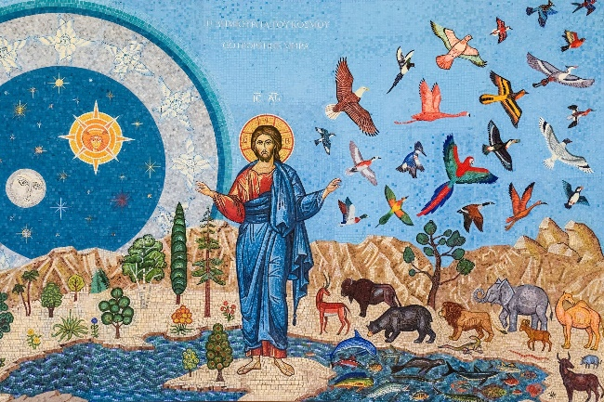
Understand
By the end of this unit of study, pupils will be able to:
U1.1.1 | Recognise that the story of Creation in Genesis 1:1-4,24-26, is an ancient, prayerful, poetic reflection on God’s world and retell this story in any form.
U1.1.2 | Recognise in an age-appropriate way that the Church teaches that all that is comes from God, our Father, who made heaven and Earth.
U1.1.3 | Recognise that though people cannot see God, they can sense his presence through the awe and wonder experienced in the beauty and order of Creation.
U1.1.4 | Recognise that the Church teaches that God gave human beings the responsibility for taking care of the world and its people and in doing this, we show love for God and each other.
U1.1.5 | Know that Pope Francis wrote a letter, called Laudato Si’, about the gift of Creation and the importance of taking care of the world as it is everyone’s home.
U1.1.6 | Recognise that prayer is a way of drawing closer to God.
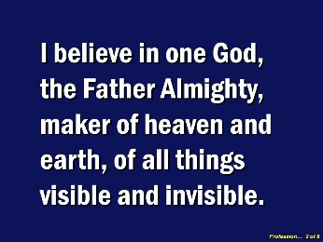

Key Vocabulary
God Father Creation
Pope Francis Laudato Si
Our Father Creed

