Discern
By the end of this unit of study, pupils will be able to talk and think creatively and critically about what they have studied, for example, through:
D1.3.1 | Imagining how some of the people who met Jesus felt and how knowing Jesus changed them.
D1.3.2 | Listening to the stories and experiences of how people celebrate Candlemas
Respond
During this unit of study, pupils will be invited to respond to their learning, for example by:
R1.3.1 | Reflecting on what the Good News might mean for them.
R1.3.2 | Reflecting on how Jesus is a ‘light’ for all people, consider how they can bring ‘light’ to their families and communities. (RVE)
R1.3.3 | Reflecting on how Jesus cares for other people and what they can learn from his actions.

Understand
By the end of this unit of study, pupils will be able to:
U1.3.1 | Identify some of the people that encounter Jesus and recognise that he is special.
U1.3.2 | Retell, in any form, one of the stories they have heard, recognising these are religious accounts from the Gospel of Luke.
U1.3.3 | Make simple connections between Jesus’ announcement of his mission (Lk 4:16-19) and how Christians are called to tell people about God’s love today.
U1.3.4 | Ask and answer questions about the story of Zacchaeus and how he changed after meeting Jesus.
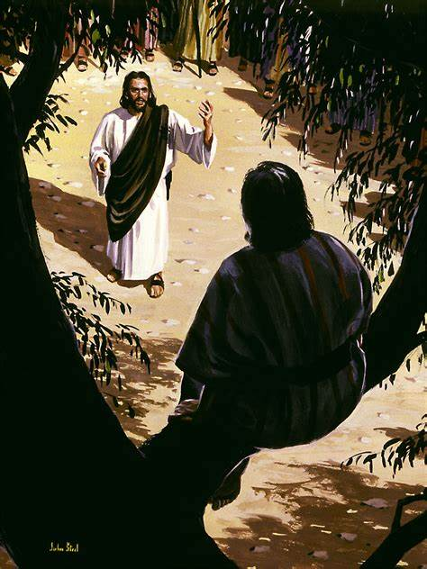

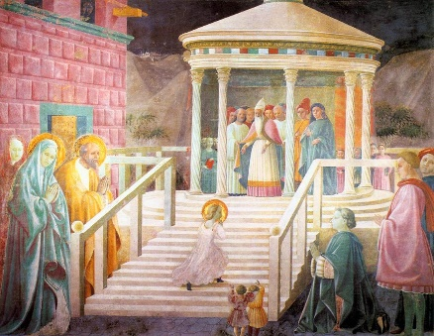
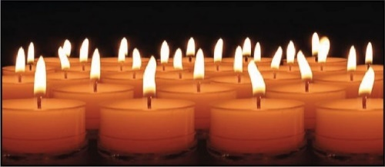
Key Vocabulary
Presentation Temple
mission Son of God
light Candlemas
Our Father Creed

