Discern
By the end of this unit of study, pupils will be able to talk and think creatively and critically about what they have studied, for example, through:
D1.4.1. | Asking ‘I wonder’ questions about the story of the last week of Jesus’ life.
D1.4.2. | Experiencing and reflecting on music or art that shows how Christian communities in another part of the world celebrate Lent and the last week of Jesus’ life. (RVE)
Respond
During this unit of study, pupils will be invited to respond to their learning, for example by:
R1.4.1. | Recognising that fasting in Lent is giving something up to help others and CAFOD Family Fast Day is a way of doing this.
R1.4.2. | Considering what they might give up and choose to do to help others. (RVE)
R1.4.3. | Reflecting on what they know about Jesus including the events of the last week of Jesus’ life and his resurrection.

Understand
By the end of this unit of study, pupils will be able to:
U1.4.1 | Make simple connections between Jesus’ time in the desert (Lk 4:1-13) and Christians praying and fasting for forty days in Lent. (RVE)
U1.4.2 | Recognise that Jesus shows the importance of giving to others, making simple connections with the story of the widow’s mite (Lk 21:1-6) and the season of Lent.
U1.4.3 | Correctly sequence the events of the last week of Jesus’ life.
U1.4.4 | Recognise that angels bring God’s message and are a sign the Jesus is the Son of God, truly alive.
U1.4.5 | Recognise that the Church teaches that Jesus suffered, died, and rose again.
U1.4.6 | Recognise simple connections between the use of ashes and the Christian belief that Lent is an opportunity for a new start.
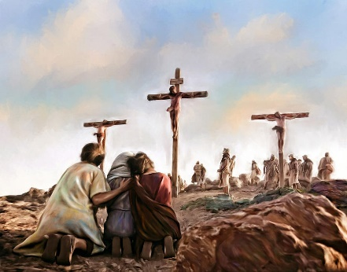

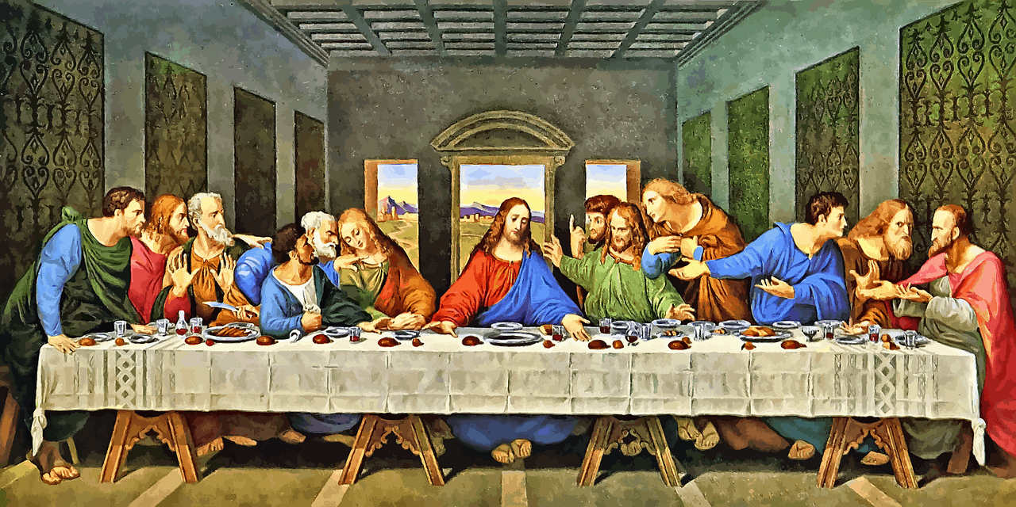
Key Vocabulary
Temptation Last Supper Crucifixion
Resurrection Ash Wednesday
Palm Sunday Lent Easter
Family Fast Day

