Discern
By the end of this unit of study, pupils will be able to talk and think creatively and critically about what they have studied, for example, through:
D1.5.1. | Imagining how the apostles felt during the events following the Resurrection.
D1.5.2. | Talking about the different ways experience of the Holy Spirit is expressed in some of the stories from the Bible they have heard across the Year One branches (e.g., ‘God’s spirit hovered over the water’ (Gen 1:1), a shadow in the Annunciation (Lk 1:35), or wind and fire in Pentecost (Acts 2:1-4)).
D1.5.3. | Looking at and discussing ways the Holy Spirit is described in art or music. (RVE)
D1.5.4. | Listening to and asking questions about the experiences of how others celebrate Pentecost in different places and cultures. (RVE)
R1.5.3. | Considering how Christians announce the Gospel to others through their words and actions.
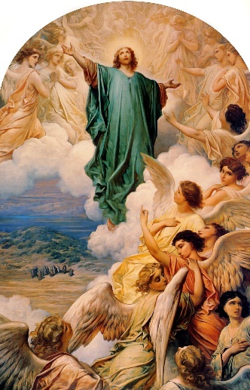
Understand
By the end of this unit of study, pupils will be able to:
U1.5.1. | Retell with increasing detail one of the following accounts: the Road to Emmaus (Lk 24:13-35), the Promise of the Spirit and the Ascension (Acts 1:1-11), Pentecost (Acts 2:1-4).
U1.5.2. | Simply sequence the story of Jesus studied from earlier branches (as Luke does in Acts 1:1).
U1.5.3. | Make simple connections between the mission of the Church and the mission of Jesus as he announced it at the beginning of Luke’s Gospel (Lk 4:16-19). (See branch 3.)
U1.5.4. | Recognise that Catholics celebrate the Ascension of Jesus and Pentecost on special days called holydays. (RVE)
Respond
During this unit of study, pupils will be invited to respond to their learning, for example by:
R1.5.1. | Thinking about why prayer is an important part of life for many people. (RVE)
R1.5.2. | Hearing the words of the Glory Be and hymns that reference Father, Son, and Holy Spirit and joining in prayerfully if they choose to do so.

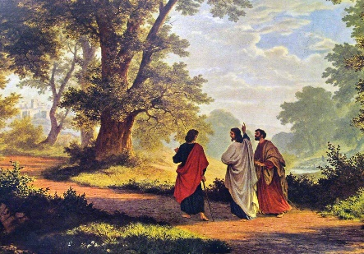
Key Vocabulary
Emmaus Holy Spirit
Ascension Pentecost Church
Glory Be Gospel

