Discern
By the end of this unit of study, pupils will be able to talk and think creatively and critically about what they have studied, for example, through:
D1.6.1 | Listening to the stories and experiences of Christians from their local parish and asking them questions. (RVE)
D1.6.2. | Talking about their personal response to and artistic expression of Christian belief in a different Christian community (e.g., Missa Luba; Pentecostal Gospel music tradition; Contemporary Christian Praise and Worship music; Welsh choirs, Jesus Mafa paintings).
D1.6.3. | Asking questions about the stories and experiences of Jewish people. (RVE)
Respond
During this unit of study, pupils will be invited to respond to their learning, for example by:
R1.6.1. | Considering how Christians in their local parish community could work together to help people. (RVE)

Understand
By the end of this unit of study, pupils will be able to:
U1.6.1. | Know that Christian means follower of Jesus Christ.
U1.6.2. | Recognise that Catholics are a part of a global Christian family, and all Christians are sisters and brothers.
U1.6.3. | Recognise simple connections between Jesus’ life and message and how Christians live today. (RVE)
U1.6.4. | Recognise that the cross is a symbol of Christianity, and the sign of the cross is a prayer expressing Christian belief.
U1.6.5. | Correctly use religious words and phrases to recognise features of Jewish religious life and practice (e.g., including specific vocabulary about the Jewish belief in one God and the special clothes some Jewish people wear each day). (RVE)
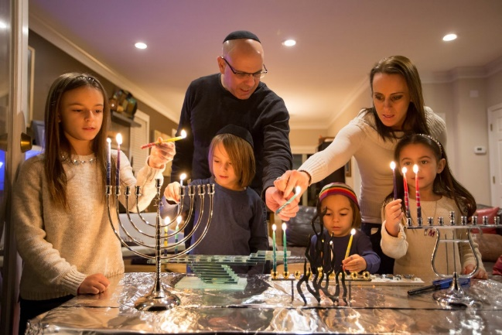

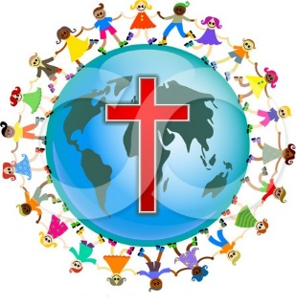
Key Vocabulary
Christian Church parish
community sign of the cross
Jew Judaism Torah

