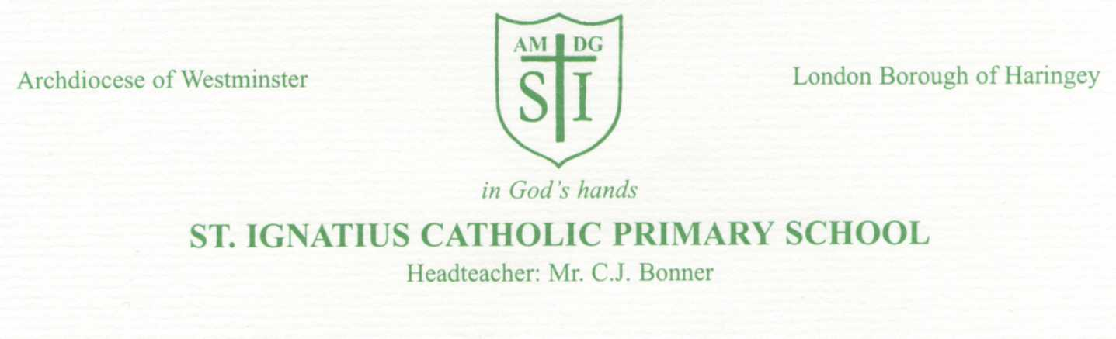
4th May 2022

Dear Parents / Carers,

Re: SATS WEEK Monday 9th – Thursday 12th May 2022

We would like to remind you about arrangements next week for SATs, following our mock SATs week, last week.

Hopefully this weekend will be a mixture of work, rest and play! They do have some revision to do but we also ask that you make sure they rest and sleep well, in order they are refreshed and prepared for the week ahead.

Breakfast club.
To help the children feel settled in the morning, we are inviting our Year 6 pupils to arrive at school at 8.15am where they will be provided with BREAKFAST of toast and juice in the hall.
This is an optional provision and your child does not need to come to school until the normal time of 8.45am if they so choose.
Either way, it is VERY important that your child is in school each day and ON TIME.

Please note also, that this breakfast provision is available only for Year 6 pupils and not siblings or children in other year groups. There is no cost for this provision.

Timetable for next week – All the tests are in the morning.

Monday | Tuesday | Wednesday | Thursday
SPaG | Reading | Maths Arithmetic  Maths Reasoning | Maths Reasoning

Absences during SATS week
We understand that children may be sick at times but we ask that if this situation arises next week, you call school so that we can ascertain the nature of any illness and put arrangements in place to allow your child to attend later that day, to sit their paper if possible.
Please do not arrange any external appointments during next week for your child, unless they can take place in the afternoon or after school.

After SATs
Friday 13th May 2022 – We are aiming to have a fun day this day and will send you details next week.
As we still have 2 months of school until Y6 leave St Ignatius, we will still have a strong focus on improving our academic skills. There will be some focus on writing skills initially and then more on a topic based curriculum.
We also hope to take Y6 on other trips, prepare for their end of year production and leavers party.

For now, we will all stay focussed on the week ahead, hoping the children have a productive and rewarding week.

Best wishes, The Year 6 Team

