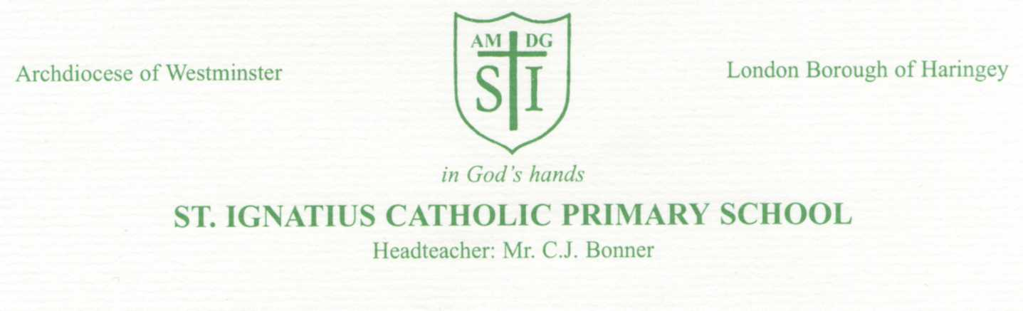
Thursday 4th May 2022
Dear Parents/Carers,
Our Year 6 children are very nearly at the end of their time here at St Ignatius. They are currently working hard towards their SATs, so as well as organising a fun end of term trip, we would also like to help to buy the children a leaver’s hoodie.
This will be something they can have as a keepsake from their time at primary school. We would like if possible a £15 contribution from you towards the hoodies- they RRP at £25. Payment for the hoodies can be made via ParentPay or through contactless payment at the school office. Once the hoodies have arrived, the children will be able to wear them for the remainder of their time at school.
In order to be sure we have the correct sizing for the pupils please look at the table below and let me know which size your child would need. If I do not have this information by Monday 16th May, then I will order the Junior size (age 11-13). Please return the slip below to the class teacher and please also make sure you clearly write how you wish their first name to be written on the back of the hoodie.
Yours Sincerely
Miss Taylor
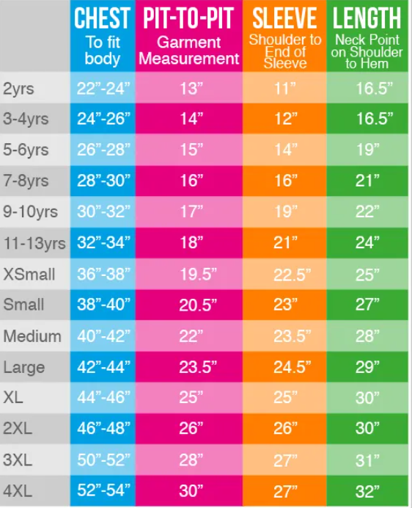 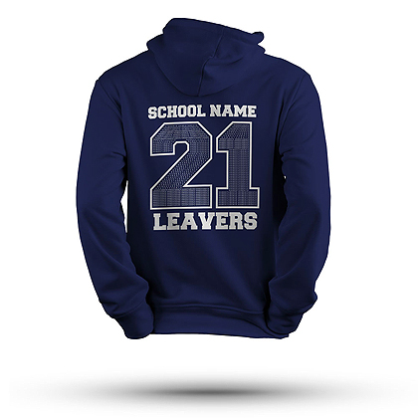-------------------------------------------------------------------------------------------------First Name of Child (please write clearly):
Class:
Size needed: __________________________

