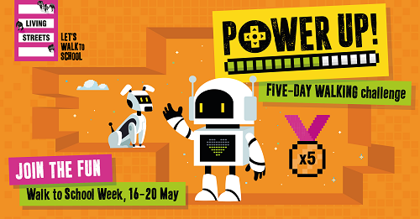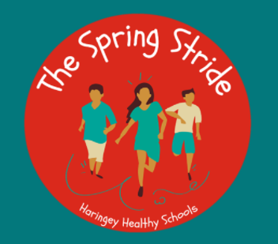
Friday 6th May 2022
Dear Parents/Carers.
The Spring Stride (9th- 27th May) and Walk to School Week (16th- 20th May) 2022
What is the ‘Spring Stride’?
The Spring Stride starts on 9th May and is a three week competition to encourage pupils in Haringey to take part in physical exercise every day for three weeks. Research has shown that over the last two years (due to Covid lockdowns), the percentage of children who are obese in Reception, across the country, has risen from 23% to 27% and in Year 6 this has increased from 35% to 40%. Due to this increase, Haringey has created the Spring Stride to try to encourage pupils to move more. This may be by taking part in the ‘The Daily Mile’, Yoga, Dance or any other movement/exercise in addition to their regular PE lessons.
Parents- there are also ways for you to get involved at home, so please keep an eye on Class Dojo daily.
During the second week of the Spring Stride it is ‘Walk to School Week’.
What is ‘Walk to School Week’?
WC 16th May our school will be taking part in ‘Walk to School Week’. It is a nation- wide campaign to get more children walking to school. We will be encouraging the children to walk to school instead of travelling by car or public transport. Walking to school is an ideal way of spending time with your child, saving money and doing your bit for the environment..
This year’s challenge, #PowerUp, will engage pupils through video game-inspired design, encouraging them to travel sustainably to school every day of the week. Each day will see a level unlocked and a new mission to complete, through which pupils will discover the incredible benefits of walking for individuals, communities and the planet.
Why are we encouraging children to walk to school?
Walking has so many benefits from physical to mental wellbeing; aiding concentration and creativity and creating safer, less polluted and more welcoming streets. All that makes for a happy healthy child set up for success in and out of the classroom.
How can you and your child take part?
If you usually walk to school, then carry on doing exactly that and your child will get their daily sticker! If you don’t usually walk, it couldn’t be easier to give it a go. Perhaps you can just walk to school on one day during the week. If you live too far away from school, or you need the car for work, parking a five minute walk away will reduce the congestion just outside school. You’ll still get the health benefits and help improve your child’s road sense. By taking part you will be joining thousands of other children and their families across the country. Please see attached map with 5 and 10 minute walking zones for St Ignatius and some other ways to support Walk to School Week. We have been working very hard with Haringey Smarter Travel to think of ways to make our journeys safe and good for us and the environment.

What will we be doing in school?
We will be having a whole school assembly explaining the benefits of physical exercise and walking to school. The children will also be taking part in daily physical activities in class each day..We hope that as many of you as possible will walk to school during the next three weeks and that you will encourage your children to be as active as possible. Keep your eyes peeled on Class Dojo for updates and photos of the children being active.
Yours Sincerely
Miss Taylor
Assistant Head Teacher

