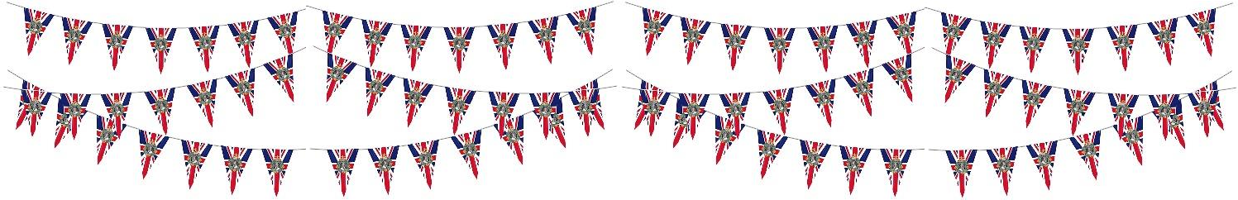
The Queen’s Platinum Jubilee Celebrations

Friday 13th May 2022

Dear Parent/Carers,

This year Her Majesty the Queen has become the first British Monarch to celebrate a
Platinum Jubilee, marking 70 years of service to the people of the United Kingdom, the Realms and the Commonwealth. We are all very much looking forward to celebrating this special occasion in school. As a school we have been learning a special Jubilee song which we have shared on Class Dojo.

During the week of 23rd May-27th May, each class will study a different decade from during the
Queen’s reign. The decade to be studied by each class is shown below.

EYFS –Present day
Year 1 – 1990s Year 2 – 1980s Year 3 – 1960s Year 4 – 1950s Year 5 – 1970s Year 6 – 2000s

On Friday 27th May, we will be holding a tea party (outside weather dependent) to celebrate the Platinum Jubilee during the afternoon. Children may come dressed in any red, white and blue clothing this day, if they wish. Further information regarding the tea party will follow, we will be asking for food donations for our tea party.

We will be taking part in various events during the week of the 23rd May, one of which is planting a tree in our garden area, which is part of the Queen’s Green Canopy campaign. We will share news of this special event nearer the time.

If you have any questions, please speak to a member of staff or contact the school office. Your sincerely,
Miss Taylor

Assistant Head

