July 2020
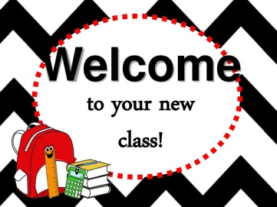

Dear Parents
In September all our pupils will be going to new classes.
Your child’s new class teacher is Ms Haddon
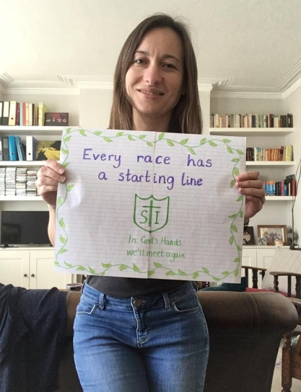
They will be in Lion Class (1H) in Campion building.
The children return to school:
Monday 7th September 9.15am – 3.15pm
For more details of our September return, please see our Stay Connected newsletter sent today to our website
https://stignatiuscatholicprimary.co.uk/our-news/Summer-2020

