

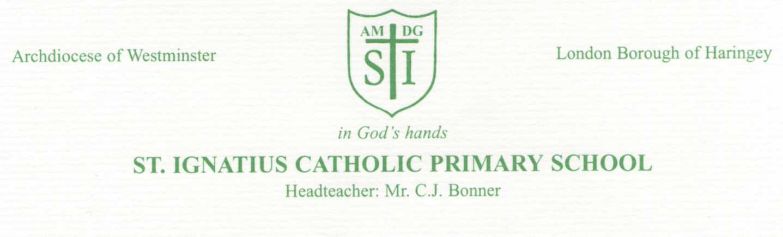
ST. IGNATIUS PRIMARY SCHOOL

24 June 2026
Dear Parent of Streetz Ahead Dance Giants Club LATEST UPDATE ON PERFORMANCE
Friday 26 June 2026 - Dance Giants Performance at The Bernie Grant Arts Centre
As you will be aware from communication via Dance Giants – there have been changes made to arrangements for the performance due to the impact of the heatwave.
Essentially the three main changes are:
- Thursday performances are cancelled and they are all going to take place on Friday 26 June.
- There will now be two casts who will perform at different times – one at 11am and one at 2pm
- There will only be ONE performance for each cast
- There will be no pupil audiences as the seats are now needed for parents previously booked in to attend the Thursday performance.
These are the following arrangements:
8.40am | All pupils performing are to come to school at the usual time – they can wear their school PE t-shirt and shorts and bring their Dance Giants outfits in a bag to change in to after lunch
10.00am | All Streetz Ahead pupils will leave school and either walk or get on the bus to The Bernie Grant Arts Centre N15 4RX – behind the Tottenham Town Hall.  The Arts Centre is air conditioned.
10.30am | Our group are Cast B so will be allocated seats in the arena.
11.00am | We will watch the Cast A performance.
11.45am | Pupils will have their lunch and a break / rest time
1.00 – 2.00pm | Time will be allocated to rehearse ahead of their performance.
2.00 – 3.00pm | Cast B performance  This will be to an audience of parents / families  There will be NO audience from the rest of our Y5 and Y6 group of pupils
3.00pm | Home arrangements: These are the 4 options:  - Pupil can go home with their parent if they have either come to watch the performance or come to collect their child from the Bernie Grant Arts Centre.  - Pupil can go home on their own from The Bernie Grant Arts Centre.  - Pupil returns to school with staff to be dismissed to go home on their own  - Pupil returns to school with staff to be dismissed to their parent/ sibling.
Pupils are expected to bring a packed lunch or, if entitled to Free School Meals via a School Meals Certificate, they can order one for the day.
Please either complete the slip below if your child is in school or send a response via Dojo.

Ms Curran

Name of pupil ____________________________________________________ Class ______________
I agree for my child to attend the Dance Giants performance at The Bernie Grant Arts Centre.
I will provide my child with a packed lunch
I have a Free School Meals Certificate and would like my child to be provided with a school packed lunch

Home Arrangements
- I agree to collect my child up to from the Bernie Grant Arts Centre at 3pm

- I give my permission for my child to go home on their own from The Bernie Grant Arts Centre.

- I give my permission for my child to return to school with staff to be dismissed to go home on their own

- I give my permission for my child to return to school with staff to be dismissed to parent / sibling.

My phone number for contact _______________________________________________

Signed ________________________________________ Date __________________

