July 2020
Dear Parents
In September all our pupils will be going to new classes.
Your child’s new class teacher is Ms Akunda
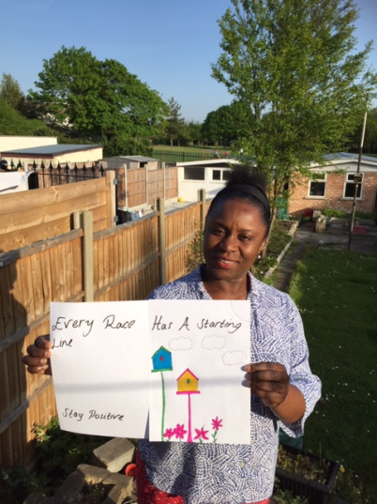
They will be in Panda Class (3A) in Anne Line building.
The children return to school:
Monday 7th September 9.00am – 3.00pm
For more details of our September return, please see our Stay Connected newsletter sent today to our website
https://stignatiuscatholicprimary.co.uk/our-news/Summer-2020

