July 2020
Dear Parents
In September all our pupils will be going to new classes.
Your child’s new class teacher is Ms Fothergill
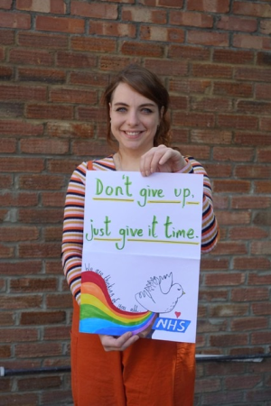

They will be in Orang-utan Class (3F) in Anne Line building.
The children return to school:
Monday 7th September 9.00am – 3.00pm
For more details of our September return, please see our Stay Connected newsletter sent today to our website
https://stignatiuscatholicprimary.co.uk/our-news/Summer-2020

