July 2020

Dear Parents
In September all our pupils will be going to new classes.
Your child’s class teacher is Ms Crome
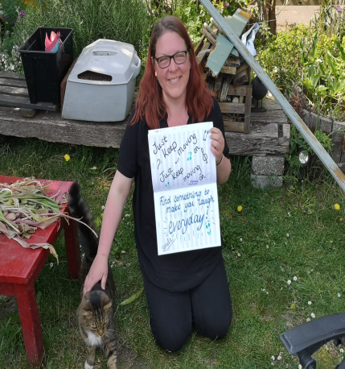

They will be in Polar Bear Class (4C) in Anne Line building.
The children return to school:
Monday 7th September 9.00am – 3.00pm
For more details of our September return, please see our Stay Connected newsletter sent today to our website
https://stignatiuscatholicprimary.co.uk/our-news/Summer-2020

