July 2020
Dear Parents
In September all our pupils will be going to new classes.
Your child’s class teacher is Ms Celliers
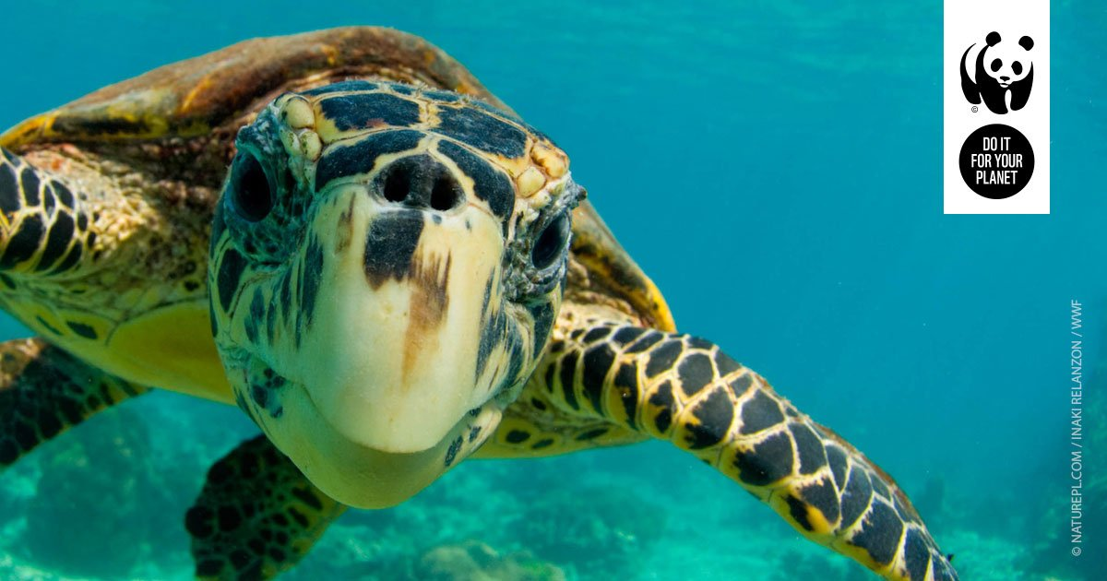
They will be in Turtle Class (5C) in Briant building.
The children return to school:
Monday 7th September 8.45am – 2.45pm
For more details of our September return, please see our Stay Connected newsletter sent today to our website
https://stignatiuscatholicprimary.co.uk/our-news/Summer-2020

