Activities to develop fine motor skills

One of the most important ways we can help our children while playing with them at home is through setting up simple activities that help to develop fine motor skills. Young children need to be able to hold and use scissors and pencils appropriately before using them in a classroom context. We cannot expect them to be able to write if they haven’t yet developed the strength needed in their hands and fingers.
There are plenty of easy ways to strengthen these muscles, practise co-ordination and develop hand:eye co-ordination using simple, everyday materials and a bit of creative fun!
Here are some ideas you can use at home. There are a million variations you could make from each of these to cater for your own child’s particular interests and learning dispositions.

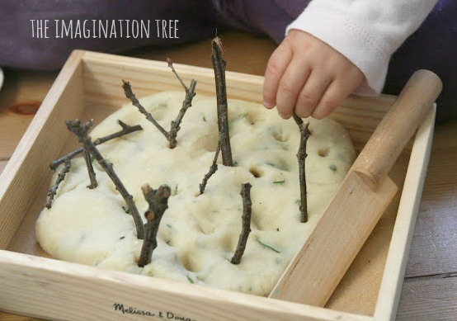

Play dough with natural materials to explore

Poking straws into holes

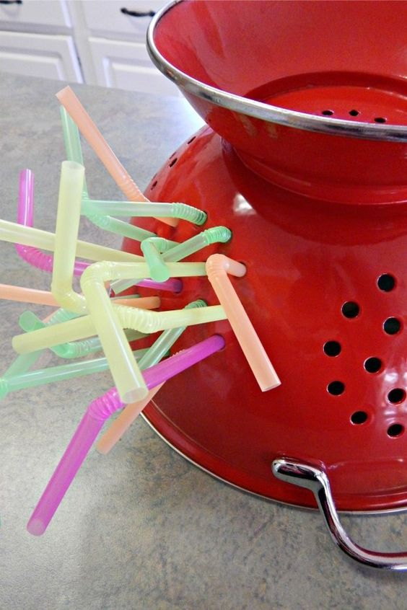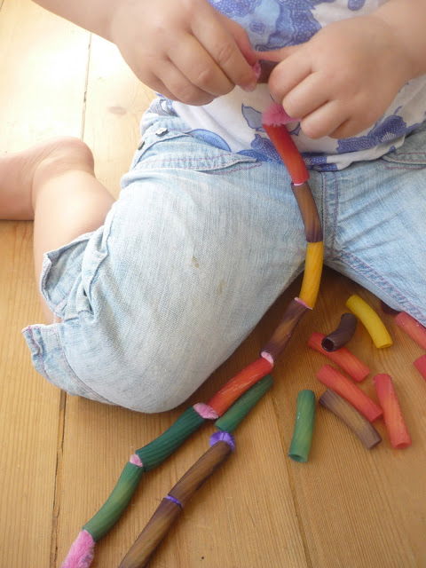
Pasta necklaces

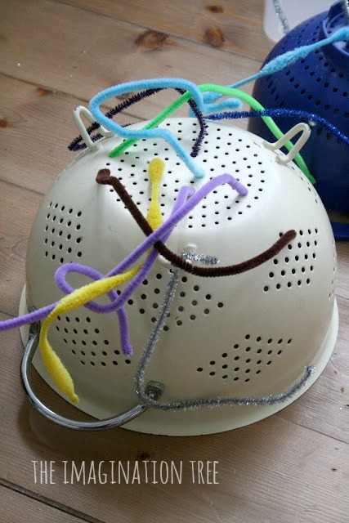

Pipe cleaners and colanders

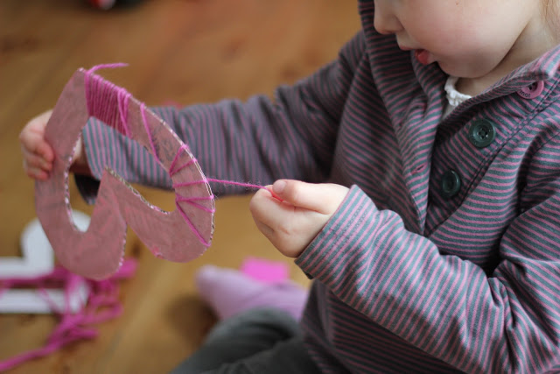

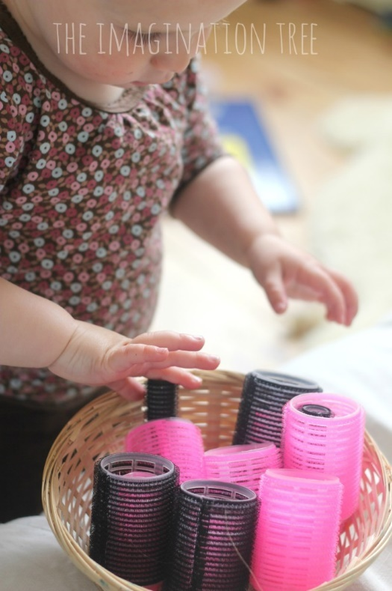
Hair rollers sticky construction

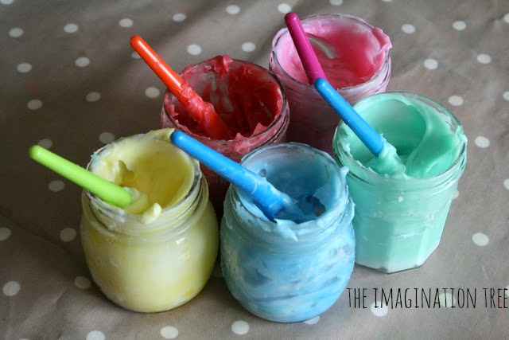 Fingerpainting
Mark making in salt/sand
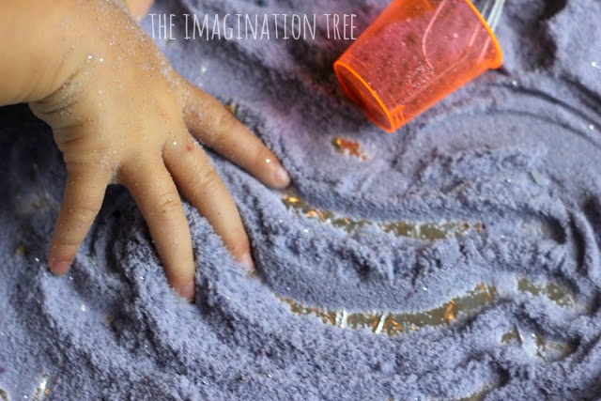

Building 3D models
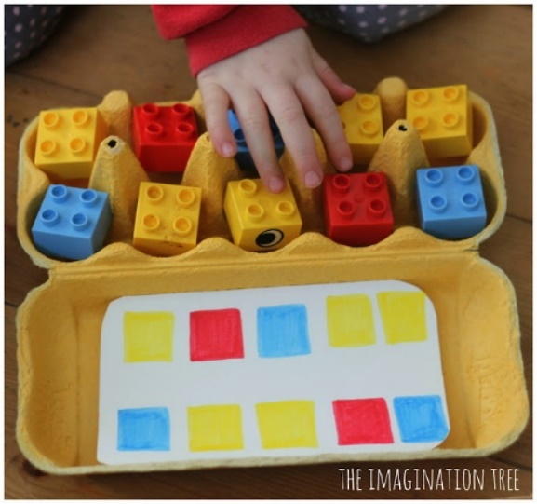
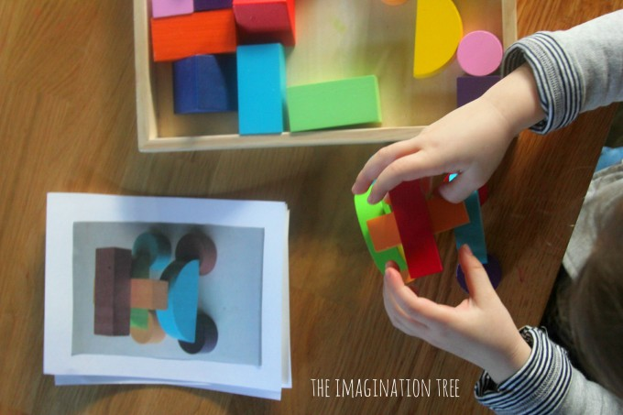

Patterning with Lego

Salt dough alphabet modelling
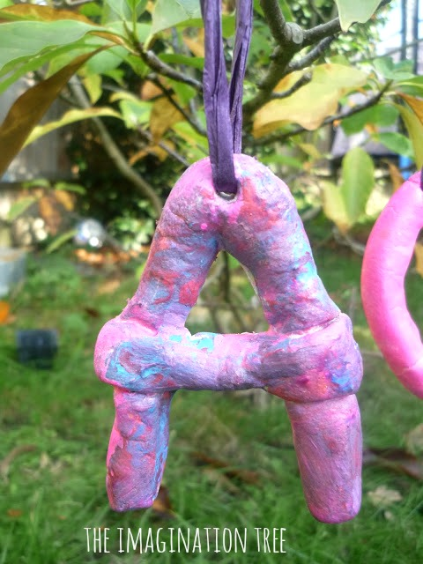

Stacking cups
Play dough cupcakes
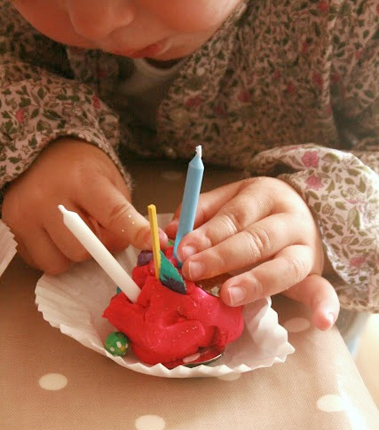

Painting with water
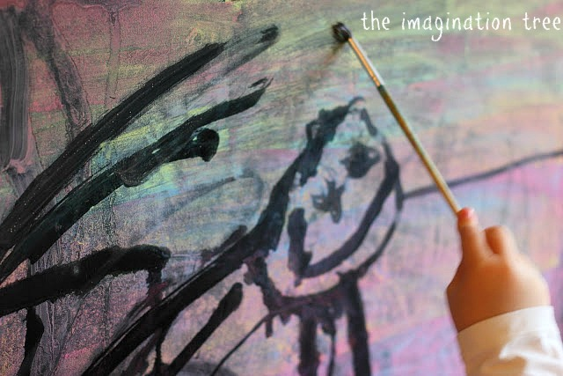

Finger paint printing
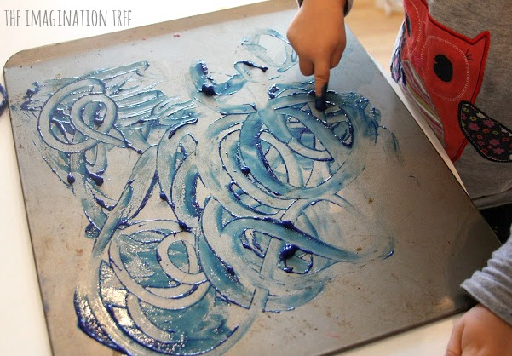
Painting with ear buds 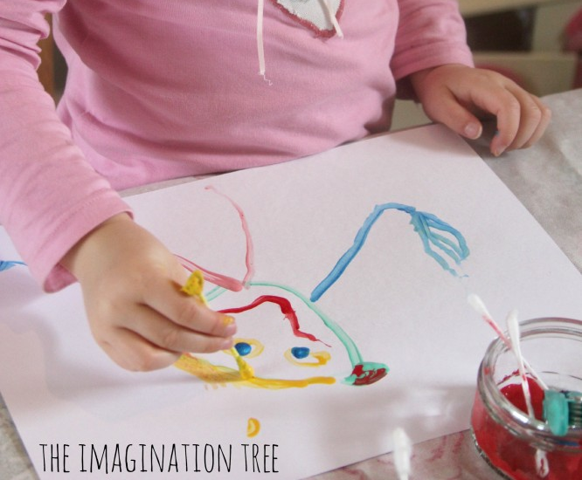

Tearing and sticking collage
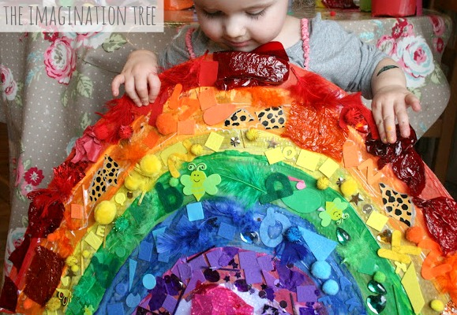

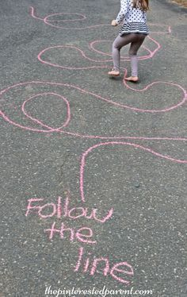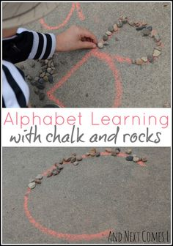

Fun with chalk outside

