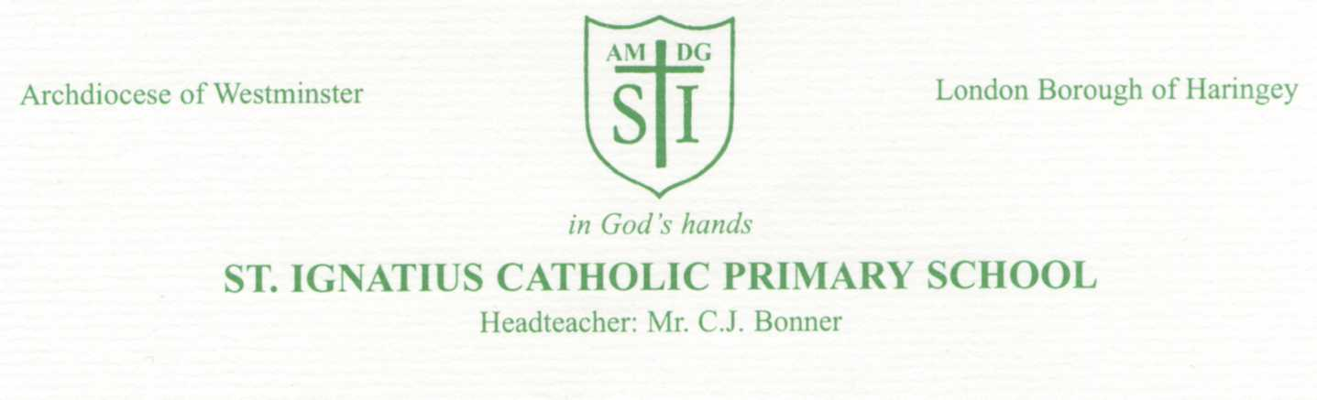
Anti-Bullying Week 14th-18^{h} November 2022
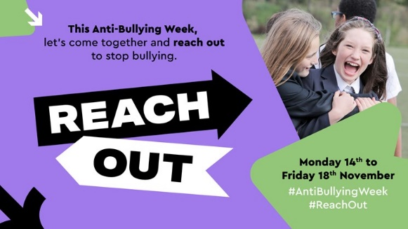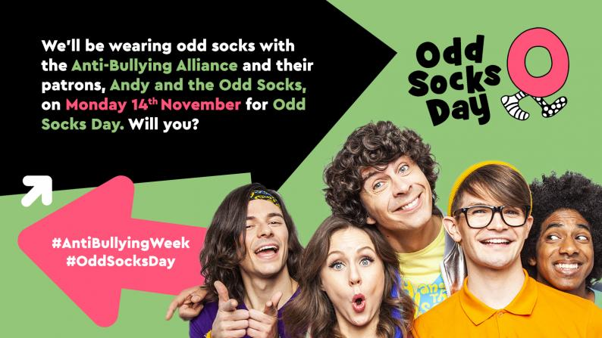
Monday 9th November 2020
Dear Parents/Carers,
As some of you may be aware, the week commencing Monday 14th November is national Anti-Bullying week. The theme this year is ‘Reach out!.’ At St Ignatius Catholic Primary School, we will spend the week reinforcing our anti-bullying stance (See it, Say it, Stop it!) and encouraging the pupils to discuss bullying issues and how to deal with them.
As a school we are pro-active in ensuring your child feels safe and is free from bullying. We do this by promoting positive behaviour, including good manners, kindness and how to be a good friend. During Anti-Bullying Week, your children will be taking part in activities to support their understanding of the different types of bullying, their rights to be happy and safe, and their responsibilities towards bullying. In addition.......
In order to show that, as a school community, we are standing together against bullying, the Anti-Bullying Alliance are asking children in schools around the country to wear ODD SOCKS next Monday (14th) to kick start Anti-Bullying week off. It is a chance for children to express themselves and appreciate individuality. The wackier the socks and the brighter the blue the better!
Further information on Anti-bullying week, ODD SOCKS DAY and WEAR BLUE DAY can be found at www.anti-bullyingalliance.org.uk
Yours Sincerely
Ms Lyons
