Art and Design at St Ignatius – Yearly Overview
 | Autumn | Spring | Summer
Year 1 | 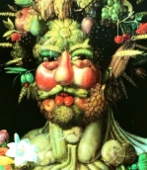  Techniques:  Drawing and collage  Craft/Artist study:  Giuseppe Arcimboldo  Outcomes:  Children will look at shape and colour as they learn to draw a variety of fruits. They will work towards creating their own collage portrait made up of drawings of fruit. | 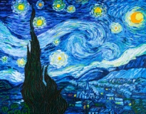  Techniques:  Painting  Craft/Artist study:  Vincent Van Gogh  Outcomes:  Children will work collaboratively on a class painting of a night sky. They will also paint their own still life of plants, trying out different painting techniques. | 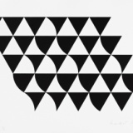  Techniques:  Pattern and printing  Craft/Artist study:  Bridget Riley  Outcomes:  Children will learn technique of printing using everyday materials as printing blocks. They will go on to create a pattern using chosen printing block and print onto a t-shirt with fabric paint.
 | Links: Body parts (Science), 2D shape (Maths) | Links: Observations of sky (Geography), parts of a plant (Science) | Links: 2D and 3D shape (Maths), animal pattern (Geography)
Year 2 | 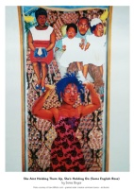  Techniques:  Painting and pattern  Craft/Artist study:  Sonia Boyce  Outcomes:  Children will draw and then paint a portrait of someone important to them, based on a photograph. They will look at pattern within the work of Sonia Boyce and other artists. They will use pastels to create their own patterns on paper, and then layer their portrait on top to create artwork inspired by Sonia Boyce. | 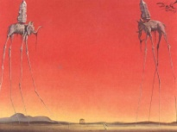  Techniques:  Sculpture  Craft/Artist study:  Salvador Dali  Outcomes:  Children will observe and discuss the work of the surrealist artist Salvador, looking at the dream-like scenes and bizarre or impossible situations depicted. They will design and create a clay sculpture, drawing inspiration from dreams they have had. | 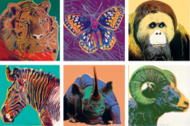  Techniques:  Drawing  Craft/Artist study:  Andy Warhol  Outcomes:  Children will do line drawing of their chosen animal. They will then choose 4 different colourways to colour a set of duplicated drawings, in the style of Warhol.
 | Links: Black history | Links: Everyday materials (Science) | Links: Animals around the world (Science)
Year 3 | 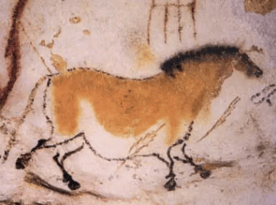  Techniques:  Painting and carving  Craft/Artist study:  Prehistoric cave paintings  - look at Pablo Picasso  Outcomes:  Children will use natural materials to experiment with making their own paints. They will contribute to a collaborative class cave painting. They will use natural tools to make cave painting style carvings in clay. | 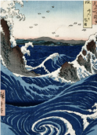  Techniques:  Drawing  Craft/Artist study:  Hokusai  Outcomes:  Children develop technique of drawing light and dark through studies of water droplets. They go on to do drawings of seascapes. Use coloured pencils/watercolour paints to add colour. | 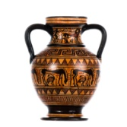  Techniques:  Sculpture  Craft/Artist study:  Ancient Greek pottery  Outcomes:  Children will learn the technique of making coil pots out of clay. They will go on to build and then decorate their own amphora using patterns they have studied as part of the unit.
 | Links: Prehistoric Britain (History) | Links: Coastal processes (Geography) | Links: Ancient Greece (History)
Year 4 | 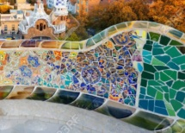  Techniques:  Drawing and mosaic  Craft/Artist study:  Antoni Gaudi  Outcomes:  Children will learn about and practise the art of mosaic, looking at how it was used in Roman times as well as by artists such as Gaudi. They will do drawn studies of animals. They will design and create their own mosaic using coloured card pieces. | 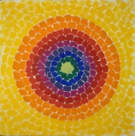  Techniques:  Painting  Craft/Artist study:  Alma Thomas  Outcomes:  Children will explore the idea of colour mixing, creating colour wheels and learning about primary, secondary and tertiary colours. They will look at the abstract work of Alma Thomas and her use of colour. They will go on to do their own painting of an element of the natural world in an abstract style. | 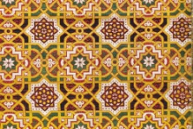  Techniques:  Pattern and printing  Craft/Artist study:  Islamic tiles  Outcomes:  Children will look at Islamic tiles, spotting common shapes and colours. They will draw/ paint possible designs. They will go on to make their own printing block using cardboard, string, and recycled materials before using this to make a 2 stage print with 2 different colours.
 | Links: Romans (History) | Links: Black history | Links: Early Islam (History), shape/symmetry/pattern (Maths)
Year 5 | 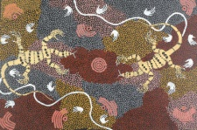  Techniques:  Painting  Craft/Artist study:  Aboriginal Dot Art/  Clifford Possum Tjapaltjarri  Outcomes:  Children explore the technique of dot painting, including contrasting colours and colour graduation. They look at Aboriginal artwork and paint their own work based on the story of the Creation. | 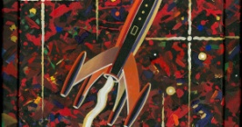  Techniques:  Drawing  Craft/Artist study:  Peter Thorpe  Outcomes:  Children will study the work of Peter Thorpe. They will draw with 2B pencils as well as charcoal, exploring how light and dark can be represented through lines and shading. | 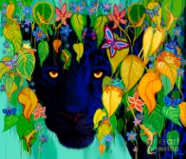  Techniques:  Mixed media  Craft/Artist study:  Nick Gustafson  Outcomes:  Children will experiment with mixed media and collage, evaluating the effects of various materials layered over a painted background. They will work towards creating a mixed media piece based on a rainforest animal.
 | Links: Creation (RE) | Links: Earth and space (Science) | Links: Rainforests (Geography)
Year 6 | 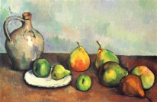  Techniques:  Drawing and painting  Craft/Artist study:  Paul Cezanne  Outcomes:  Children will study the paintings of Paul Cezanne, particularly looking at composition, colour and light. They will do observational drawings of their own arrangements of fruit, developing their use of shading to show direction of light. They will go on to produce a painting, mixing their own colour palette and using layers of colour to represent the solid forms. | 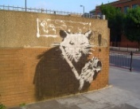  Techniques:  Painting/ graffiti/ stencilling  Craft/Artist study:  Banksy  Outcomes:  Children will look at graffiti as an art form, including the work of Banksy. They will go and observe some graffiti in situ. They will decide on a topic that is important to them and create stencils which convey a short message and a simple image. They will use a variety of paint effects to fill in stencil onto a board/paper/ shoebox for important keepsakes. | 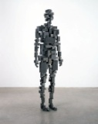  Techniques:  Sculpture/ found objects  Craft/Artist study:  Antony Gormley  Outcomes:  Child will look at a variety of sculptors and which materials they have used. They will look, in particular, at the work of Antony Gormley and his representation of the human form. The children will look at examples of found object art and will go on to construct a sculpture of themselves in robot form using recycled materials and found objects.
 | Links: Healthy living (Science) | Links: Local area (Geography) | Links: Robots (English)

