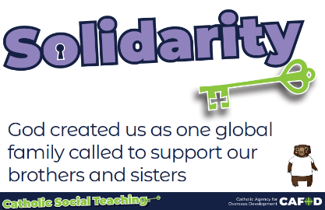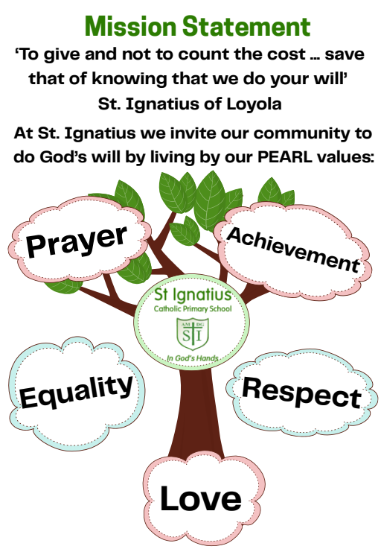 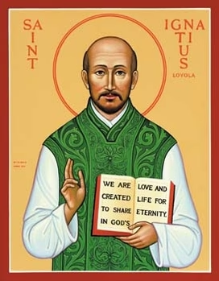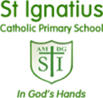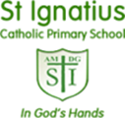

**Month of the Rosary**

October is the Month of the Rosary, a special time to reflect on the life of Jesus through prayer, with Mary, our Mother, guiding us. During this month, our pupils will have various opportunities to pray the Rosary. There will also be opportunities for parents and carers to pray the Rosary in school with us. We hope this helps you enjoy some meaningful and prayerful moments together, inspired by Mary’s example of faith and love.

**Macmillan Coffee Morning**

We invite you to our Macmillan Coffee Morning on Friday 26th September, as we come together to support those affected by cancer. In the spirit of Catholic Social Teaching, we show care and compassion for the vulnerable through our collective actions. Cake donations are welcome—please label any homemade items with a list of ingredients. As we are a nut-free school, no cakes containing nuts can be accepted. Thank you for your kindness and support!

**Catholic Life at St. Ignatius Newsletter: Autumn Term 1**

We would like to share with you some dates for your diary of upcoming Celebrations of the Word and assemblies for your information.

**Our Class Saints this year are:**

|  |  |
| --- | --- |
| Reception | Saint Francis of Assisi |
| Year 1 | Saint Thérèse of Lisieux |
| Year 2 | Saint John the Baptist |
| Year 3 | Saint Martin De Porres |
| Year 4 | Saint Josephine Bakhita |
| Year 5 | Saint Carlo Acutis |
| Year 6 | Saint Pope John Paul II |

**Feast Days**

**Saint Matthew (September 21)**

**Saint Padre Pio (September 23)**

**Saint Vincent de Paul (September 27)**

**Feast of the Archangels (September 29)**

**Saint Thérèse of Lisieux (October 1st)**

**Saint Francis of Assisi (October 4th)**

**Our Lady of The Rosary’s Feast Day (October 7th)**

**Saint Carlo Acutis (October 12th)**

**Saint Pope John Paul II’s Feast Day (October 22nd)**