

St Ignatius Primary School
Behaviour Policy

Status | Statutory
Date of policy adoption | NOVEMBER 2025
Date of policy review | DECEMBER 2027

St Ignatius Vision Statement

St Ignatius Primary School has a holistic approach to education, valuing all learning, both in and out of the classroom. We are an ‘Attachment Aware’ school which means we focus on
building positive relationships between children and staff and children with their peers.

We recognise that understanding our emotions is a key aspect of understanding and managing behaviour. Through Emotion Coaching and being attachment aware, both
children and adults are able to both manage their behaviour and to create an environment
that is conducive to learning. We understand that part of our role, in partnership with home,
is to help pupils to understand what is right and wrong …
Underpinning our Behaviour Regulation Policy is the belief that everyone can learn to self-manage/self-regulate their own emotions and behaviour. Through this we encourage reflective thinking and do not accept prejudice in any form. Ultimately, we wish to give our children confidence about their capacity to think for themselves and to make sense of their own lives and experiences, both within school and the world beyond.

As a Catholic school, we believe that everyone in the school community has the right to:
- Be treated with respect
- Work free without physical or verbal abuse
- Be able to work without distraction from others
- Be honest with each other and with ourselves
- Learn, grow and develop as confident considerate people
- Always do our best
- An environment cared for by all
- Listen to each other’s’ view without disruption from others
- Feel safe and secure
- Be happy
- Feel we all belong

Each child’s education is seen as a partnership between home and school.
This Behaviour Regulation Policy is presented as a balance of rights and responsibilities for children, parents and staff.

Children have a right to :
- Feel safe and secure in a school free from verbal or physical abuse
- Be listened to by the staff of the school and have any problems dealt with fairly
- Learn to play in a pleasant and attractive environment

Children have a responsibility to:
- Do their best in all their learning and co-operate with all members of staff
- Not threaten other children
- Listen to, respect and try to understand other people’s point of view
- Keep St Ignatius school a pleasant and welcoming place

Parents and Carers have a right to :
- Expect their children to be educated to their full potential within an equal opportunity environment

Parents and Carers have a responsibility to :
- Support the staff in their task of educating children by encouraging hard work and good behaviour
- Let school know of any problems that arise so that they can be dealt with

Teachers and other staff have a right to:
- Be free to teach and care for children to the best of their ability without disruption
- Expect co-operation and respect from children in their care
- Expect the support of parents and carers in carrying out their jobs

Teachers and other staff have a responsibility to :
- Ensure that they treat all children equally and ensure that they are valued, safe and secure at school
- Keep parents and carers informed of their children’s progress and consult them if any problems arise.

Policy Aims and Objectives

Our school is committed to the emotional mental health and well-being of its staff, pupils students and parents/carers. We wish to work towards this in all aspects of school life, and to provide an ethos, environment and curriculum that supports the social, emotional and mental health of the whole school community. It is acknowledged that members of the school community may have very different parenting experiences and views on behaviour. However, the aim of our Attachment Aware Behaviour Regulation Policy is to bring us all together to adhere to some basic key principles and practices that reflect our school ethos.
St Ignatius Primary School treats all children with unconditional respect and has high expectations for both adults’ and pupils’ learning and social behaviours. We understand that positive behaviour can be taught and needs to be modelled. We understand that negative behaviour can signal a need for support which we will provide without diluting our expectations.
We have an approach to learning that builds security through recognising strengths in learning and celebrates success leading to good classroom relationships. Our systems and structures make a large school personal, providing the scaffolding for good learning and for independence and character building. Our ethos builds relationships by recognising every child, building self-esteem and self - awareness.

We aim to:

• maintain a caring, orderly community in which effective learning can take place and where there is mutual respect between members
• help children develop a sense of worth, identity and achievement
• help all children to become self-disciplined, able to accept responsibility for their own actions and make positive choices
• develop in all children the ability to listen to others; cooperate and to appreciate other ways of thinking and behaving

We hope to achieve these aims through a policy based on rights, responsibilities and respect. Praise, rewards, privileges, and positive role-modelling support the development of self-discipline and the capacity to make positive choices.

Guiding Principles

- Pupils learn best in a calm, ordered environment
- Rules and sanctions need to be age- appropriate
- Positive reinforcement must be the key factor in managing behaviours
- Partnership between home and school
- Adults must model positive relationships

To successfully implement this policy and uphold its key principles there is a need to consider :

1.The promoting and embedding of our school’s PEARL values of
- Prayer,
- Equality
- Achievement
- Respect
- Love

These values are at the centre of all our behaviours in school.

2. The establishing of our new Growth Mindset programme as the foundation to guide our behaviours as Learners.

This initiative also refers to:
- The Power of Yet
- Proud Cloud
- Mojo and Dojo

- Whole school Golden Goals that are shared with and understood by the children at an age appropriate level ( Appendix A )

- Reward and consequence procedures that are linked directly to the Golden Goals

- Linking our Behaviour Policy to other school policies, in particular the Equal Opportunity Policy, Anti-Bullying Policy, PSHE Policy and Inclusion Policy.

Policy Statement

This policy has included input from: members of staff, representatives from the governing body,
parents and carers, pupils our school nurse, our local authority colleagues, our educational psychology services and counselling services.

Foundation Stage | Key Stage One and Key Stage Two
The Golden Goals  - Use kind words and actions  - Listen to my teachers and do what they ask me to do  - Look after and share the toys and books | The Golden Goals  - To follow our PEARL values in class and school  - To be kind, caring and helpful to each other.  - To look after school property  - To be a good learner  - To listen when other people are talking  - To follow instructions given by an adult
Rewards for achievement  Praise  Stamps  Stickers  Special awards  ( watch film, choosing time, computer games, outdoor games) | Rewards for achievement  Praise  Dojo rewards – individual /group / class  House points – House Teams  Moving up through Stay on Green colour chart  Stars in the jar
Consequences  Children reminded of appropriate behaviour  If repeated, the child is reminded of the consequences  Children withdrawn to the ‘Thinking chair’ for N minutes  (Time to be decided at the discretion of the staff based on the circumstances, needs and abilities of the child)  Child to be reminded of appropriate behaviour before leaving chair  Staff to speak with parents and carers if the inappropriate behaviour persists  SENCO to be involved to support and develop strategies with staff and parents | Consequences  Moving down through Stay on Green colour chart  Reflection sheets ( Y5 Y6)  Target Book  Missed play time  Meetings with parents / carers  Pastoral Support Plan written  Red Letters sent home  Staff may keep a book to monitor identified pupils  Staff to speak with parents and carers if the inappropriate behaviour persists  SLT to be involved to support and develop strategies with staff and parents

Stay On Green

Stay on Green is a visual Behaviour Management system centred on promoting positive behaviour.
Each class has a visual chart with all the pupils individually named.
Each pupil has an individual pocket.
Each day is a fresh start and all pupils will begin on a green card.
In each case the pupil will go to the board to adjust it to reflect their behaviour.

The aim is for children to move up through the system where positive behaviour (following a Golden Rule) is recognised and rewarded. However, poor behaviour (i.e. breaking a Golden Rule) and subsequent poor behaviours will result in sanctions as outlined below.

The system will be explained and visually displayed next to or near the Stay on Green chart
(Appendix B)

 | Outstanding behaviour
 | Very good behaviour
 | Good behaviour
* | *Verbal warning for poor behaviour ( not following the Golden Rules)
 | Repeated poor behaviour after first warning
 | Continued poor behaviour – pupil sent to another class
Repeated occurrence after return to class – pupil sent to SLT
Parents may be told of concerns

A Senior Leader may be involved with discussions with the pupil at any stage of the sanction process.
* What constitutes ‘poor behaviour’ will be decided at the discretion of the member of staff responsible for the pupil with a clear reference to the Golden Rules.
If the pupil continues to disregard the Golden Rules, parents and carers may be involved alongside a member of the Senior Leadership Team in setting targets and finding a positive outcome.

A pupil who receives a yellow, blue or red card will have opportunities to return to green and move back up the reward system, demonstrating positive behaviours.

A pupil on a silver or gold card will receive their reward for this achievement. However, they
may move back down through the sanction system, if seen to be demonstrating negative behaviours.
If this happens, they will retain their silver or gold card for that day – the yellow, blue or red card will just sit in front of it on the Stay on Green board.
At the end of each day, the chart will be discussed with the pupils. This is an essential part of the system where pupils receive positive reinforcement from staff if they have ‘stayed on green’ or received a silver or gold card.
The charts will then be wiped clean and cards returned to their original pockets so that all pupils start the following day as a new, fresh start on a green card.

Fast Track System

In circumstances where negative behaviour is considered to be ‘extreme’ ** and / or endangering the pupil or other pupils – a pupil may be fast-tracked through the sanction system/ moved to red immediately and very likely will be removed from the situation in which the negative behaviour occurred.
This applies throughout the school day.

A member of the Senior Leadership Team will be involved at this stage.

** What constitutes this level of behaviour will be decided at the discretion of the member of staff responsible for the pupil.

Once the pupil has been removed from the situation, there will be a ‘time-out’ period – the length of which will be at the discretion of a member of the Senior Leadership team.

During this period, the pupil will be set work which he / she will undertake in another part of the school under the supervision of a member of staff. Pupils are not to be left outside classrooms unsupervised.

These arrangements will be reviewed on a daily basis.

Red Letters

Pupils who have been ‘fast-tracked’ through the Behaviour Management system are likely to receive a ‘Red Letter’ – this informs parents formally of the concerning behaviours, which may lead to a fixed term exclusion of the pupil.

Exclusions

If inappropriate behaviour persists over a period of time (Parents will have received Red Letters informing them of this), it is likely the pupil will be excluded for a fixed term period.

Example of such inappropriate behaviour include:
- Damage to property
- Threats of violence towards pupils or adults
- Intimidating behaviour towards pupils or adults
- Acts of violence or physical aggression
- Persistent refusal to follow adult instructions
- Any other actions which are likely to result in an increased risk to the health and safety of the pupil or other pupils.

For an isolated incident of a serious and extreme nature, permanent exclusion will be considered by the head teacher.
An example of such extreme behaviours, would be bringing a weapon or an object capable of causing injury on to school premises or extreme violent / aggressive acts.

Additional Individual Rewards

Our ‘Stay on Green’ system will be the dominant procedure to manage behaviour of pupils in and out of the classroom. However, for greater effectiveness, there will be a need to supplement this system with additional rewards and incentives.
The electronic Dojo point system will operate throughout KS1 and KS2 to compliment the Stay on Green system.

Whole Class Rewards

There will also be times when there will be a need to reward the whole class for collectively following the Golden Rules.
The achievement of individuals / groups towards a shared goal can be a powerful incentive for encouraging positive behaviours.
In Key Stage One and Two, classes will continue to use the ‘Stars in the Jar’.

Each class will have to work together to achieve an agreed number of stars in order to be given a class reward. The number of stars to be collected will be decided by the class teacher depending on the age of pupil and the appropriate length of time given to achieve this target. How often a Star in the Jar will be awarded will be decided by the class teacher in order for whole class motivation to be kept high and effective.

The stars may be given to the whole class for achievements such as
- good lining up
- productive whole class work sessions
- cooperative whole class behaviour

These incentives may also be given to groups of pupils who have demonstrated positive behaviours and learning to earn a star for their class.
Class teachers can set up a variety of groups within their class Dojo system, to recognise these groups.

Rewards for achieving whole class targets could be :
- ‘n’ minutes of free choice activities
- ‘n’ minutes of ‘golden time’ / extra play / organised game
- a quiz or game

Beyond the ‘Stay on Green’ system, the individual raffle tickets/ Dojo points/ House points and whole class ‘Star in the Jar’ incentive systems, teachers may also like to continue to give stickers in books or on pupils’ clothing alongside verbal praise.
For some pupils, with specific social, emotional or behavioural needs, they may benefit from having a very specific, personalised reward system in place.
Sweets and chocolates must not be given as rewards to the pupils.

For a member of staff to reward a pupil/ group of pupils following a Golden Rule, a decision may be made, at times in consultation with the pupils, whether they move up through the ‘Stay on Green’ system or, alternatively, they receive a sticker/raffle ticket/ Dojo point/ group point /House point to reward their achievement.

In order for a whole school Behaviour Policy to be implemented effectively and successfully across the school, there is a need for consistency across the year groups. Any additional rewards or sanctions which members of staff would like to put in place with their class, will need to be discussed with the Senior Leadership Team beforehand.

Lunchtime Rewards

Pupils will also have opportunities to obtain rewards during the lunchtime period.
School Meals Supervisory Assistants (SMSAs) will reward positive behaviours such as co-operative play, turn-taking and friendship support.
A new lunchtime incentive programme will be introduced in September 2019.

Assembly Rewards

Once a week pupils will take part in an Achievement Assembly.
Each class teacher will nominate a pupil to receive a certificate and give reasons for their choice.
These include a Teacher’s Award ( PEARL), Writer’s, Mathematician and Handwriting award.

Dojo winners will be selected (one prize per class) and the selected pupil will receive a PEARL pencil.

Teachers will be required to keep records of pupils receiving certificates / awards during the course of the term / year. It is important that staff keep these records to ensure that all pupils get an opportunity throughout the year to receive a certificate / win a raffle prize. No pupil should end the year without having won a certificate. There may be some weeks that a member of staff awards a certificate to more than one pupil.

Certificates for achievement in other areas of school life will also be presented at this assembly e.g. swimming, sports events, attendance.

Linked policies

Please view this policy together with the following policies:
Teaching and Learning | SEND Policy | Cyber-bullying policy
Anti-Bullying | PSHE Education Policy
Health and Safety | Equality Policy
Mental Health Policy | Restraint Policy
Safeguarding Policy | E-safety policy

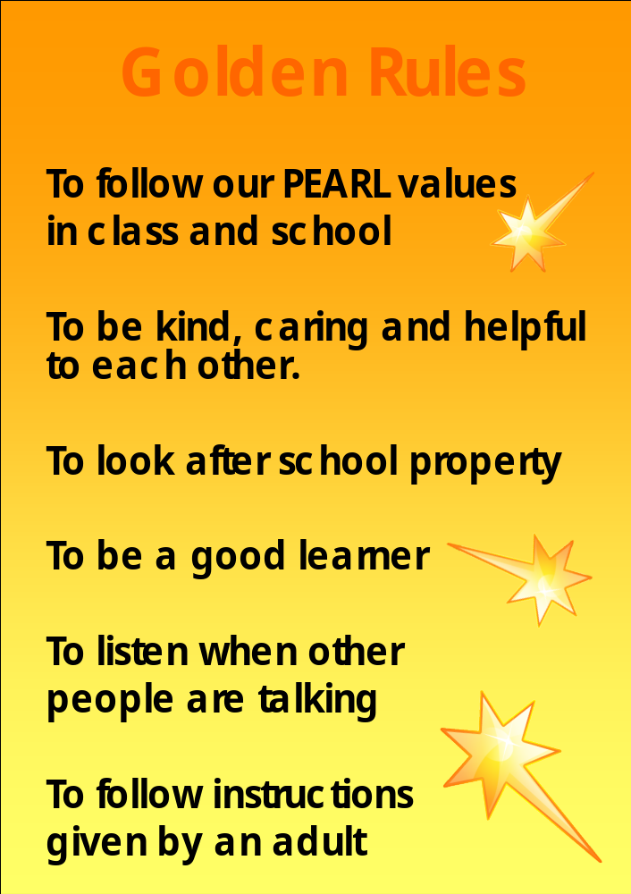

Appendix B

Chart displayed in classroom

 | My behaviour is outstanding
 | My behaviour is very good
 | My behaviour is good
* | * My teacher has given me a verbal warning for doing something which was not following the Golden Rules
 | My behaviour continues to be poor after the first warning
 | My behaviour continues to be poor after the second warning and I must go to another class
 | My behaviour continues to be poor after I return to class – I must go to Mr Bonner, Ms Curran or Ms Taylor and my parents may be contacted

