Bold Patterns
This week we are learning to create large patterns with bold, contrasting colours. Click on the link below and see how it is done.

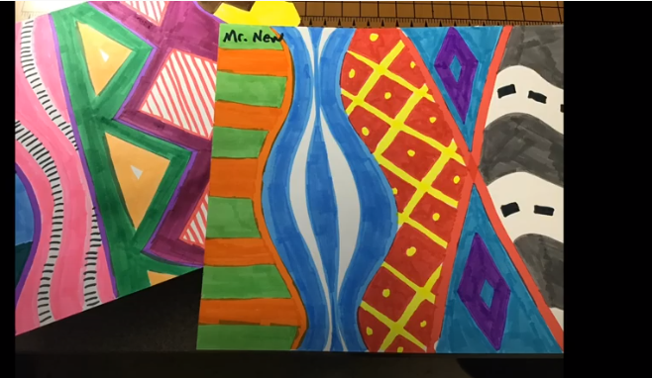

https://www.youtube.com/watch?v=LqM_G_qbmr8

