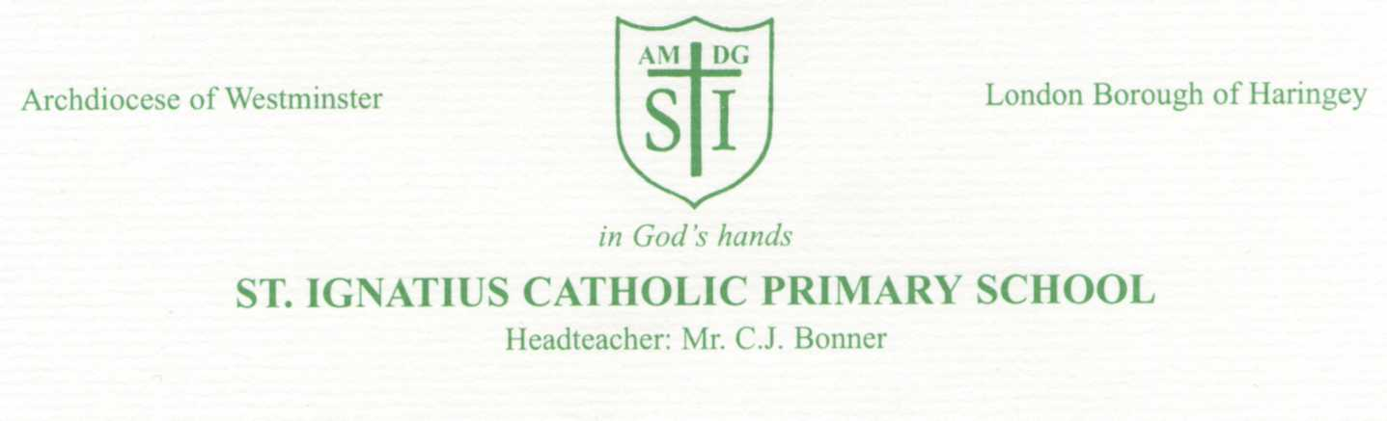
Christmas at St Ignatius
Monday 3^{0th} November 2020
Dear Parents/Carers,
We are very pleased, that despite the challenging times, our school and staff will be hosting the following annual festivities during December. We wanted to share with you, some of the plans we have in store for the children.
The children will also be learning to use sign language to sign some of the traditional carols/songs. We hope to share these with you on Class Dojo.
Wednesday 2nd December | Building Christmas post boxes will be available so that children can bring in named Christmas cards (with classes) and post them in the box. Please no cards after Tuesday 15th December. The cards will then remain in quarantine until they are handed out on Thursday 17th December.
Monday 7th December | Early Years and KS1 children will be filming a special Nativity tableau on this day. Teachers will be sending out information about what the children will need to wear. We will then share with you what we have recorded on 14th December.
Wednesday 9th December | Christmas Dinner- See menu over the page!  If you would like your child to have a Christmas Dinner please let the office know.
Thursday 10th December | Christmas with Dickens-Online Pantomine- (Globe Players)  @9:30am
Friday 11th December | Christmas Jumper Day!  Remember- to be ECO friendly- try to recycle or upcycle a festive jumper.  Christmas Movie afternoon- 1-3pm.  The children will each get a sweet treat to enjoy during the movie.
Monday 14th December | Early Years and KS1 Nativity Book will launch on our school website. KS2 will also be filming some Christmas Readings and songs by signing (British Sign Language).
Tuesday 15th December | Quizmas will be held in school.
Wednesday 16th December | Father Christmas Visit- Early Years/KS1
Thursday 17th December | Class Christmas Parties

We are asking parents to send in a donation of £3.00 to contribute towards these events for the children. We will also be purchasing a class present for the children to enjoy in class. Please send in your contribution of £3.00 in a labelled envelope to the class teacher.
Thank you for your continued support.
Miss Taylor

