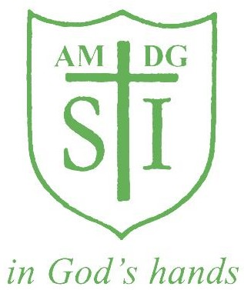

St Ignatius Catholic Primary School
Code of Conduct for Employees

Policy Originator | St Ignatius Primary School
Person /Governor Responsible | Lourdes Keever
Last reviewed | September 2017
To be next reviewed | September 2019
Signed

