Computing Intention at St Ignatius | 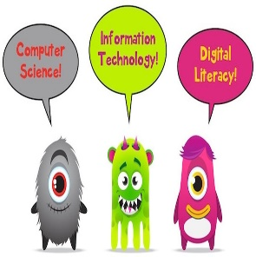
It’s not that we use technology, We live technology! Godfrey Reggio
Intent

Technology is everywhere and will play a pivotal part in students' lives. Therefore, we aspire to model and educate our pupils on how to use technology positively, responsibly and safely. We want our pupils to be creators not just consumers and our broad and ambitious curriculum reflects this by equipping them to use technology, computational thinking and creativity that enable them to understand become active participants in the digital world. It is now more important than ever that children understand how to use technology positively, responsibly and safely, and that they see good models of this.

By the end of EYFS, pupils will:

Be able to explore technology in a safe and often child-led way developing a familiarity with equipment and vocabulary allowing them to have a strong start in Key Stage 1 computing and all that it demands. Computing in EYFS is centred around play-based, unplugged activities that focus on building pupils’ listening skills, curiosity, creativity and problem solving. Pupils will be able to take a photograph with a camera or table, play games on the interactive whiteboard or on iPads, watch video clips and listen to music.

By the end of Key Stage 1, pupils will:

Be able to identify technology and how its responsible use improves our world in school and beyond. Through creating media, our pupils can digitally paint, write and format text, capture and change digital photographs and create musical compositions. Pupils will also be able to create and debug programs using logical reasoning along with designing algorithms and programs. Pupils will be able to group and label data and represent information using simple pictograms.

By the end of Key Stage 2. pupils will:

Understand the interrelated networks within computers, including the World Wide Web and how the Internet can be used to communicate and be searched to find information. Pupils will develop the skills to create and develop stop-frame animations, edit photos, audio and videos, create vector drawings and 3D models and be able to design their own webpages. Programming skills will be further developed through selection, variables in games and sensing. Pupils will develop their data and information skills further through their creation and use of flat-file databases and spreadsheets. Children will have gained key knowledge and skills in the three main strands of the National Curriculum for Computing (2014). These strands are: computer science ( programming and understanding how digital system work), information technology (using computer systems to create, store,
retrieve and send information) and digital literacy (evaluating digital content and using technology safely and
respectfully).

Our knowledge- engaged curriculum enables children to understand how computers and computer systems
(such as the internet) work, and how they are designed and programmed. It ensures they know what to do if
they have concerns about anything they encounter online, and how to be safe, responsible and respectful
when using the internet. Equally, our offer provides many opportunities for learners to apply their evolving
knowledge imaginatively, becoming fluent and creative in their mastery of computing. The depth and breadth
of our coverage aims to provide all our children with a solid grounding for future learning and the ability to
become active digital citizens in the modern world.

Online Safety is a key focus in our curriculum. At St Ignatius Catholic Primary School – we ensure our children are
taught the importance of safe internet use (at home and at school) during computing lessons and through
whole-school ‘Safer Internet’ focus weeks in September and February, where there is a school assembly and
class-based activities. Within Computing we also teach children the skills they need to be able to question what
they see on the internet and make their own judgements; an increasingly important aspect of being a digital
citizen in the time of ‘fake news’. Children have opportunities to use IT outside the timetabled lesson slot as it is
embedded across the curriculum. We subscribe to National Online Safety which supports the teaching of
online safety and provides vital training for staff. We have recently been accredited ‘Certified Status’ as an
National Online Safety school. Pupils and staff complete user agreements each year and our Online Safety
page on the school website provides a great deal of information, support and resources for parents.

Implementation

At St Ignatius, computing we use the ‘Teach Computing’ scheme of work which ensures National Curriculum coverage, as a starting point for the planning of their computing lessons.
The key knowledge and skills that must be taught within each unit have been identified and carefully mapped to support the progression of children’s learning across the primary phases. Building towards mastery at the end
of key stage objectives from the National Curriculum. Freedom for teachers to develop and adapt computing units within the framework of the progression map leads to rich links with engaging contexts in other subjects and topics, while still ensuring systematic coverage of objectives. Cross-curricular links with the foundation subjects have been suggested on the year group overview.

Teach Computing also recognises the ‘spiral’ nature of progression within computing: new knowledge, skills and understanding within each of the strands of the subject build on what’s gone before. Our children begin their journey with technology in Early Years, with access to iPads and Bee-Bots. Teachers facilitate children’s curiosity with challenges and modelling of how to use the equipment carefully and safely. In KS1 children continue their journey with the Bee-Bots, using them more precisely. They learn how to program a Bee-Bot to reach a destination and to debug when something doesn’t work out the way that was planned. Coding then progresses from Bee-Bots onto a computer-based programs where children learn how to program a variety of sprites.

An overview of each unit’s key vocabulary, key knowledge and outcomes is shared with parents on the termly curriculum brochures. The children also have knowledge organisers which pupils can use to reinforce key vocabulary and understanding. After completing a unit, learners complete a brief key knowledge quiz to assess their retention and understanding of core facts and concepts.

The implementation of our new progression framework in computing ensures a balanced coverage of the three computing strands (computer science, information technology and digital literacy). The children work on the three strands each year. As they progress through the school, children build on their prior learning within each strand, covering new or deeper knowledge and developing their technical skills. The relevant, context-embedded computing experiences through which this knowledge-engaged curriculum is taught will benefit learners in secondary school, further education and future workplaces.
From research methods, use of presentation and creative tools and computational and critical thinking, computing at St Ignatius gives children the building blocks that enable them to pursue a wide range of interests and vocations in the next stage of their lives.

E-Safety and Digital Citizenship

A key part of implementing our computing curriculum was to ensure that safety of our pupils is paramount. We take online safety very seriously and we aim to give children the necessary skills to keep themselves safe online. Children have a right to enjoy childhood online, to access safe online spaces and to benefit from all the opportunities that a connected world can bring them, appropriate to their age and stage.

Children build online resilience through the use of the ‘Project Evolve – Education for a Connected World’ framework. The framework aims to support and broaden the provision of online safety education, so that it is empowering, builds resilience and effects positive culture change. The objectives promote the development of safe and appropriate long-term behaviors, and support educators in shaping the culture within their setting and beyond.

A key part of implementing our computing curriculum was to ensure that safety of our pupils is paramount. We take online safety very seriously and we aim to give children the necessary skills to keep themselves safe online. Children have a right to enjoy childhood online, to access safe online spaces and to benefit from all the opportunities that a connected world can bring them, appropriate to their age and stage.

Children build online resilience through the use of the ‘Project Evolve – Education for a Connected World’ framework. The framework aims to support and broaden the provision of online safety education, so that it is empowering, builds resilience and effects positive culture change. The objectives promote the development of safe and appropriate long-term behaviours, and support educators in shaping the culture within their setting and beyond.

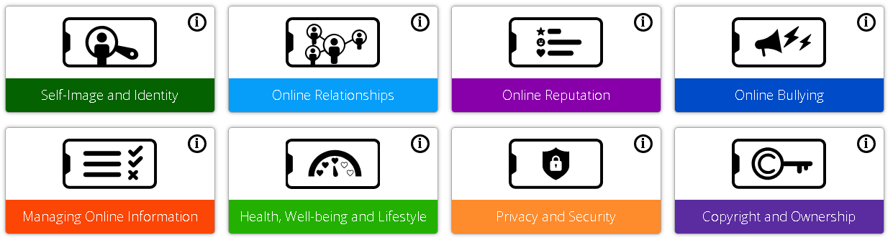

Within each year group topics include:

Self Image and Identity - This strand explores the differences between online and offline identity beginning with self-awareness, shaping online identities and media influence in propagating stereotypes. It identifies effective routes for reporting and support and explores the impact of online technologies on self-image and behaviour.

Online Relationships - This strand explores how technology shapes communication styles and identifies strategies for positive relationships in online communities. It offers opportunities to discuss relationships, respecting, giving and denying consent and behaviours that may lead to harm and how positive online interaction can empower and amplify voice.

Online Reputation - This strand explores the concept of reputation and how others may use online information to make judgements. It offers opportunities to develop strategies to manage personal digital content effectively and capitalise on technology’s capacity to create effective positive profiles.

Online Bullying - This strand explores bullying and other online aggression and how technology impacts those issues. It offers strategies for effective reporting and intervention and considers how bullying and other aggressive behaviour relates to legislation.

Managing Online information - This strand explores how online information is found, viewed and interpreted. It offers strategies for effective searching, critical evaluation of data, the recognition of risks and the management of online threats and challenges. It explores how online threats can pose risks to our physical safety as well as online safety. It also covers learning relevant to ethical publishing.

Health Well-being and Lifestyle - This strand explores the impact that technology has on health, well-being and lifestyle e.g. mood, sleep, body health and relationships. It also includes understanding negative behaviours and issues amplified and sustained by online technologies and the strategies for dealing with them.

Privacy and Security - This strand explores how personal online information can be used, stored, processed and shared. It offers both behavioural and technical strategies to limit impact on privacy and protect data and systems against compromise.

Copyright and Ownership - This strand explores the concept of ownership of online content. It explores strategies for protecting personal content and crediting the rights of others as well as addressing potential consequences of illegal access, download and distribution.

To help with the implementation of the computing curriculum we have a variety of hardware available, including;

- Laptops
- Ipads ( a set of 30 in each building which staff book out)
- ICT suite with new desktop PC’s to be used

All pupils in KS2 have a J2E log in for the J2E platform.

Impact

Our approach to the curriculum provides fun, engaging and meaningful learning for all pupils, in which the
children understand not only the content that is taught but the opportunities offered to them by their
computing education, enabling them to be creators and change-makers in our digital world. Evidence of progress is collated in a number of ways. Work is collected in named school files on the server where pupils save their work. Examples of the children’s work is saved on laptops and printed out to be put in the class floor book. Children will see the digital world as part of their world, extending beyond school, and understand that they have choices to make. They will be confident and respectful digital citizens who are able to apply the British values of democracy, tolerance, mutual respect, rule of law and liberty when using digital systems in their digital happy and healthy digital lives.

