Cooking Challenge:
Chicken Fajitas
Have fun as a family following this easy recipe for delicious chicken fajitas. This recipe makes enough for 4 or 5 people. Things to remember:
- Ask a grown-up if you can cook
- Wash your hands before you begin
- Be very careful if you are using a knife to chop
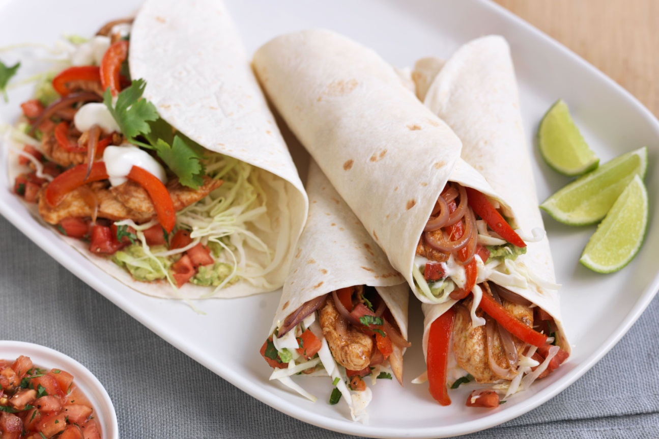
- Make sure you follow the guidance about jobs for grown-ups and children.
Ingredients:
4 chicken breasts
Ground cumin
Ground coriander
Smoked paprika
Juice of 2 limes
2 cloves of garlic, crushed
1 red onion, sliced
2 peppers, sliced
10-12 mushrooms, sliced
Cheddar cheese (or similar)
Fresh coriander
Sour cream
Tomatoes
Avocado
Tortilla wraps

Method:
1. Grown-ups: Chop the chicken into chunks and mix in a bowl with the cumin, coriander, paprika, juice of 1 lime, crushed garlic, onion, peppers and mushrooms. You can leave out the peppers and mushrooms if your children don’t like them. Cover and put in the fridge for at least two hours.

2. Children: With guidance, chop some tomatoes using a cutlery knife and grate some cheese.

3. Children: Make a guacamole by squeezing or spooning the avocado into a bowl and using a potato masher to mash it. Stir in the juice of the other lime and some black pepper with a spoon. Lime juice can sting so grown-ups may want to squeeze them for younger children.

4. Grown-ups: Heat a little olive oil in a frying pan and pour the contents of the chicken bowl into the pan. Cook until the chicken chunks are cooked through (approx 10 minutes).

6. Children: Put the grated cheese, fresh coriander, sour cream, tomatoes and guacamole into separate bowls to put on the table.

7. Grown-ups: Heat the tortillas according to the pack instructions and put the cooked chicken mix in a bowl. Show children how to fill and roll their tortilla.

8. Children: Fill your tortilla with the toppings you like, then roll and eat!

