Cooking Challenge:
Frozen banana lollies
Have fun following this easy recipe for your own banana lollies. They are perfect to have in the freezer, ready for a hot day. Things to remember:
- Ask a grown up if you are allowed to cook
- Wash your hands before you begin
- Tidy up when you have finished
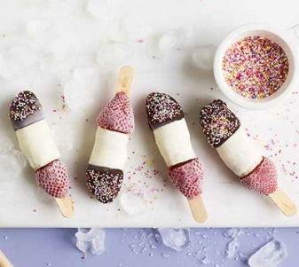
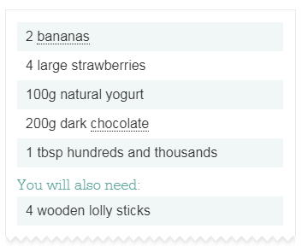

1. Peel the bananas and chop them into 4 chunks. Thread a strawberry and then 2 pieces of banana onto each lolly stick (you could use wooden skewers instead).

2. Lay onto a baking tray and put in the freezer for 1 hour.

3. Dip each lolly into the yoghurt, so that just the pieces of banana are covered. Then put them back on the tray and freeze again.
4. Melt the chocolate in the microwave for 30 second blasts, stirring after each blast. Dip the end of each lolly into the melted chocolate, just covering one piece of banana, and then sprinkle over the hundreds and thousands.
5. Put the lollies back into the freezer until you are ready to eat them!

