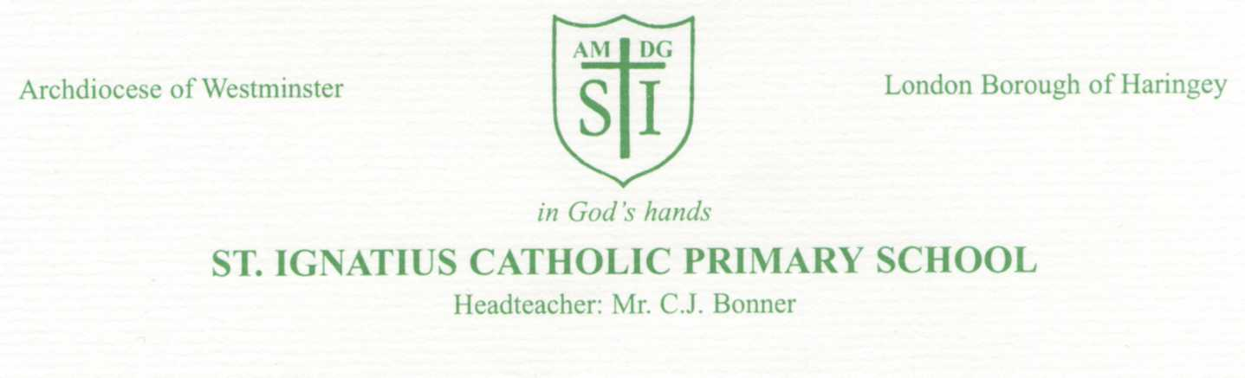
19th March 2020. Dear Parents/Carers,
Re: School Closure - Coronavirus
As you are probably aware, as part of the country’s ongoing response to coronavirus, the Department for Education yesterday announced that all school settings are closing at the end of the school day on Friday 20th March. This means that we will be closed until further notice.
Key Workers
Presently, key workers have been defined by the government as NHS staff, police and supermarket delivery drivers who need to be able to go to work to support the country’s fight to tackle coronavirus. Thank you to those parents who have responded to our previous email. We will be in contact soon.
Vulnerable Children
Vulnerable children include those who have a Social Worker and those with an Education, Health and Care Plan (EHCP) – a legal document that describes a child’s special educational needs and the support they require. If you fall into this category a member of staff will contact you shortly so we can agree the best way to support you in these challenging times.
Children who receive free school meals
More information about the government free school meal scheme will be published on our website as soon as possible. Thank you for your patience.
Home Learning
Your child has been given a log-in and can now access a number of on-line learning activities on the school website. A suggested weekly learning timetable will be uploaded by Monday for each year group on the online learning pages. While the school remains closed, please continue to check for updates via text message, twitter and our website. Please continue to check these regularly. We will also continue to check the guidance for educational settings on a daily basis and share any important and/or relevant information with you.
The whole school community are in our thoughts and prayers at this difficult time and I ask that you, in turn, pray for the most vulnerable in our society. Please pray too for the dedicated staff in our hospitals, medical centres and surgeries throughout the country.
God bless.
C.J.Bonner
Mr C.J. Bonner
Headteacher

