Courage
The word ‘courage’ comes from the Latin word for ‘heart’ and it basically means that you are brave. Courage is a gift of the Holy Spirit – it makes us strong. Putting our faith in Jesus and his teachings gives us the courage to do the right thing. It takes courage to stand up for the truth. Courage helps us to do many great things: to resist temptations, to overcome obstacles and to face our fears.

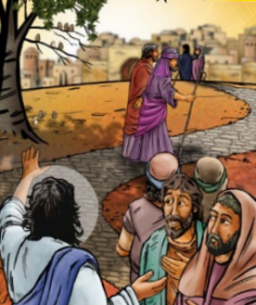
Adapted from Matthew 10:26-33

Jesus said to his disciples, “Do not be afraid. What is now hidden will be made known. What you have heard said in whispers, I want you to tell out loud to everyone. And do not be afraid of people; they cannot harm your soul. Think more about God who has power over both body and soul. Aren’t two sparrows cheap to buy – sold only for a penny? Yet not one sparrow falls to the ground without your Father knowing about it. So do not be afraid. You are worth much more than lots of sparrows. If anyone speaks up for me in front of other people, then I will speak up for that person in front of my Father in Heaven.”

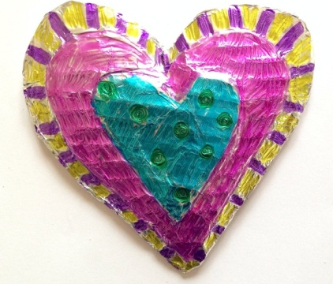
Activity:
We all need courage at times in our lives. Why not make a heart keepsake to remind you to be brave? Cut out a heart shape from some card and decorate it beautifully, then put it in your pocket. Next time you feel worried about doing something, put your hand in your pocket and feel the heart – it will remind you to be courageous and do what is right.

Prayer:
Challenge
Think about a time when you have used your courage to do something you were worried about. How did you feel afterwards?
Is there something new that you want to do but you feel scared? Say a prayer, take courage and try it!

Dear Lord Jesus,
We ask that you will give us the courage to do and say what is right, even when we are afraid. Please help us to remember that we can always put our faith in you.
Amen.

