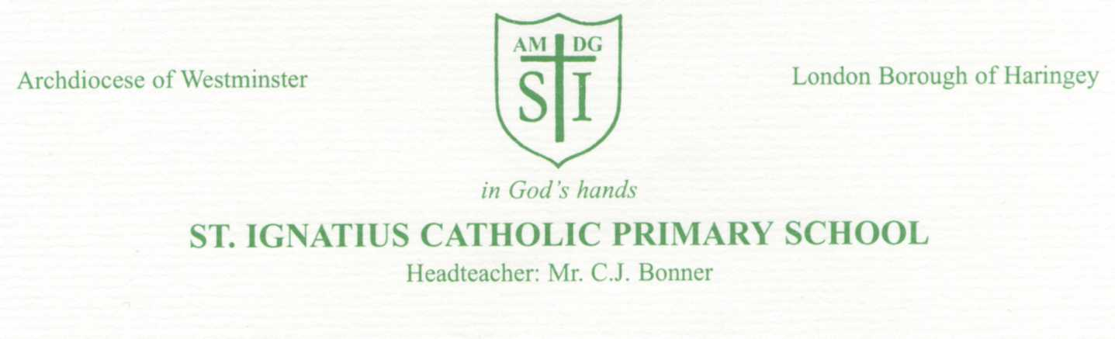
Notification: Positive cases of coronavirus COVID – 19 in your child’s class- Reception

Date: 27th January 2022

Dear Parents and Carers,

Case of COVID-19

We have been informed that individuals within your child’s class have tested positive for coronavirus (COVID-19).

What should you do now?
- Your child can continue to attend school if they are feeling well and showing no symptoms of COVID-19.
- We kindly ask that your child takes a lateral flow test (rapid test) as soon as possible and before returning to school. If your child is younger than 12 years old, or has disabilities, you will need to do the test for them.
- If the lateral flow test is negative, they can continue to attend school. Please repeat the test again 3 days later.
- If the test is positive, your child begins self-isolating straight away and does not need a confirmatory PCR test.
- If your child develops any of the main symptoms of COVID-19 at any time, even if these are mild, self-isolate immediately, arrange to have a COVID-19 PCR test and follow the guidance for people with COVID-19 symptoms – regardless of having previously tested negative a few days before.

Families can collect a lateral flow testing kit from any local pharmacy (or library). A full list of where to collect testing kits is available here: https://maps.test-and-trace.nhs.uk/. If you are unable to collect one, lateral flow testing kit can be posted to your address using the Government website: https://www.gov.uk/order-coronavirus-rapid-lateral-flow-tests.

We thank you for your support as we continue to stride towards keeping our school and wider community safe.

Yours sincerely,
C.J Bonner
Headteacher

For more information:
www.gov.uk/coronavirus/education-and-childcare
www.nhs.uk/conditions/coronavirus-covid-19/symptoms/ or by phone 111

