Theme/Term | Autumn 1 |  |  |  | Autumn 2
Writing Root /  Spelling Seed Text | 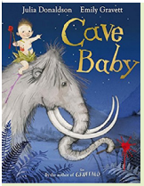  Cave Baby  Julia Donaldson  and Emily Gravett | 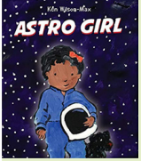  Astro Girl  Ken Wilson-Max |  |  | 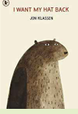  I Want My Hat Back  Jon Klassen | 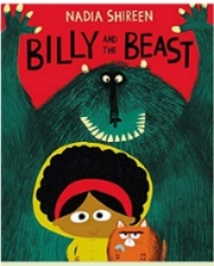  Billy and the Beast  Nadia Shireen
Length | 10+ sessions, 2 weeks | 11 sessions, 2+ weeks |  |  | 15 sessions, 3 weeks | 15 sessions, 3 weeks
Outcomes | Narrative retellings  Labels and captions, informal letters | Fact files about being astronauts Writing in role, commands, ‘how to’ guides |  |  | Story sequels  Questions, speech bubbles, letters, lists | Own version ‘defeat a monster’ narratives Wanted posters, summaries, emails, character descriptions, recipes
Theme/Term | Spring 1 |  |  |  | Spring 2
Writing Root /  Spelling Seed Text | 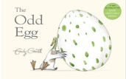  The Odd Egg Emily Gravett |  | 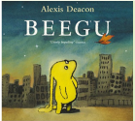  Beegu  Alexis Deacon |  | 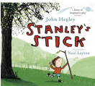  Stanley’s Stick  John Hegley and Neal Layton | 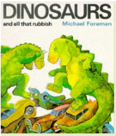  Dinosaurs and all that Rubbish  Michael Foreman
Length | 10 sessions, 2 weeks |  | 10 sessions, 2 weeks |  | 11 sessions, 2+ weeks | 15 sessions, 3 weeks
Outcomes | Egg-spotter’s guides (nonfiction reports)  Thought and speech bubbles, diaries, letter, certificate |  | Own version ‘alien’ narratives Descriptions, commands, letters, nonsense-word dictionary, poems, nonfiction reports |  | Own version narratives  Retellings, descriptions | Pamphlets  Letters, setting descriptions, instructions, narrative retellings, pamphlets, posters
Theme/Term | Summer 1 |  |  |  | Summer 2
Writing Root /  Spelling Seed Text | 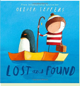  Lost and Found  Oliver Jeffers |  |  | 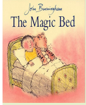  The Magic Bed  John Burningham | 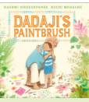  Dadaji’s Paintbrush  Rashmi Sirdeshpande | 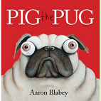  Pig the Pug  Aaron Blabey
Length | 15 sessions, 3 weeks |  |  | 15 sessions, 3 weeks | 15 sessions, 3 weeks | 15+ sessions, 3+ weeks
Outcomes | Own version ‘losing/finding’ narratives Character descriptions, retellings, advice, instructions, non-chronological reports |  |  | Own version fantasy stories  Setting descriptions, additional scenes, description of magical piece of furniture, lists | Own version narrative  Labels, captions, character comparisons, thought and speech bubbles, fact files | ‘How to’ guides  Character comparisons, fact sheets, shared poetry, own version narratives

