Theme/Term | Autumn 1 |  |  |  | Autumn 2
Writing Root /  Spelling Seed Text | 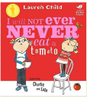  I Will Not Ever Never Eat a Tomato  Lauren Child | 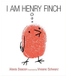  I am Henry Finch Alexis Deacon |  |  | 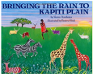  Bringing the Rain to Kapiti Plain  Verma Aardema | 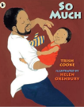  So Much Trish Cooke and Helen Oxenbury
Length | 10+ sessions, 2+ week | 10+ sessions, 2+ week |  |  | 10+ sessions, 2+ weeks | 10+ sessions, 2+ weeks
Outcomes | Own stories about a fussy eaters Statements, writing in role, shopping lists | Guidebooks - How to Think Timetables, thought-bubbles, lists, commands, letters of advice |  |  | Tourist information leaflets Labels and captions, retellings, simple explanations | Own ‘So Much’ narrative poems  Past tense sentences, writing in role, performance/ narrative poetry
Theme/Term | Spring 1 |  |  |  | Spring 2
Writing Root /  Spelling Seed Text | 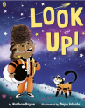  Look up!  Nathan Bryon and Dapo Adeola |  | 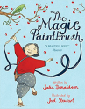  The Magic Paintbrush Julia Donaldson and Joel Stewart |  | 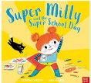  Super Milly and the Super School Day Stephanie Clarkson | 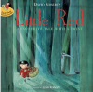  Little Red  Lynn Roberts and David Roberts
Length | 10+ sessions, 2+ week |  | 10+ sessions, 2+ week |  | 10+ sessions, 2+ week | 10+ sessions, 2+ week
Outcomes | Non-chronological reports Dialogue, diaries, re-telling (oral dictation), mini-autobiography, ship’s log |  | Own version ‘overcoming’ tales  Thought bubbles, labels, oral re-telling, writing in role, thank you letters |  | Alternative character version  Letters of encouragement; a retelling; song lyrics and job applications | Alternative character versions  Labels, notes of advice, adverts
Theme/Term | Summer 1 |  |  |  | Summer 2
Writing Root /  Spelling Seed Text | 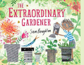  The Extraordinary Gardener Sam Boughton |  |  | 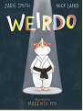  Weirdo  Zadie Smith and Nick Laird | 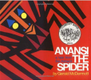  Anansi  Gerald McDermott | 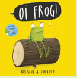  Oi! Frog  Kes Gray and Jim Field
Length | 10+ sessions, 2+ week |  |  | 10+ sessions, 2+ week | 10+ sessions, 2+ week | 10+ sessions, 2+ week
Outcomes | Narrative inspired by the original text  Labels, letters of advice, instructions, narratives |  |  | Instructional guides to being brave  Writing in role, letters, captions and labels, narrative retellings | Booklets about spiders Labels and captions, call-and-response poems, descriptive posters, simple explanations | Own version rhyming narratives  Rhyming flipbooks, questions, captions and labels

